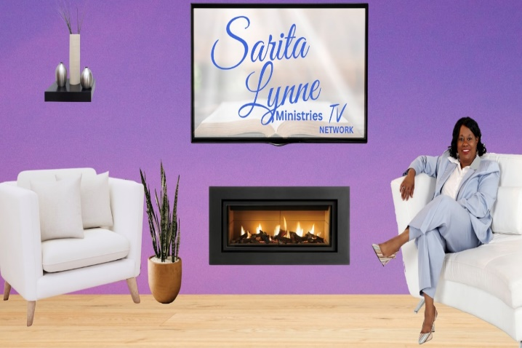 IT’S TIME TO TAKE YOUR MESSAGE TO THE NATION!
SLM TV NETWORK PACKAGES
$275 Month | $500.00 Month
30 minute show- 2 times a month | 30 minutes Show-4 times a month
Multi- Platform Bundle 4 Channels  $875.00 | Multi -Platform Bundle 4 Channels  $1750.00
$550 Month | $1050 Month
1 hour show- 2 times a month | 1 hour show -4 times a month
Multi- Platform Bundle 4 Channels  $1875.00 | Multi- Platform Bundle 4 Channels  $3800.00
Package detail
Personal TV Platform choice one(1) of your choice
_____ ROKU TV _____ APPLE TV
_____ AMAZON FIRE TV_____Android TV
_____ PODCAST
. With all purchases we provide access the link “Sarita Lynne Minisistries “ to all Mobile Apps and Apple App Stores. We will be forwading a 6 month contract to sign.
Requirements
You must submit complete & edited show
- Upload Fee of $50/month per show
- $100- Additional one time set up fee which includes: Cover Artwork & Basic Intro and Outro Creation by: Editor Franklyn Pimentel @ Fp.f0805@gmail.com
CONTACT INFORMATION
Producer: Dr. Sarita Graham @ saritagraham@aol.com
816.561.0035-OFFICE / 816.946.1834-CELL

PROVIDER | TIME SLOT  Date and Time
ROKU

ANDROID TV
AMAZON FIRE TV
APPLE TV
PODCAST
Each Package will be seen on all Mobile Apps
Multi - Platform Bundle
4 Channels

