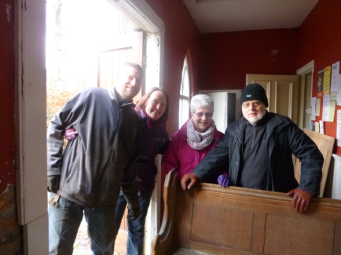
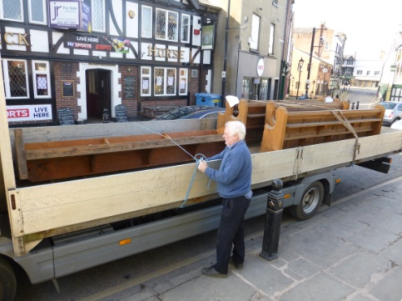

The disposal of the pews has been problematic to say the least, but now that they have all been sold (including those at St Mark’s) we can put more effort into the procurement of the chairs – the Alpha Winchester. For now, we will just have to manage with the brown plastic ones we acquired last summer. We are also in the process of ordering cushions for the chancel pews (and those in the hospitality area).
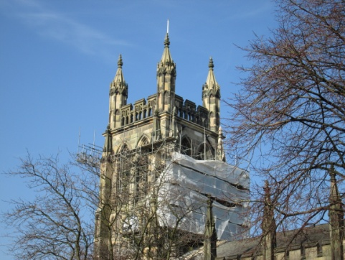
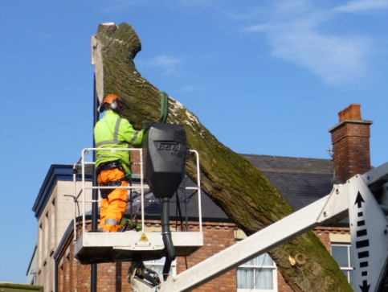
We have watched with interest over recent days the removal of the willows. It has been a complex task for the team from Solutions SK, but they have gone – to the relief of the Council Officer responsible for organising their removal.
Also coming down in stages, the scaffolding. Once the clock face returns around the 13th March the rest will be taken away. A wonderful job completed.
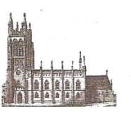
St Mary’s in the Marketplace.
Issue No 33 (3rd March 2013)

“Securing the future for the next 100 years”

Welcome back to St Mary’s after our few weeks of closure. There is still plenty to be done before the interior re-ordering (Phase I) is completed but you must surely be impressed with what has been achieved so far.
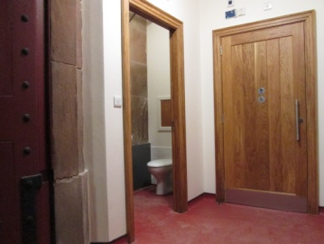
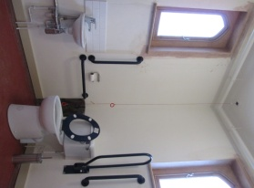
The toilets are such an improvement – automatic lighting, electric hand-dryers, baby changing and full disabled facilities.
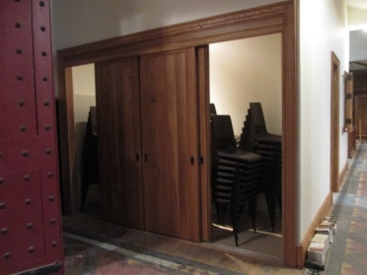
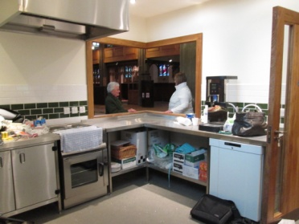
A semi-professional kitchen with cooker & extractor unit, fridge and dishwasher. There is still plenty to be done to equip our kitchen and fully set-up the Nave Café – but we are working on this. For now however we will continue to keep it simple with drinks and pre-packaged refreshments only.
Purpose-built chair store above which are the water tanks and immersion heaters.
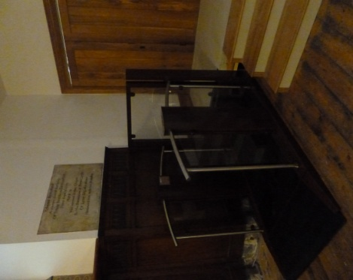
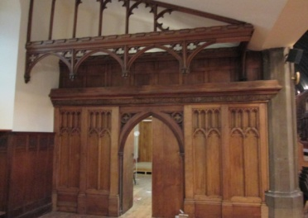
Stockport Heritage Trust members are waiting (slightly impatiently) to return to set-up in their new area, which will incorporate the church shop. We will in due course have to give more consideration to the merchandise we intend to stock and sell as income generation to St Mary’s.
The lift is now installed leaving just a little more joinery work to be completed (handrail to the steps and skirting boards) before Heritage start to assemble their display furniture.
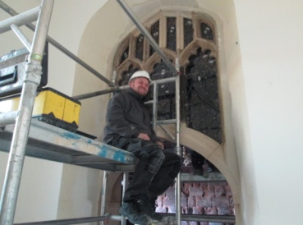
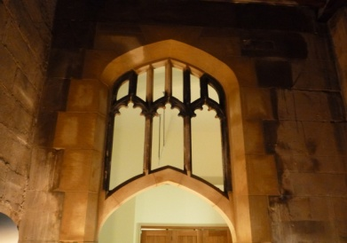
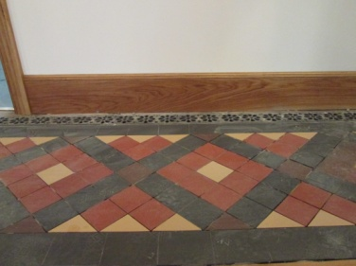
We are waiting now for the remainder of the floor tiling to be completed – there has been a delay in the supply of replacement tiles from the manufacturer which has caused additional delay to completion of the work. Once all the tiling is in place, all will be stripped and sealed – not to a high gloss but satin finish.

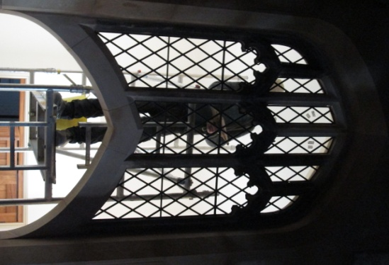

The newly created archway from the Choir vestry is just about complete with the restoration of the window above. Regrettably it will need to be temporarily boarded (with evacuation door) until the work on the vestry area is undertaken as soon as funding is secured and contracts put in place.
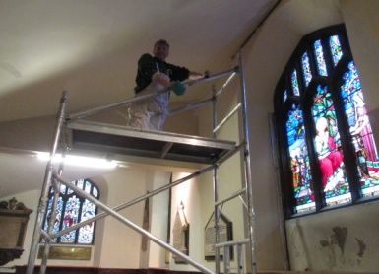
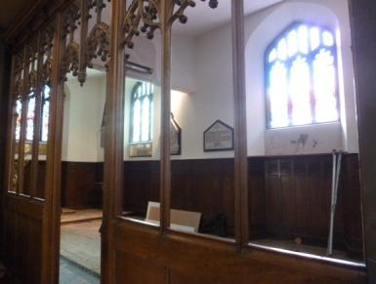
You will notice that work continues in the south aisle. Painting to the whole area is presently ongoing, the glazing of the memorial chapel likely to be completed around April. Again we are delayed due to availability of the glass and sub-contractors undertaking the work. However this has given us breathing space to review the electricity supply in that area and bring in the power supply needed for convector heaters (funding permitted) and at the same time provide additional sockets in the church office area.
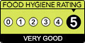
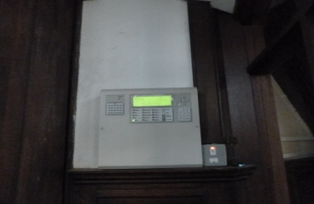
We have a smoke detector system installed, but must ensure that the north gallery remains unused, in particular when the kitchen is in use. Full evacuation procedures will be issued shortly with inspections completed as necessary with the Fire Service and Stockport Council. Before we fully open the kitchen/café will need to be registered with Stockport MBC and we need to ensure that procedures are set-up to help us to comply with necessary regulations. We are pleased to have been able to accept assistance from “Pure Innovations Ltd” to help set-up these necessary systems - in particular those concerning food hygiene. Blackshaws Café scores 5 – we aim to do the same! Still lots to do, but very exciting times ahead.

