Accessing your card on your PC:
Log into your memberplanet account. You should open to a page similar to this:
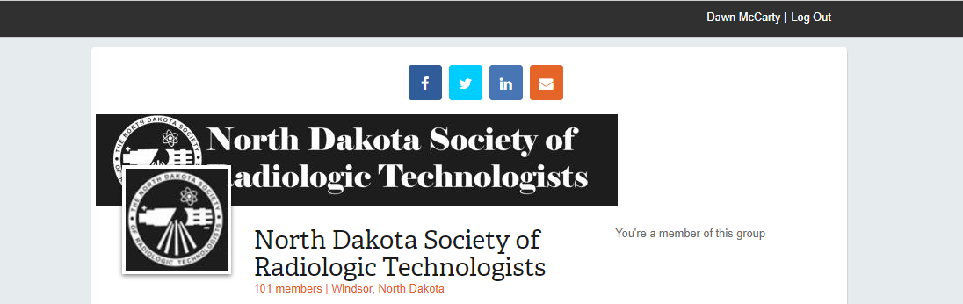
On the top left corner, you should see your name, (mine is displayed for example). You need to click on your name and then this page opens to find your card:
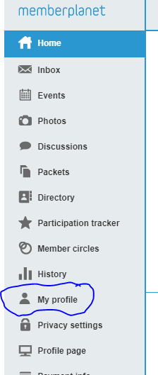
- On the left navigation bar, click My Profile
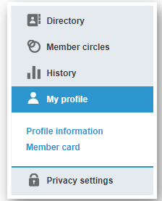
- Click Member Card in the submenu that appears below My Profile
- Select the gear icon on the right
- Click View Card in the dropdown menu
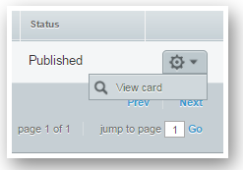
- Under the preview that displays, select Download PDF
The file will be downloaded to your desktop computer.

Accessing your card from the mobile app:
Download the app on iTunes App Store or Google Play.
- Tap the main menu icon in the upper left
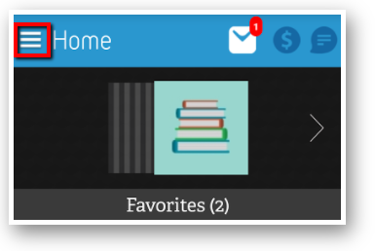
- Go to My Member Card
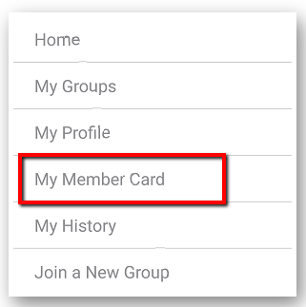
- Select the group for the card you want to view

cess my member card from the mobile app
Access my member card from the mobile app

