Clearing up the B Complex Confusion
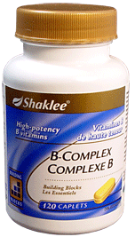

Is Your B Complex “In Harmony with Nature?”

Shaklee B Complex B Complex 50 B Complex Super

B1 20.25 mg B1 50 mg B1 50 mg
B2 22.95 mg B2 50 mg B2 50 mg
Niacinamide 270 mg Niacinamide 50 mg Niacinamide 300 mg
B6 27 mg B6 50 mg B6 50 mg
B12 81 mcg B12 50 mcg B12 100 mcg
Biotin 200 mcg Biotin 50 mcg Biotin 400 mcg
Pantothenic Acid 135 mg Pantothenic Acid 50 mg Pantothenic Acid 100 mg
Folic Acid 400 mcg Folic Acid 100 mcg Folic Acid 400 mcg

“B Complex 50” and B Complex Super are “man-made ratios”
that are not in harmony with nature and create imbalances in the body’s chemistry, hormones & metabolism!

These imbalances cause the body to “dump” nutrients … so what started out being an effort to “overcome deficiencies”
often ends up “creating deficiencies”.

