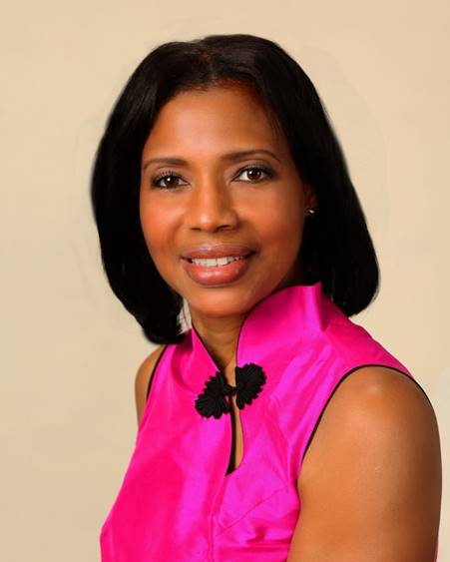
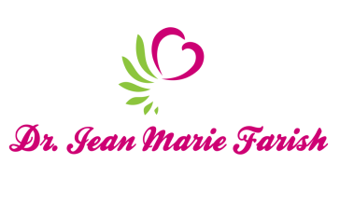

LOVE LIGHT NewsLetter

I am excited to host my VoiceAmerica Empowerment Show-LOVE LIGHT with amazing Guests to cultivate a lifestyle of love and wholehearted connections through worthiness. My show is aligned with my mission to live an altruistic and heart centered life.

MEET GUEST AUTHOR AND SONGWRITER

Richelle Putnam

February 21, 2020

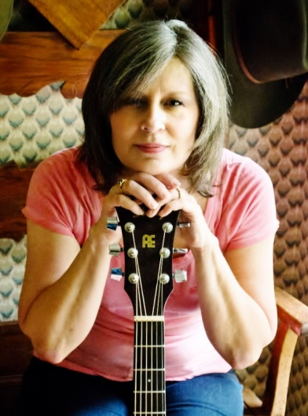

“Creative Expressions of Love”

ABOUT Richelle Putnam

Richelle Putnam is an author/freelance writer, literary artist, and songwriter. She is featured on many online stations as well as American Songwriter Magazine. Her mission as a writer is to help children experience the beauty of words and realize their power. Richelle engaged children, family, staff and caregivers with storytelling and musical renditions at the UMMC Children’s Hospital for the “Prime Time Show Time” PEP For Angels Cultural Arts Festival hosted by Life Care Wellness PEP For Angels, Inc. in partnership with the Mississippi Arts Commission. Her accomplishments are highlighted below to capture the range of her gifts and talents.

Author/Freelance Writer
www.richellputnam.net

Managing Editor, The Bluegrass Standard
www.thebluegrasstandard.com

Publisher/Editor, Southern Roots Magazine
http://www.southerrootsmag.com

Books
Mississippi and the Great Depression, (Bronze Medal -2017 Foreword Indie Book Awards)
The Inspiring Life of Eudora Welty (Silver Medal -2014 Moonbeam Children’s Book Awards)
Legendary Locals of Meridian
Lauderdale County, Mississippi, a Brief History

Literary Achievements
Mississippi Arts Commission (MAC) Roster/Teaching Artist
MAC Literary Fellow
Mississippi Humanities Speaker
Founder/Mississippi Writers Guild

Former Talk Radio Host
Behind the Scenes (Arts/Entertainment)
Looking Back (People, Places, Issues, Historical Events in Mississippi)
Supertalk Meridian 103.3
www.supertalk.fm

“An empowered self is a loving self and keep your love light shining”

