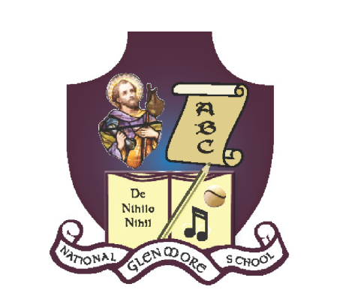
 | Mo | Tu | We | Th | Fr | Sa | Su | Mo | Tu | We | Th | Fr | Sa | Su | Mo | Tu | We | Th | Fr | Sa | Su | Mo | Tu | We | Th | Fr | Sa | Su | Mo | Tu | We | Th | Fr | Sa | Su
Sep | 28 | 29 | 30 | 31 | 1 | 2 | 3 | 4 | 5 | 6 | 7 | 8 | 9 | 10 | 11 | 12 | 13 | 14 | 15 | 16 | 17 | 18 | 19 | 20 | 21 | 22 | 23 | 24 | 25 | 26 | 27 | 28 | 29
Oct |  |  |  |  |  | 30 | 1 | 2 | 3 | 4 | 5 | 6 | 7 | 8 | 9 | 10 | 11 | 12 | 13 | 14 | 15 | 16 | 17 | 18 | 19 | 20 | 21 | 22 | 23 | 24 | 25 | 26 | 27 | 28 | 29
Nov | 30 | 31 | 1 | 2 | 3 | 4 | 5 | 6 | 7 | 8 | 9 | 10 | 11 | 12 | 13 | 14 | 15 | 16 | 17 | 18 | 19 | 20 | 21 | 22 | 23 | 24 | 25 | 26 | 27 | 28 | 29 | 30
Dec |  |  |  |  | 1 | 2 | 3 | 4 | 5 | 6 | 7 | 8 | 9 | 10 | 11 | 12 | 13 | 14 | 15 | 16 | 17 | 18 | 19 | 20 | 21 | 22 | 23 | 24 | 25 | 26 | 27 | 28 | 29 | 30 | 31
Jan | 1 | 2 | 3 | 4 | 5 | 6 | 7 | 8 | 9 | 10 | 11 | 12 | 13 | 14 | 15 | 16 | 17 | 18 | 19 | 20 | 21 | 22 | 23 | 24 | 25 | 26 | 27 | 28 | 29 | 30 | 31
Feb |  |  |  | 1 | 2 | 3 | 4 | 5 | 6 | 7 | 8 | 9 | 10 | 11 | 12 | 13 | 14 | 15 | 16 | 17 | 18 | 19 | 20 | 21 | 22 | 23 | 24 | 25 | 26 | 27 | 28 | 29
Mar |  |  |  |  | 1 | 2 | 3 | 4 | 5 | 6 | 7 | 8 | 9 | 10 | 11 | 12 | 13 | 14 | 15 | 16 | 17 | 18 | 19 | 20 | 21 | 22 | 23 | 24 | 25 | 26 | 27 | 28 | 29 | 30 | 31
Apr | 1 | 2 | 3 | 4 | 5 | 6 | 7 | 8 | 9 | 10 | 11 | 12 | 13 | 14 | 15 | 16 | 17 | 18 | 19 | 20 | 21 | 22 | 23 | 24 | 25 | 26 | 27 | 28 | 29 | 30
May |  |  | 1 | 2 | 3 | 4 | 5 | 6 | 7 | 8 | 9 | 10 | 11 | 12 | 13 | 14 | 15 | 16 | 17 | 18 | 19 | 20 | 21 | 22 | 23 | 24 | 25 | 26 | 27 | 28 | 29 | 30 | 31
Jun |  |  |  |  |  | 1 | 2 | 3 | 4 | 5 | 6 | 7 | 8 | 9 | 10 | 11 | 12 | 13 | 14 | 15 | 16 | 17 | 18 | 19 | 20 | 21 | 22 | 23 | 24 | 25 | 26 | 27 | 28 | 29 | 30
SCOIL NAISIÚNTA SEAMUS NAOFA, GLENMORE NATIONAL SCHOOL
GLENMORE, CO. KILKENNY. Y34 C527
051 – 880269 glenmorens@gmail.com Roll No: 18158L
Calendar for School year 2023- 2024

□ School opening and closing □ Standardised School closures Teacher planning days: TBC

