Monday | Tuesday | Wednesday
Breakfast:  Toasted crumpets with a choice of spreads, selection of cereals with milk  Lunch:  Shepard’s pie either vegetable option with Quorn minced or with minced beef  Dessert:  Fruit salad  Tea:  Vegetable or Tomatoes soup served with bread rolls | Breakfast:  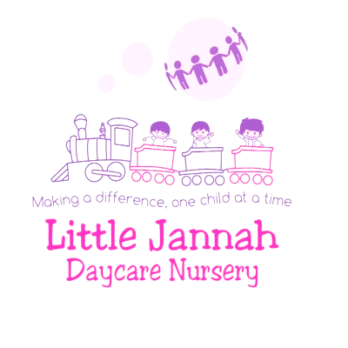  Toasted bread with a choice of spreads, selection of cereals with milk  Lunch:  Vegetable Pasta bake served with salad  Dessert:  Fruit salad with Greek yogurt/Diary free yogurt  Tea:  Tuna pasta bake | Breakfast:  Toasted pancake with a choice of spreads, selection of cereals with milk  Lunch:  Chicken / vegetable stir fry  Dessert:  Cake and custard or dried fruits  Tea:  Chicken / Quorn chicken wraps which will have tomatoes, lectures, onions, cucumbers, and dressing
Thursday
Breakfast  Toasted bread with a choice of spreads, selection of cereals with milk  Lunch  Traditional chicken/vegetable tikka masala curry served with steamed rice  Dessert:  Ice cream/Dairy free ice cream  Tea: Homemade pizza’s | 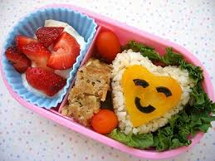 | Snack time: Children are provided with a range of different health snacks such as breadsticks, rice cakes and a selection of fruits and raisins. 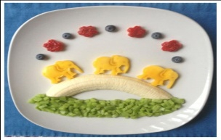

Monday | Tuesday | Wednesday
Breakfast:  Toasted bread with a choice of spreads, selection of cereals with milk  Lunch:  Lasagne with Quorn mince  Dessert:  Ice cream/Dairy free ice cream  Tea:  Bagels served with a choice of spreads and a selection of fruit | Breakfast:  Toasted pancakes with a choice of spreads, selection of cereals with milk  Lunch:  Cheese and Onion quiche served with a salad selection  Dessert:  Fruit smoothie  Tea:  Baked Potatoes with a selection of toppings and salad | Breakfast:  Toasted bread with a choice of spreads, selection of cereals with milk  Lunch:  Chickpea vegetable curry served with steamed rice  Dessert:  Greek yogurt/Dairy free yogurt  Tea:  Carrot sticks and Hummus
Thursday
Breakfast  Toasted crumpets with a choice of spreads, selection of cereals with milk  Lunch  Roast dinner served with chucky vegetable  And One day a term a traditional meal from another country  Dessert:  Fruit salad  Tea: Grilled cheese and tomatoes sandwich's |  | Snack time: Children are provided with a range of different health snacks such as breadsticks, rice cakes and a selection of fruits and raisins. 