Page 1 of 2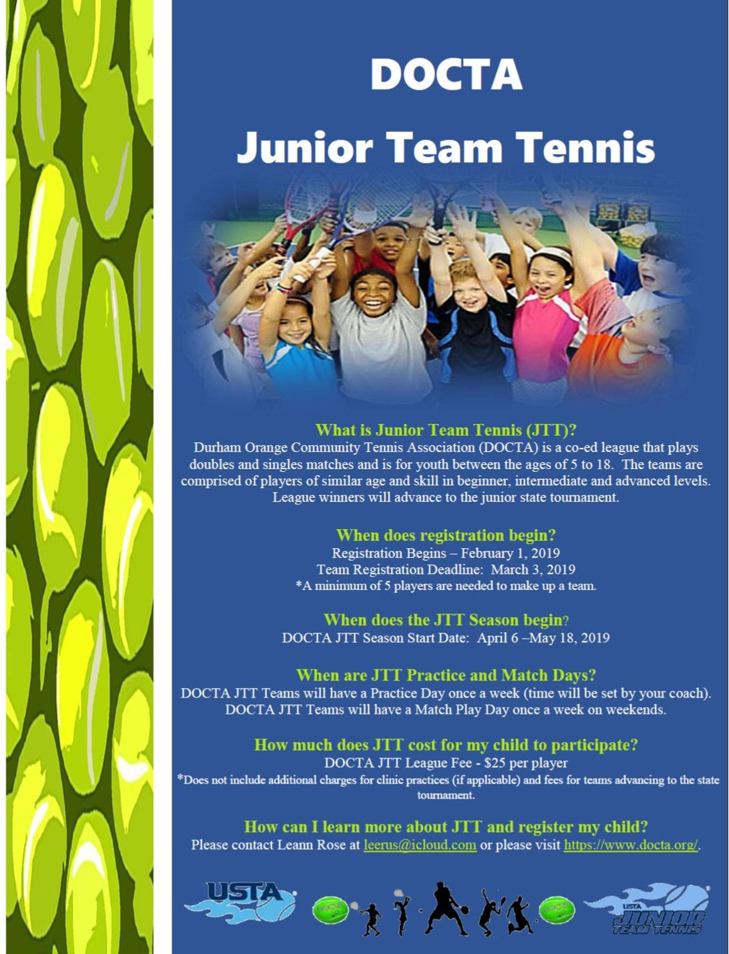Recreational Team Numbers
Page 2 of 2

Recreational Team Numbers
(playing out of public tennis courts)
Please register according to your age group or one level up.

8 beginner DOCTA Smashers
7039374511

10&U DOCTA Ace Magic
7039374515

12&U DOCTA Court Wizards
7039374516

14 &U DOCTA Court Control
7039374523

18&U DOCTA Sonic Smashers
7039374524

