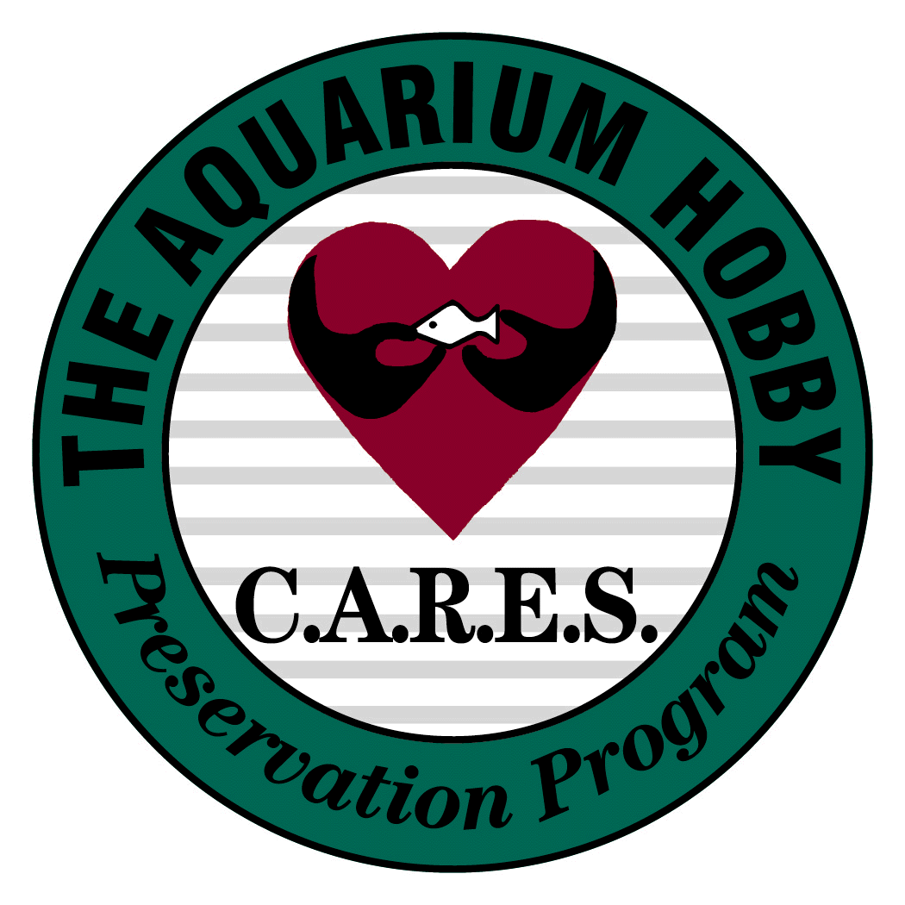

The CCY C.A.R.E.S. Preservation Program
Species Registration Sheet

Enter all species on this CCY C.A.R.E.S. Preservation Program Registration Sheet that you are currently maintaining and which are listed on the C.A.R.E.S. Preservation Program Conservation Priority List.

Your Name | Your E-mail Address and Other Contact Information | Name of Species-at-Risk | Where or from Whom Species-at-Risk was Obtained | Date Species-at-Risk was Obtained | Today’s Date | For Office Use:  Initialed by  Date  Species Journal

Good luck and thank you for your invaluable contribution towards preserving our fishes for generations to come!!!

The C.A.R.E.S. Preservation Program is about our fishes, and it is about people.
Please, clear a tank ~ save a fish!
Because of you, we are making a difference!

Your Name | Contact | Species | Where Obtained | When Obtained | Today’s Date | Official Use
Jay Stephan | cichlidsarespecial1@gmail.com | Astatotilapia Aeneocolor | Old Work Exotic Fish | 6/2011 | 2/12/2013
Jay Stephan | cichlidsarespecial1@gmail.com | Astatotilapia Latifasciata | Old World Exotic Fish | 6/2011 | 2/12/2013
Jay Stephan | cichlidsarespecial1@gmail.com | Haplochromis Obliquidens | Atlantis Tropical Fish | 4/2010 | 2/12/2013
Jay Stephan | cichlidsarespecial1@gmail.com | Aulonocara Baenschi | Treasure Coast Tropicals | 3/2012 | 2/12/2013
Jay Stephan | cichlidsarespecial1@gmail.com | Aulonocara Kandeense | Treasure Coast Tropicals | 3/2012 | 2/12/2013
Jay Stephan | cichlidsarespecial1@gmail.com | Aulonocara Lwanda | Old World Exotic Fish | 6/2012 | 2/12/2013
Jay Stephan | cichlidsarespecial1@gmail.com | Cyrtocara Moorii | Treasure Coast Tropicals | 10/2012 | 2/12/2013

Jay Stephan | cichlidsarespecial1@gmail.com | Hap. Sp. “Ruby” | Mike’s Cichlids | 7/2010 | 2/12/2013
Jay Stephan | cichlidsarespecia1l@gmail.com | Paralabidochromis Chromogynos | Old World Exotic Fish | 6/2011 | 2/12/2013
Jay Stephan | cichlidsarespecial1@gmail.com | Paralabidochromis Sauvagei Checkerboard Rock Kribensis | Old World Exotic Fish | 2/2012 | 2/12/2013
Jay Stephan | cichlidsarespecial1@gmail.com | Placidochromis sp. Phenochilus Tanzania | Florida Exotic Fish | 8/2012 | 2/12/2013
Jay Stephan | cichlidsarespecial1@gmail.com | Platytaeniodus sp. Red Tail Sheller | Florida Exotic Fish | 8/2012 | 2/12/2012
Jay Stephan | cichlidsarespecial1@gmail.com | Psammochromis riponianus | CCA Mini Auction | 3/2011 | 2/12/2013
Jay Stephan | cichlidsarespecial1@gmail.com | Pseudotropheus Saulosi | Treasure Coast Tropicals | 1/2013 | 2/12/2013
Jay Stephan | cichlidsarespecial1@gmail.com | Ptyochromis Sp. Salmon | Mike’s Cichlids | 2/2011 | 2/12/2013

Jay Stephan | cichlidsarespecial1@gmail.com | Pundamila Igneopinnis | Icthyos Enterprises | 5/2011 | 2/12/2013
Jay Stephan | cichlidsarespecial1@gmail.com | Pundamilia Nyereri Ruti | Icthyos Enterprises | 5/2011 | 2/12/2013
Jay Stephan | cichlidsarespecial1@gmail.com | Pundamilia Sp. Red Flank | Treasure Coast Tropicals | 6/2011 | 2/12/2013
Jay Stephan | cichlidsarespecial1@gmail.com | Xystichromis Sp. Kyoga Flameback | Mike’s Cichlids | 6/2011 | 2/12/2013
Jay Stephan | cichlidsarespecial1@gmail.com | Xystichromis Sp. Dayglow | Mike’s Cichlids | 6/2012 | 2/12/2013
Jay Stephan | cichlidsarespecial1@gmail.com | Xystichromis Sp. Flameback | Mike’s Cichlids | 6/2011 | 2/12/2013

