MBA MOTHERS’ DAY SHOWCASE: 6TH GRADE DIV. TOURNAMENT RECAP
The 6th grade division of our MBA Mothers’ Day Showcase was loaded with elites. Not only did it feature highly ranked 2023 teams like Memphis Basketball Association and Team No Name, but highly ranked 2024 teams like Team Payne Wareagles and Team Heat. Adidas sponsored Team Magic Elite and the always competitive Memphis Dragons rounded out the 6th Grade division.
In pool play; Team Heat defeated the Dragons, Team Magic Elite defeated Team No Name, Memphis Basketball Association defeated the Dragons, Team Magic Elite defeated Team Heat, Team No Name defeated Memphis Basketball Association, & Team Heat defeated Team Payne.
This put Team Magic Elite in 1st place. There was a 3-way tie between Memphis Basketball Association, Team Heat, and Team No Name. The tie was decided by margin of victory, putting Team No Name in 2nd Place, Team Heat in 3rd, and Memphis Basketball Association in 4th. The Dragons and Team Payne were in 5th and 6th places.
In bracket play Team Magic Elite defeated Memphis Basketball Association and Team No Name defeated Team Heat setting up a championship matchup between Team Magic Elite and Team No Name, and 3rd place game between Memphis Basketball Association and Team Heat.
Team No Name prevailed as our MBA Mothers’ Day Showcase Champions and Team Magic Elite were RunnerUps. Memphis Basketball Association defeated Team Heat, and they finished 3rd and 4th respectively.
TEAM NO NAME: MBA MOTHERS’ DAY SHOWCASE CHAMPIONS
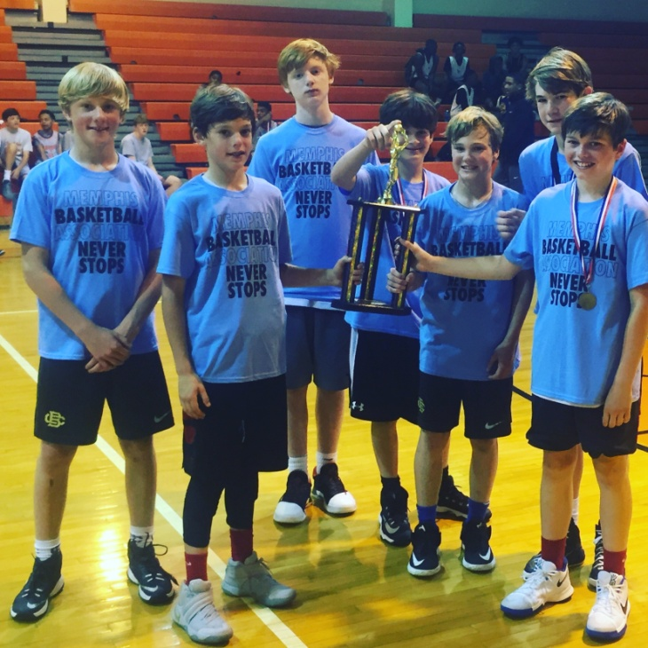
Coach Chip’s Team No Name has exactly what it takes to get the job done.
Guard Jack Pender is a solid player that can be relied upon for carrying the scoring load. He takes care of the ball, is a good passer, and will consistently knock down the trey ball.
JP isn’t the only No Name that can shoot it. They’ve got a certified sniper in Ryan Hall, this kid is a REAL shooter.
In the post they’ve got “Big Red”, also known as Josh Lykes. Lykes is the definition of “post presence”. He rebounds and blocks shots for a living. On the offensive end he is a definite low post threat as far as scoring is concerned.
Throw in consistent scorers like Henry Pietrangelo and Jack McLoughlin (or as Coach Chip calls him Jack Mac) and it’s no wonder why Team No Name is becoming a household name.

TEAM MAGIC ELITE: MBA MOTHERS’ DAY SHOWCASE RUNNERUPS
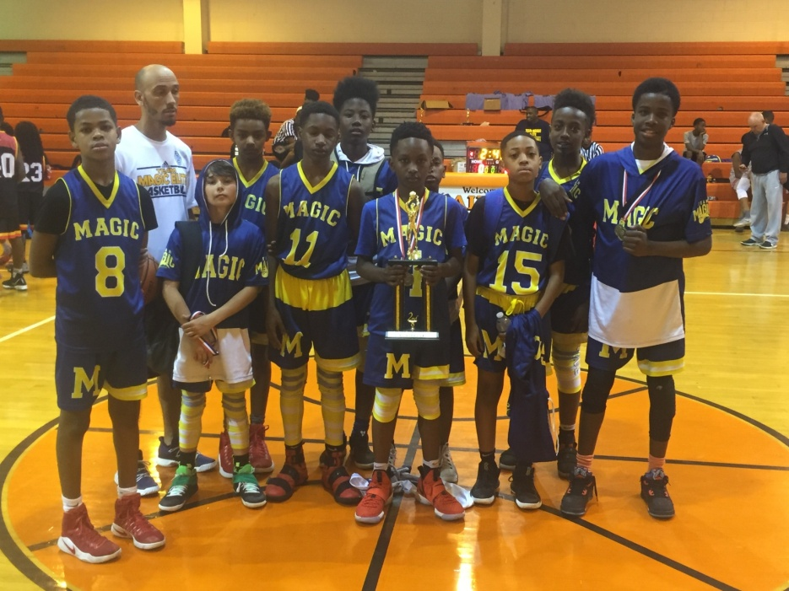
Team Magic Elite has come on strong! Usually only known for their high school age gauntlet teams, Coach Chris Robinson’s (Coach Cowboy’s 17 year old son!) 6th grade squad has been making a name for itself as well. Their roster includes at least 3 5th graders or 5th grade age kids in Hugh McFarland, a tough as nails wingman who is comfortable battling in the paint, but has of late becoming more and more of a guard. He is joined by Braxton Jumper, a sniper from the outside, who just may have the best looking shot of any kid his age, and Kenton “KJ” Smith and aggressive defender whose offensive skills seem to improve every time he touches the floor, and who’s patented euro step always seems to create just enough space for him to finish at the basket.
Josiah Nelson is a ball-handling wizard that has the rock on a string and is another weapon from outside the arc.
Devin McGhee and Jermaine Brown aretwo long kids whose size allow them to play multiple positions. Devin McGhee though, is yet another three point threat. He can absolutely shoot the long ball.
And there’s Montrallis Greer, yet another solid piece. Greer is a proven scorer with great size. He along with the others will help make Team Magic Elite a force in the 2023 class.

MEMPHIS BASKETBALL ASSOCIATION: MBA MOTHERS’ DAY SHOWCASE 3RD PLACE
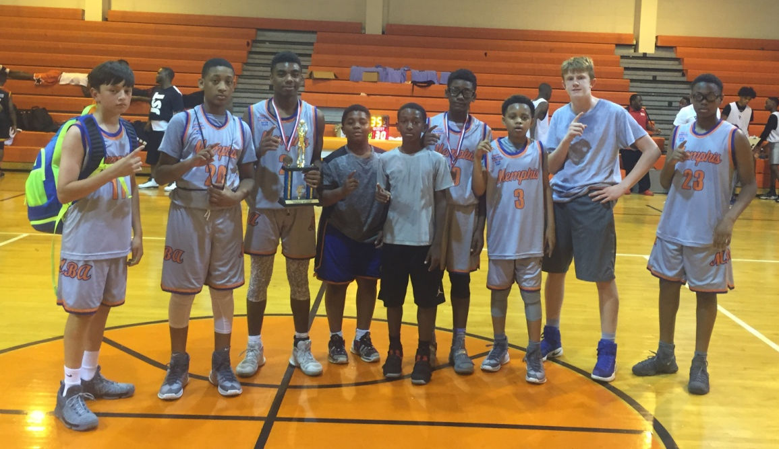
MBA’s 6th grade squad is led by lefty Snoody Wilkinson, a lockdown defender, powerful finisher, and all-around stud.
Fred “Mane-Mane” Deere is one of MBA main scoring options, he’s a crafty guard, with an array of moves to free up space, and an automatic free throw shooter.
Anthony Medlock Jr. is a reliable piece for MBA, capable of playing several positions, and besides having a very consistent midrange shot, he can score from several spots, from the post, to three point line, thus stretching the floor out.
Speaking of the three point line, they have two snipers in Reid Chauan and Brian Gilmore, both who are easily capable of double digit performances from the three point line alone.
The addition of guards Tookie Rogers and Mike Hastings, will add to depth, as well as helping Snoody with ball-handling duties. Tookie is on his way to being a pure PG and he can light it up from the outside, while Mike doesn’t mind getting in it on defense.
In the post is Hunter Stallings a giant kid, that will definitely intimidate opponents. He’s a solid rebounder, decent shot blocker, and his scoring range extends from the paint to around the free throw line. Kam Temple gives MBA solid minutes as well, he is good rebounder and is emerging as solid point contributor in paint.

TEAM HEAT: MBA MOTHERS’ DAY SHOWCASE 4TH PLACE
We’ve been hearing about them, and hearing about them, but this past weekend we got a chance to see them first hand. Impressive is an understatement. They played up in the 6th grade division and held their own.
First you’ve got to talk about the beast. No need for first or last names, just call him “KING”. Like Lebron James? Yeah, like Lebron James. He’s as strong as any kid in the class, he can handle the ball, he’s physical, he’s aggressive, he attacks the basket, he finishes. There is NO kid in the class like him.
Now add, Gerald Burris. A good ball-handler and decision maker, capable of handling presses and traps. He has a nice stroke and is a solid scorer. Burris can definitely be considered a two-way player as he gets in it on both ends of the floor.
Dominique Jamison is another solid contributor. We would consider him to be undersized, but I don’t think he knows it. The kid gets out and gives 100%, takes no plays off, and produces! One of Team Heat’s lead scorers Jamison is BIG TIME!
William H. Carver is another big time contributor. He’s a consistent scorer, and teamed with the others makes Team Heat a formidable match for ANYBODY!

MBA MOTHERS’ DAY SHOWCASE: 6TH GRADE ALL-TOURNAMENT TEAM
Pictured from left to right; Dominique Jamison (Team Heat), Gerald Burris (Team Heat), King Thelford (Team Heat), Montrallis Greer (Team Magic Elite), Josiah Nelson (Team Magic Elite), KJ Smith (Team Magic Elite), Fred Deere (MBA), Snoody Wilkinson (MBA), Anthony Medlock (MBA), Henry Pietrangelo (Team No Name), Jack Pender (Team No Name), and Jack McLoughlin (Team No Name).

PLAYERS TO WATCH
Players’ Name | Pos. | Team | Class
Gerald Burris | G | Team Heat | 2024
Fred Deere | G | Memphis Basketball Association | 2023
Christian Gilliland | G | Team Payne Wareagles | 2024
Braxton Jumper | G | Team Payne Wareagles | 2023*
Jack Pender | G | Team No Name | 2023
Marcus Prewitt Jr. | F | Memphis Dragons | 2023
KJ Smith | G | Team Magic Elite | 2024
King Thelford | F | Team Heat | 2024
Snoody Wilkinson | G | Memphis Basketball Association | 2023
*Age allows him to play in a class below his own

