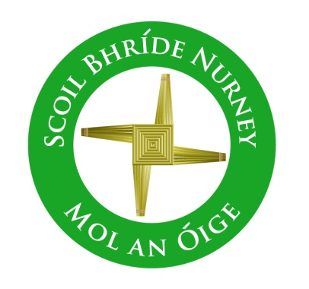
Scoil Bhríde,
Nurney,
Principal – Dr. Vinny Thorpe
Dep. Principal – Catherine Owens

County Kildare.
Tel/Fax: (045)526767
Email: sbnurney@gmail.com
www.nurneyns.com
Roll no: 16345A
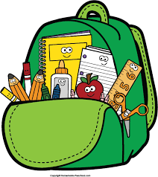

2nd Class 2022 – 2023
Additional requirements
- Items to be purchased and labelled by parents in advance of September 2022:
(We have also indicated the ‘likely’ costs of these required items at best value stores)
- 10 x 88 page copies (€2.99 for 10)
- Plastic A4 zip lock folder (€2)
- 10 x pencils – labelled and sharpened (€4 for 10)
- Packet of ‘Twistables’ or similar (NOT Markers!!) (€3.49)
- Eraser and pencil sharpener (99 cent each)
- 30cm ruler (99 cent)
- 2 x large Pritt stick – labelled (€1.99 each)
- Highlighter (any colour) – labelled (99 cent)
- Tin whistle in the key of ‘D’ – labelled (€5.99)
- 2 x Whiteboard markers (50 cent each)

- €35 to be paid to class teacher or online by mid-September 2022 (if paying by cash/cheque this should be in a sealed envelope with your child’s name and class printed clearly on it)
This amount will be allocated as follows:
- Art and craft €15
- Photocopying €10
- Homework Journal €3.50
- Specialised stationary €4
(i.e. test notebook, handwriting copies, maths copies, A4 notebooks and folders)
- Assessment tests €2.50
Please label all of your child’s belongings, stationery, uniform and tracksuit tops, coats etc.
Books will be provided under our Book Rental Scheme for those who have fully paid up and will be in your child’s classroom in September. Please impart to your child the importance of taking care of these books as any damage to Book Rental Books will be charged to you at the end of the school year.

Thank you for your co-operation and looking forward to a great year ahead!
___________________
Class Teacher

