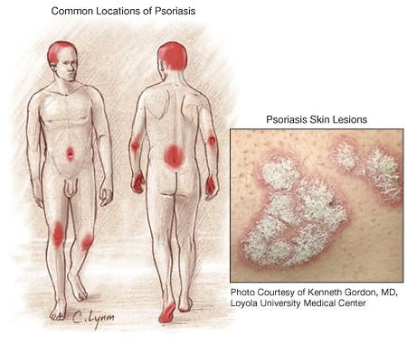
Psoriasis
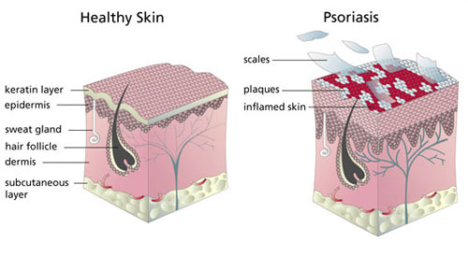

- Inflamed skin irritation with flaking and reddened patches
- An over reactive response of the immune system, often associated with arthritic disease
- More common among those who are sensitive to wheat, oats, rye and barley
- Is not contagious
- Generally follows a pattern of periodic flare-ups alternating with periods of remission
- Is a very stubborn disorder, and will not be overcome without a totally committed health approach, including a major diet change and optimal supplementation. After a period of time, supplementation can be reduced to a maintenance level, but large amounts will be needed at first … it is imperative that the client does not have “unreasonable expectations”

Causes:
- Faulty utilization of fat
- Faulty immune system
- Unhealthy colon
- Attacks can be triggered by nervous tension, stress, illness, injury, surgery, cuts, poison ivy, viral or bacterial infection, sunburn, etc.
- Attacks can be triggered by drugs: NSAIDS, beta-blockers, etc.
- Can be caused, aggravated, or made worse by heavy alcohol consumption

Traditional Medical Treatment:
- Immunosuppressive drugs such as cyclosporine or methotrexate are prescribed, which suppress the over reactive response of the immune system. These drugs can cause undesirable side effects. They are not addressing the root problem.

Complementary Alternative Methods:
While generally not included in a patient’s medical plan, many people have found relief through alternative treatments that address the root of the problem and down-regulate the over reaction of the immune system.

Diet:
- Start each morning with “the water flush”
- Every morning breakfast must include 2 scoops of “Cinch Shake” and 2 tablespoons of “milled flaxseed” in
- Water
- Water with 2 tablespoons of Shaklee Soy Protein
- Rice milk
- Almond milk
- Eat two stalks of celery every day (not two bunches of celery, but two full 1 foot stalks). This is important for electrolyte balancing.
- Avoid caffeine, white flour, white sugar and salt
- Eat a diet composed of at least 51% raw food … including plenty of fibre
- Reduce animal protein, especially red meat – it is high in arachidonic acid which causes flare-ups
- Eat RAW nuts and seeds for healthy snacks (for the EFA content)
- Essential: Avoid foods you are allergic to … shown by your Elisa Allergy Test

Recommended Complementary Protocol
Arrange for an Eliza RAST allergy test to determine if there are foods in your diet that are triggering this auto-immune response in the body. (Call 905-871-4281 and ask for Martha Willmore)

For the first 10 days, use the following supplements …
- Shaklee Vitalizer
- Alfalfa tablets (natural anti-inflammatory) – 10 per meal
- Shaklee GLA (natural corticosteroid) – 2 per meal
- Shaklee Pain Relief Complex (natural inflammatory) - 1 per meal
- Shaklee Take 2 B Complex every 2 hours from early morning until 6 p.m. at night … this causes the adrenal glands to make more natural corticosteroid hormones
- Shaklee Take 2 Vitamin C every 2 hours from early morning until bedtime … this causes the adrenal glands to make more natural corticosteroid hormones
- Shaklee OmegaGuard: take 3 to 4 three times a day … it is important to use a large amount initially
- Shaklee CarotoMax for the skin repair – 2 per day
- Shaklee Vitamin D3 – 4 per meal
- Shaklee NutriFeron – 2 two times per day
- Shaklee Vivix – 2 teaspoons

Maintenance program:
- Continue with the optimal amounts of OmegaGuard for 3 more weeks … (after a month, 3 per day is adequate)
- Continue with smoothies & ground flaxseed
- Continue with 1 Alfalfa for every 10 pounds of body weight
- Continue with 2 GLA per day
- Continue with 1 Vitalizer strip per day
- Continue with whatever additional B Complex you need to maintain yellow urine all day long
- Continue with 3+ additional Vitamin C 500
- Continue with 4+ Vitamin D3 per day
- Continue with 2 NutriFeron per day
- Continue with 1 teaspoon of Vivix per day

Suggested Detoxification:
- Liver DTX (Milk Thistle Formula) keeps the liver and blood clean
- Herbal Laxative – bowel conditioner
- Several cleanses are in order: Rejuvenating Body Cleanse, Liver Cleanse & Kidney Cleanse

Other Suggested Tips:
- Add healing oils to bath water and soak
- Add up to 10 crushed Stomach Soothing Complex tablets to your bath water & soak (once a week)
- Have hormone levels checked, and work on balancing hormones
- If DHEA is low, you can’t heal
- If testosterone is high, psoriasis will be worse
- If progesterone is low, you’ll suffer from more inflammation

