Equine Haven Recovery Care and Equestrian Centre Ltd
Fall Festival Horse Show
Hunters and Jumpers Oct. 2nd and 3rd, 2021

Ribbons to 6th place; Prize Money to 5th place.
Champion and Reserve Champion in Each Division
Entries Limited to 50 Riders/Day
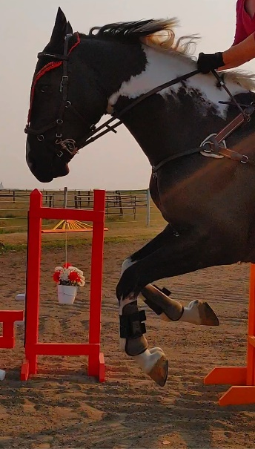
Course Designer: Crystal Turko
Judge: Sadie Turko
General Inquiries: info@equinehaven.ca
Entry Forms can be found at www.equinehaven.ca
E-transfers for entry fees can be sent to Sadie.Turko@equinehaven.ca
Credit Card accepted for additional fee.
Closing Date: September 27th, 2021
Show Details
ADMINISTRATION: Equine Haven Ltd reserves the right to cancel or combine any given classes that do not fill to their satisfaction. All exhibitors in cancelled classes will be notified by either email or telephone (if number is provided on entry form) and any entry fees refunded. No advanced notification will be given for combined classes.
ADMINISTRATION: The Fall Festival Horse Show hosted by Equine Haven Ltd is open to all riders; however, we reserved the right to refuse any entry, to make changes to arena classes run in, judges, or class order to best facilitate the running of the show. We also reserve the right to start each division up to 30 minutes earlier than the posted schedule if number of entries permit.
SAFETY: The judge reserves the right to eliminate any horse/rider combination that exhibits excessive speed, abuse to the horse, unsafe or unsportsmanlike behaviour, or lack of control, with no refund of fees.
ENTRY FORMS: Please fill out one entry form per horse/rider combination.
CANCELLATION POLICY: Cancellation before closing date of entries will receive a full refund. Cancellation after closing date but before the start of the horse show will receive a refund less the office fee. Cancellation after the start of the horse show, with proof of Vet Certificate, class fees for remaining classes will be refunded.
ADD/SCRATCHES: There will be no charge for adds/scratches the day before classes for horses already entered. Same day adds/scratches are acceptable but at a $10 charge, in addition to the class fee. Classes scratched the day before will be refunded; however, same day scratches are non-refundable.
LATE FEES: Entries received after the closing date for the show will pay a post entry fee of $20. Horses showing in a class without being entered will pay DOUBLE the class fee.
SCHOOLING ROUNDS: Schooling rounds for each height will be held at the start of each division. Coaches are allowed in the ring during schooling rounds. Riders have maximum of 5 minutes to finish the course and will not be eliminated for refusals. Rounds are unjudged and ribbons will not be given.
ACCOMODATIONS: Accommodations available in either stall, or paddock for the weekend. Day stalls are available for a fee of $25, overnight stalls are $50. Day paddocks available for $15 and overnight for $30. Bedding and daily stall cleaning included. Stalls are limited and priority will be assigned in the order entry forms are received.
HAUL INS – Trailering in is welcome for no additional fee; however, all horses and riders must be entered in the show and be assigned a number. Space for RVs and/or tents will be made available on request. There will be no service hookups.
REFUSALS – Riders with two refusals will not be buzzed out of the ring. The top pole of the fence refused twice will be dropped to the ground and the rider will be allowed to continue to the conclusion of the course. Riders with 2 or more refusals will be placed last, but not eliminated.
PROTECTIVE HEADGEAR: All competitors must wear proper fitting and approve headgear, with safety harness correctly secured, at all times while mounted on the event grounds. Helmets must meet ASTM standards and display the SEI seal. The British standard BSI is also acceptable. Any rider found violating this rule will be prohibited from further riding on event grounds until a helmet is properly in place.
DOGS: No dogs are permitted on the event grounds.
ADD BACK STAKES: $15 from each entry will be added back as prize money. Distribution of prize money will be done according to the following: 1st – 30%; 2nd - $25%; 3rd – 20%; 4th – 15%, and 5th – 10%.
HEIGHTS: Heights above 2’6” in the hunter ring, and 1.0m in the jumper ring will be offered if three or more riders request it.
CONCESSIONS: Limited concessions will be available for sale on site (ie. Chips, pop, baked goods). The Equine Haven team is currently working to secure a food truck on both days as well. If successful it will be announced via our social media closer to the event.
SEATING: Please bring your own chairs for viewing ring.

HUNTER DIVISIONS – SATURDAY OCT 2nd
$85.00/Division; Start Time 9:00am (Tentative)
Division | Class | Cost
Walk/Trot Poles – Children under 6 or those with special needs are allowed to compete on a lead line and will not be penalized. The rider will be judged on how much they are participating in all aspects of the course. | 1. Schooling Round | $10.00
 | 2. Hunter | $20.00
 | 3. Hunter Equitation | $20.00
 | 4. Hunter Add Back Stake | $40.00
Walk/Trot – 6” Cross Rails | 5. Schooling Round | $10.00
 | 6. Hunter | $20.00
 | 7. Hunter Equitation | $20.00
 | 8. Hunter Add Back Stake | $40.00
1’ Cross-Rails (Trot or Canter) | 9. Schooling Round | $10.00
 | 10. Hunter | $20.00
 | 11. Hunter Equitation | $20.00
 | 12. Hunter Add Back Stake | $40.00
1’6” Verticals (Trot or Canter) | 13. Schooling Round | $10.00
 | 14. Hunter | $20.00
 | 15. Hunter Equitation | $20.00
 | 16. Hunter Add Back Stake | $40.00
2’ Verticals | 17. Schooling Round | $10.00
 | 18. Hunter | $20.00
 | 19. Hunter Equitation | $20.00
 | 20. Hunter Add Back Stake | $40.00
Show Off (1) | 21. Hunter Under Saddle | $20.00
 | 22. Road Hack | $20.00
 | 23. Show Hack | $20.00
 | 24. Hunter Equitation Flat Add Back Stake (Top 3 will compete over short course up to 2’3”) | $40.00
2’3” Hunter | 25. Schooling Round | $10.00
 | 26. Hunter | $20.00
 | 27. Hunter Equitation | $20.00
 | 28. Hunter Add Back Stake | $40.00
2’6” Hunter | 29. Schooling Round | $10.00
 | 30. Hunter | $20.00
 | 31. Hunter Equitation | $20.00
 | 32. Hunter Add Back Stake | $40.00

JUMPER DIVISIONS – SUNDAY OCT 3rd
$85.00/Division (except 1.0m division); Start time 9:00am (Tentative)
Division | Class | Cost
0.6m Jumper Verticals | 33. Schooling Round | $10.00
 | 34. Match the Clock | $20.00
 | 35. Match the Clock | $20.00
 | 36. Table A2.2 Add Back Stake | $40.00
0.7m Jumper | 37. Schooling Round | $10.00
 | 38. Match the Clock | $20.00
 | 39. Table A2.1 | $20.00
 | 40. Table A2.2 Add Back Stake | $40.00
0.8m Jumper | 41. Schooling Round | $10.00
 | 42. Match the Clock | $20.00
 | 43. Table A2.1 | $20.00
 | 44. Table A2.2 Add Back Stake | $40.00
Show Off (2) | 45. Jumper/Dressage Under Saddle | $20.00
 | 46. Show Hack | $20.00
 | 47. Road Hack | $20.00
 | 48. Jumper Equitation Flat Add Back Stake (Top 3 will compete over short course up to 0.9m) | $40.00
0.9m Jumper | 49. Schooling Round | $10.00
 | 50. Table A2.1 | $20.00
 | 51. Power and Speed | $20.00
 | 52. Table A2.2 Add Back Stake | $40.00
1.0m Jumper ($100/Division) | 53. Schooling Round | $10.00
 | 54. Power and Speed | $20.00
 | 55. Accumulator Add Back Stake | $40.00
 | 56. Gamblers Choice Add Back Stake | $40.00

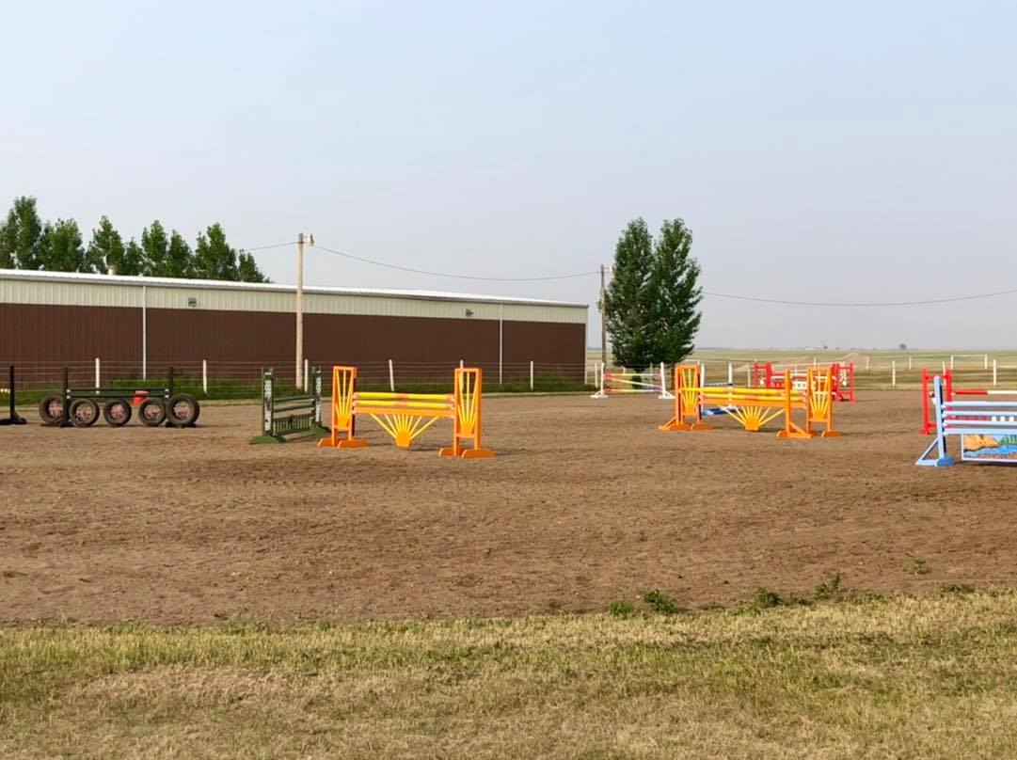

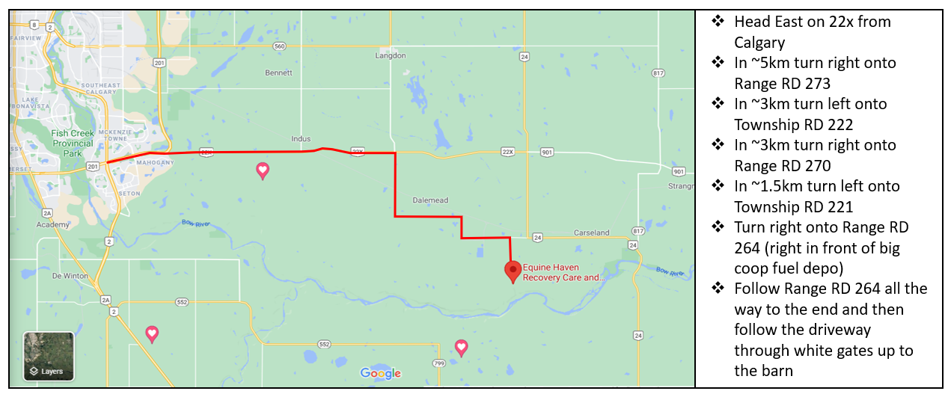
NOTE: Please do not try to use google maps to find us. It will not take you to the right location. Apple maps will if you have an iphone. Please contact 403-973-9693 if you require help with directions.

