Carol & Nik White
The Old Vicarage, Station Road
Lowestoft. Suffolk
NR32 4QF
(01502) 450059
www.carolandnik.com

15th February 2021

Hey guys,

How much have we all enjoyed these snowy days? We’ve loved them (apart from the playhouse door fiasco of course!!) So many fab opportunities for play and learning with the little ones.

The Great Outdoors

We wanted to say a massive thank you to you all for your help with selling tickets and supporting our fundraising raffle at Christmas, we are pleased to say that we have booked a date in March for the installation of the artificial grass in the children’s play area which is going to make such a huge difference to the way we can use the outdoor space.

Early Years Funding

For those of you that are eligible for the 30 hours of Early Years Funding please don’t forget that you have to check and renew your eligibility every term for the following term. You should receive reminders from SCC but we know from experience that these don’t always come through. If you are new to the whole Early Years Funding situation and need any help or advice then please don’t hesitate to ask.

Children that Attend Multiple Settings

We’ve had a few conversations recently about sharing children’s funded hours between more than one setting. During normal times this would not present a problem however current DfE guidance which we are required (quite rightly) to follow states that children should not be attending more than one Early Years setting each week in order to keep virus transmission levels as low as possible. When this guidance will change is anyone’s guess, we don’t think anyone believed that this situation would have lasted this long, due to the way that Early Years Funding works the only sensible way to assess this is on a termly basis.

Attendance

We have been working with the Early Years Team at SCC to find ways to reduce the amount of physical back and forth with paperwork. Obviously, we developed our own electronic version of the Daily Diaries which, for the most part, seems to work quite well (when Nik isn’t trying to send them all quickly and sends the wrong ones!!!). This week we have received confirmation from SCC that we are no longer required to obtain signatures from you all to confirm the children’s attendance so as to further reduce the chances of virus transmission. We will of course continue to keep a record of everyone’s attendance as it is a requirement that we have that information for every child until they are 21 years old (You should see the number of boxes we have in storage!!)

Lateral Flow Covid-19 Testing

With the introduction of two Covid-19 Lateral Flow Testing sites in Lowestoft, one at Kirkley & Pakefield Football Club and the other at Waterlane Leisure Centre we are now booking ourselves in to be tested on a weekly basis and we would encourage you all to do the same, it’s a fairly straight forward and hassle-free process. You can register and book appointments at:

https://commisceo-pcs.shiftpartner.com/

Illness

We’ve been really impressed with how well you have all done in regards to keeping both the children and us free from illnesses, usually at this time of year it’s an absolute nightmare. It’s important that we all carry on with this particularly in light of the impending easing of some restrictions. Please continue to err on the side of caution when deciding whether or not to send your children in.

Holidays

As you all know we re-scheduled our holiday that we had booked for last year to May of this year. We are still unsure about whether we will be able to go by then as it would not be feasible for yourselves or us to have a two week holiday and then a further 10 days of isolation on top. Unfortunately, the only thing we can do is to wait and see what is going to happen and make our decision closer to the time.
In addition to this we would normally have let you all know by this point our holiday dates for the rest of the year but it is just really difficult to make any sort of plans while we are still living with all of this uncertainty.

Learning Journ eys

It’s been a busy few weeks getting all of the reports bi-yearly written up for the children’s Learning Journeys, there is a light at the end of the tunnel and we are hoping to have them all ready by the 1st week of March. We will send them home with the children when they are ready for you all to have a look through and we would ask that when you return them please bring them back in a bag so we can put them in a safe place for 72 hours before having them back in the Playhouse.

That’s pretty much it for this newsletter, stay safe everyone.

Much Love
Carol & Nik.
Term Dates (for Early Years Funded Children)

Spring Term Begins – Monday 4th January
Spring Half Term – Monday 15th February to Friday 19th February
Last Day of Spring Term – Friday 26th March

First Day of Summer Term – Monday 12th April

Holiday Dates

Monday 10th May 2021 – Friday 21st May 2021

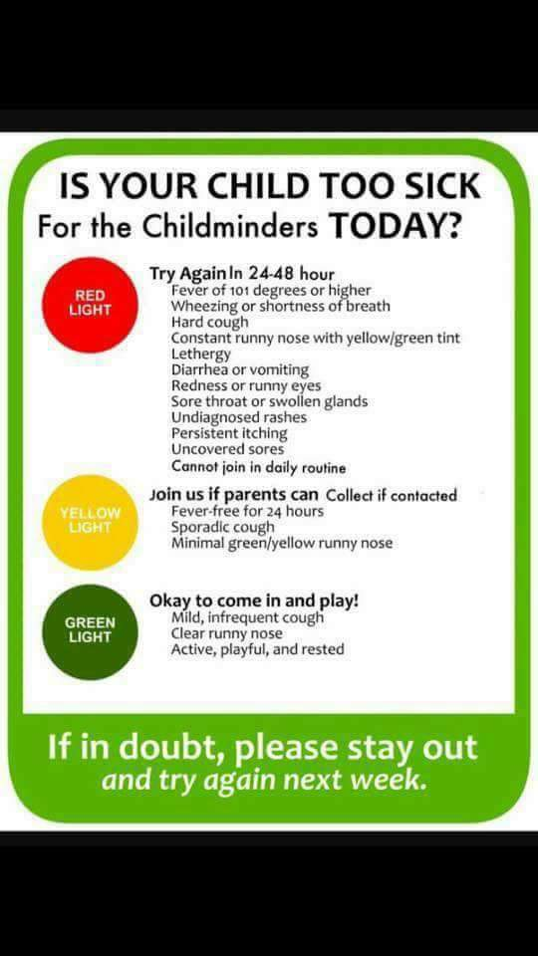
We will let you know the rest of our dates as soon as we have confirmed them.

