New Jersey
Family, Career and Community Leaders of America

2023 Alumni Achievement Award

Application Due by: March 1, 2023

Purpose
To recognize the outstanding achievements of FCCLA-FHA/HERO alumni who brings
honor to themselves and the FCCLA Association.

Eligibility
Any person who, as a student, was a member Family, Career and Community Leaders of America; Future Homemakers of America/ Home Economics related Occupations; or New Homemakers of America who in their adult life, has exemplified the mission and purposes of the organization, may be given an alumni achievement award.

Criterion
Nominees may be judged on the following criterion. The number in parenthesis indicates the maximum amount of points that may be awarded for each category.
- Demonstrates leadership in their chosen field (15)
- Accomplishments in chosen field of endeavor (20)
- Community involvement and leadership roles assumed (25)
- Reflection of the mission and purposes of FCCLA in personal life and career (40)

Policies
Nominations of individuals for the alumni achievement award may be submitted by:
- NJ FCCLA Chapter member

NJ FCCLA Chapter Adviser

NJ FCCLA State Staff
- Another NJ Friend of FCCLA/Alumni member
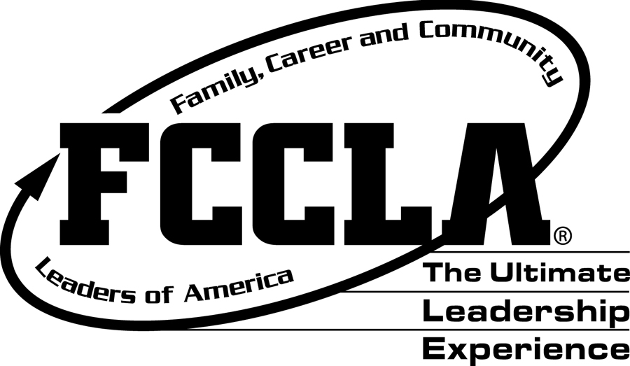

Return completed application to:
New Jersey FCCLA State Office
c/o Patricia DiGioia-Laird
NJ FCCLA State Adviser
855 Grove Avenue
Edison, New Jersey 08820-2200

New Jersey
Family, Career and Community Leaders of America
2023 Alumni Achievement Award
Nomination Form
Application Due by: March 1, 2023

Name of Nominee _________________________________________________________________________
Address___________________________________________________________________________________

City/State/Zip_____________________________________________________________________________
Telephone_________________________________________________________________________________
Current Position/Title______________________________________________________________________
Person/Organization Making Nomination___________________________________________________

- List the events participated in, honors received, and offices held while a member of FCCLA, FHA/HERO, or New Homemakers of America. (10)

- Describe a specific way that the nominee demonstrated leadership in their chosen field of endeavor. (15)

- List the nominee’s major accomplishments in their chosen field. (15)

- Explain the nominee’s community involvement and the leadership role assumed. (20)

- Please attach a double-spaced statement of 300 words or less describing how the nominee has used the mission and purposes of FCCLA in his/her personal life and career. (40)

___________________________________________________________________________________________
Signature of Nominee Date

