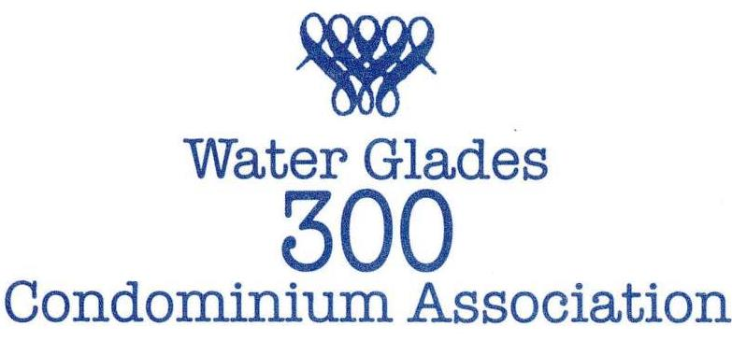

WATER GLADES TOWER 300
2018-2019
PROJECT & ACTIVITY REPORT

The current fiscal year was filled with many planned and unplanned building issues, along with the hurricane and many POA projects. Those activities required spending money and consequently assessments. In addition, the building obtained a loan, approved by the owners, to supplement payment of two of these projects. Below is a report listing and briefly describing those projects and activities.

TOWER 300 PROJECTS
Awnings
Cable/Internet
Column – Northeast Replacement
Column – Northwest and Southwest Encapsulation
Electrical Room AC Pumps
Elevator Modifications and Updates
Fire Alarm System
Flood Busters
Hallway Renovation
Leaks – Slabs
Life Support System
Painting
Pressure Reducing Valves
Spalling – A Stack
TOWER 300 ACTIVITIES
Legal
Orientation
Service and Support Animals
POA PROJECTS
Backup Generator – Clubhouse
Beach Replenishment
Gate Mechanism Replacement
Hurricane Repair
Painting – POA Property
North/South Tennis and Center Deck Refurbishment – Spalling/Wind Guards Included
POA ACTIVITIES
Civility By-Law
TOPS System

TOWER 300 PROJECT DESCRIPTIONS

AWNINGS
Our awnings were destroyed by hurricane IRMA. The committee decided to change the look and ordered and installed new awnings for both the front and side entrance. They are distinguished by a new color –navy blue. The front awning has “Tower 300” scripted on the front of the awning and “5510” on the side on the awning.

CABLE/INTERNET SYSTEM
Over the last two years a committee from the three buildings has been evaluating various companies to provide cable TV and internet services. The contract has been signed with Comcast and implementation has begun. The new system requires rewiring of the entire building and inside of each unit. We will be receiving many new channels, three X1 Infinity boxes with DVR and high speed internet service. Once the new contract begins in July, your account will automatically update to include all the newly provided services in the billing so you should see a large decrease in your Comcast bill. Most owners will end up paying for only premium channels such as HBO if they want them.

COLUMN REPLACEMENT – Northeast
The column replacement required extensive work and was a necessary and expensive endeavor. An engineer was hired to supervise the work. In order to repair the column, shoring of the lobby, 2nd and 3rd floor was required. Shoring being defined as supporting the building while repairing the column. It also required intrusion into Units 2C and 3C, including removing of the sliders on both sides of the corner column and building of a “dust wall” inside the apartments. This project was planned to be approximately five months and when completed will have taken almost eight months. This project was partially funded by the loan.

COLUMN ENCAPSULATION – Northwest and Southwest
The work to encapsulate the northwest and southwest columns will begin in February and be completed n March 2019. This work is a preventative measure to minimize any major column activities at these locations. This work is substantially less expensive (approximately 1/25 per column) than the work done on the Northeast column.

ELECTRICAL ROOM A/C PUMPS
There are 2 pumps in the electrical room that are designed to alternate every 72 hours. It was discovered that one pump had been the only pump operating for an extended time (years). If that pump failed there would be no water in the building for Heating and Air Conditioning. Consequently, that had to be corrected. This process involved replacing and updating the electrical sub panels, starter motors and relays. All of the old 40 year old system parts have been removed and all wiring disconnected that runs through the slab. Both new pumps are on line, alternating every 72 hours. This process took approximately three months.

ELEVATOR MODIFICATIONS AND UPDATES
After an independent engineer review, we have concluded that an update to both elevators to assure reliability. The work included removal and replacement of obsolete over speed governors, governor sheaves and governor ropes with latest state of the art equipment. Both elevator doors were replaced with stainless steel replacement doors including two new interlocks and hoist ways on the lobby level. The project was completed before the holiday season.

FLOOD BUSTERS
Due to liability concerns, other Towers have discontinued the replacement of the batteries for Flood Busters in the units. The Tower 300 Board voted to continue to pay for and replace the Flood Busters.

FIRE ALARM SYSTEM
State regulations required a new Fire Alarm System. This new system is a micro-processor based addressable, voice evacuation type fire alarm system. It has speakers in all bedrooms. The voice activated system is required in all high rise buildings.

HALLWAY RENOVATION
A much needed improvement to all hallways was put to a vote to all our owners. Eighty-two owners responded – 70 voted Yes, 12 No. This project included encapsulating the ceilings, new carpet, painting, new mirrors, new lighting and new woodworking. This project came in on budget and was totally funded by a loan. Owners returning have given “rave” reviews to our new look.

LEAKS - SLABS
Many pipes have burst, inside the slabs. This required breaking into the cement to stop the leaks, then rerouting the pipes outside the slabs. This caused extensive damage and inconvenience to many owners. It is believed (see below) that the Pressure Reducing Valves were the main cause of the leaks. Repair work included replacing sheetrock, rerouting pipes, painting and removing and replacing toilets. Although insurance covered a portion of the costs, we were still left with a substantial payment. In addition, the Board voted in December, 2018 mandating that all new plumbing renovations done in a unit which requires a permit must disconnect the floor slab copper pipes and run new pipes overhead in the unit.

LIFE SUPPORT SYSYTEM
The State of Florida has required a sprinkler system to be installed throughout any high rise over six stories which must be completed by Dec 31, 2019. In order to opt out of this mandate we are required to meet certain other standards such as installing new signs in all the stairwells, fire rated levers on the doors, removing all paint from the storage room, adding lights in the stairwells and painting yellow stripes on the stairs. In addition, we may be required to have the stairwells pressurized to keep them smoke free in case of a fire. This will be determined by the Fire Marshall but if he decides we need to have it done it will be an expensive project.

PAINTING
Tower 300 contracted to paint the building after the necessary column work was finished. That work is currently scheduled to start in April, 2019.

PRESSURE REDUCING VALVES
As related to the leaks, it was discovered that the pressure reducing valves (located on the 16th floor) were put in the bypass position by some unknown contractors over the years. The function of these valves is to reduce the pressure on the lower floors (below 16) caused by the weight of the water and gravity. Our current plumbers believe this is the main cause of the leaking water pipes in the slabs. These four valves (one per stack) have been replaced and the prediction is that it will solve our leak problems.

SPALLING – A STACK
After changing contractors, the long awaited completion of the spalling of the A Stack was completed in June 2018.

TOWER 300 ACTIVITY DESCRIPTIONS

LEGAL
National Ventures Litigation – Tower 300 successfully concluded this lawsuit, which had been pending for 25 years (not a typo) with a resounding victory. This was done at no out of pocket expense to Tower 300 as our insurance covered all costs.

ORIENTATION
For many years all new owners and renters were required to be interviewed and given a packet describing the various rules and regulations of Water Glades Tower 300 and the POA. That orientation lapsed and has been reinstituted in January 2019. A copy of the new orientation packet is posted on the Tower 300 website watergladestower300.com.

SERVICE AND SUPPORT ANIMALS
We have had several owners and renters request having service and/or support animals. For the most part, this has gone well. We have had several instances where the Board has felt that several owners/renters may have taken advantage of this situation, for example, excessive barking, relieving themselves in the hallways or on the decks or property without cleaning up. Consequently, our condominium lawyer has written and the Board has passed new legal guidelines for any owner/ renter to be permitted to have service and support animals. We are hoping these guidelines will address any issues.

POA PROJECTS & ACTIVITIES
In a separate eblast, the President of the POA has described the POA activities. Consequently, we chose not to repeat just point out that Tower 300 contributed our required financial share (39.1%) for all these projects and activities. Please contact our manager if you need an additional copy of their email.

