THE BOWEL REQUIRES
APPROXIMATELY 100 TRILLION MICROFLORA
AT ALL TIMES (ABOUT 3 TO 5 POUNDS)

WHAT DO HIGH LEVELS OF GOOD MICROFLORA ACCOMPLISH IN THE BOWEL?

- Increase absorption of all nutrients.
- Dramatically strengthens the immune system
- Helps digest food more efficiently and reduces “3 B Syndrome” (burp, belch, bloat)
- Reduces total cholesterol: improved HDL/LDL ratio, reduces triglycerides
- Helps prevent candida, vaginal & urinary tract infections, endometriosis, etc.
- Helps prevent bowel disorders: colitis, crohn’s, irritable bowel, constipation, diarrhea, diverticular diseases, stomach ulcers, etc.
- Helps reduce/prevent allergies, asthma.
- Reduces toxic poisoning from the bowel: (the liver, our blood filter, binds toxins and sends them down to the bowel for elimination from the body….if bad bacteria numbers are higher that good micoflora numbers, the bad bacteria releases the bound toxins and they can leak back into the bloodstream.)
- Dramatically reduces the risk of bowel cancer.

- Reduces funguses, bacteria, viruses, parasites.

SYMPTOMS OF LOW LEVELS OF GOOD MICROFLORA:
mood swings & irritability,
craving for sweets, breads, alcohol,
athlete’s foot,
warts,
fungus infections of nails & skin,

coated tongue,
chronic food odour
itchy genital and/or rectal area,
bloated abdomen,
irritable bowel syndrome/colitis/crohn’s disease,
infections: ear, tonsil, urinary, vaginal, etc.
recurrent skin problems including acne, psoriasis, eczema
sensitive to moulds, smoke, odours, perfumes, etc.
muscle aches & weakness
loss of interest in sex
endometriosis or infertility
excess vaginal discharge
anxiety attacks & frequent crying
thrush mouth
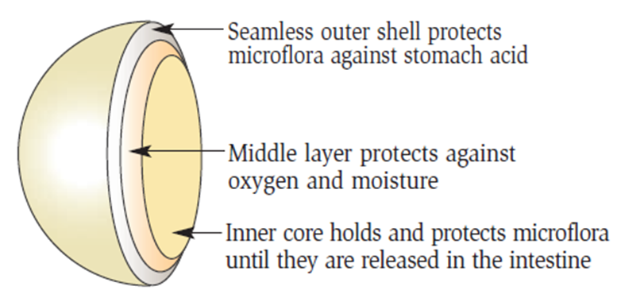
fatigue, lethargy and drowsiness

WHAT KILLS MICROFLORA?
- Chemicals in the environment
- Steroids
- Exposure to chlorine
- Slow transit time…..(purification bacteria overpowers & kills good bacteria). Therefore, increase water & fibre, and reduce processed & refined food.)
- Antibiotic use
- Traces of antibiotics in meat & eggs & milk
- Birth control pills
- Aging (the numbers reduce with age due to a slow metabolism and intoxication)

HOW TO ADDRESS THE PROBLEM – REPOPULATE THE BOWEL….DAILY
STEP 1:
Provide Microflora…..Shaklee Optiflora Part 1: (Guaranteed delivery of 500-million live micoflora per capsule):
- 250 million Bifidus – the champion of the large intestine
- 250 million Acidophilus – the champion of the small intestine

STEP 2:
Feed the Microflora…..Shaklee Optiflora Part 2: (Prebiotic powder: FOS – fructooligosaccharides, inulin, Jerusalem artichoke flour & gamma tocopherol):
this fuel causes the microflora to MUTIPLY!
- The numbers DOUBLE about every 10 minutes
- Therefore, the body can make 8 to 20 billion per hour with the proper fuel. (The Shaklee FOS prebiotic powder is incredibly essential!)
