To all my Friends and Loved Ones:

Ever so humbly, I write and ask for your patience and understanding. Although, I feel my failure to respond or associate with you is expressed justifiably. I am not without my flaws. I have been plagued with a hurt. It is a hurt like nothing I have ever experienced before, and a situation that has consumed my life. Please forgive me? Sometimes my actions or words may seem to take over.

This is an experience I never realized would exist, or take place in my lifetime. It is a situation that no parent or person should have to be confronted with before their time has come to pass. At the same time,
my actions seem to be appropriate and worthy, for my daughter’s name sake and my sanity. The madness
of search and wait for answer's motion of reality somehow take an existence. The day seems to ever so quickly turn into the night.

On November 11, 2009 my daughter was killed by a single gunshot wound to her chest. A sacrifice of my livelihood, financially and emotionally have set in motion. The search for answers to the truth of what surrounded that fatal night have taken their role. All have been a bit cumbersome. The pleading to my questions for a light of truth and from the darkness before my eyes, are my prayers. All whispers of faith, perseverance, and justice are continually begged. A white candle is lit by a photograph the memory of
my world, my beautiful baby girl.

Natasha Roseanna Boykin “King”
February 5, 1985 – November 11, 2009

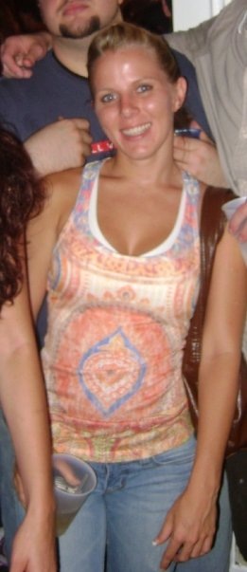
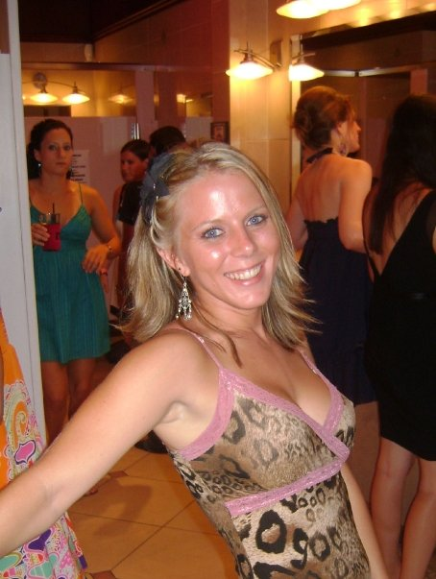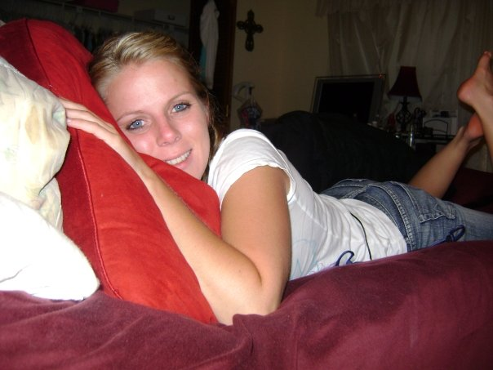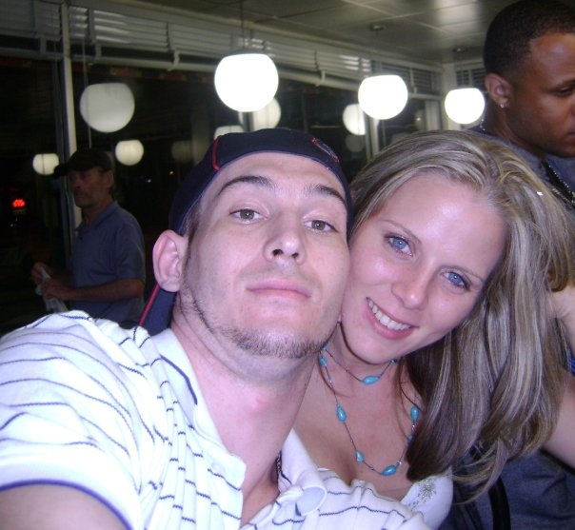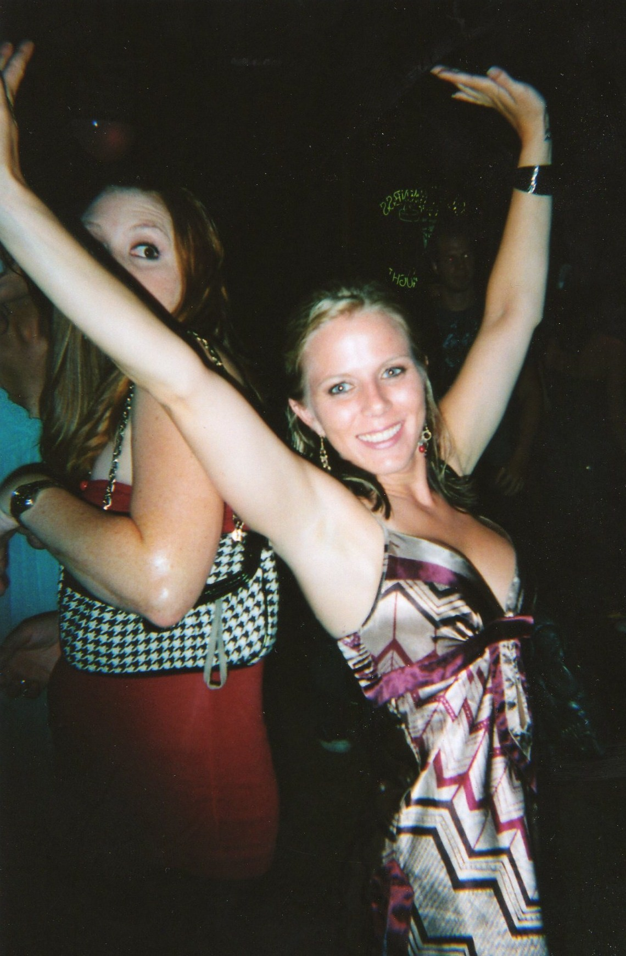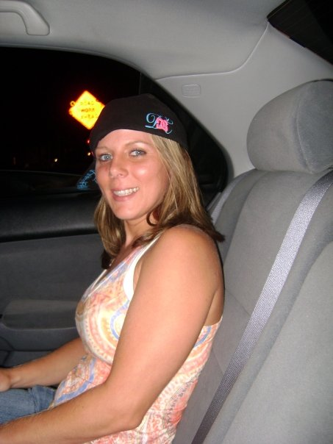

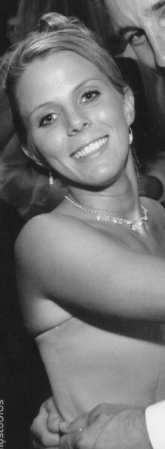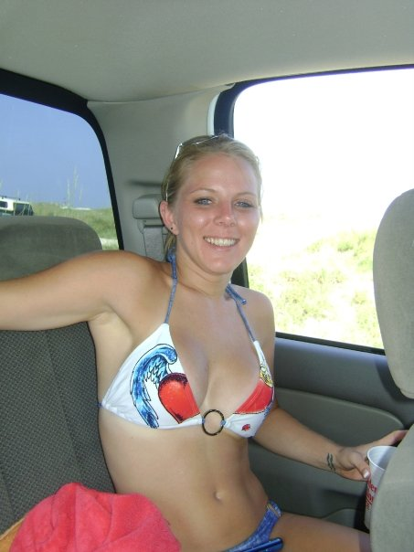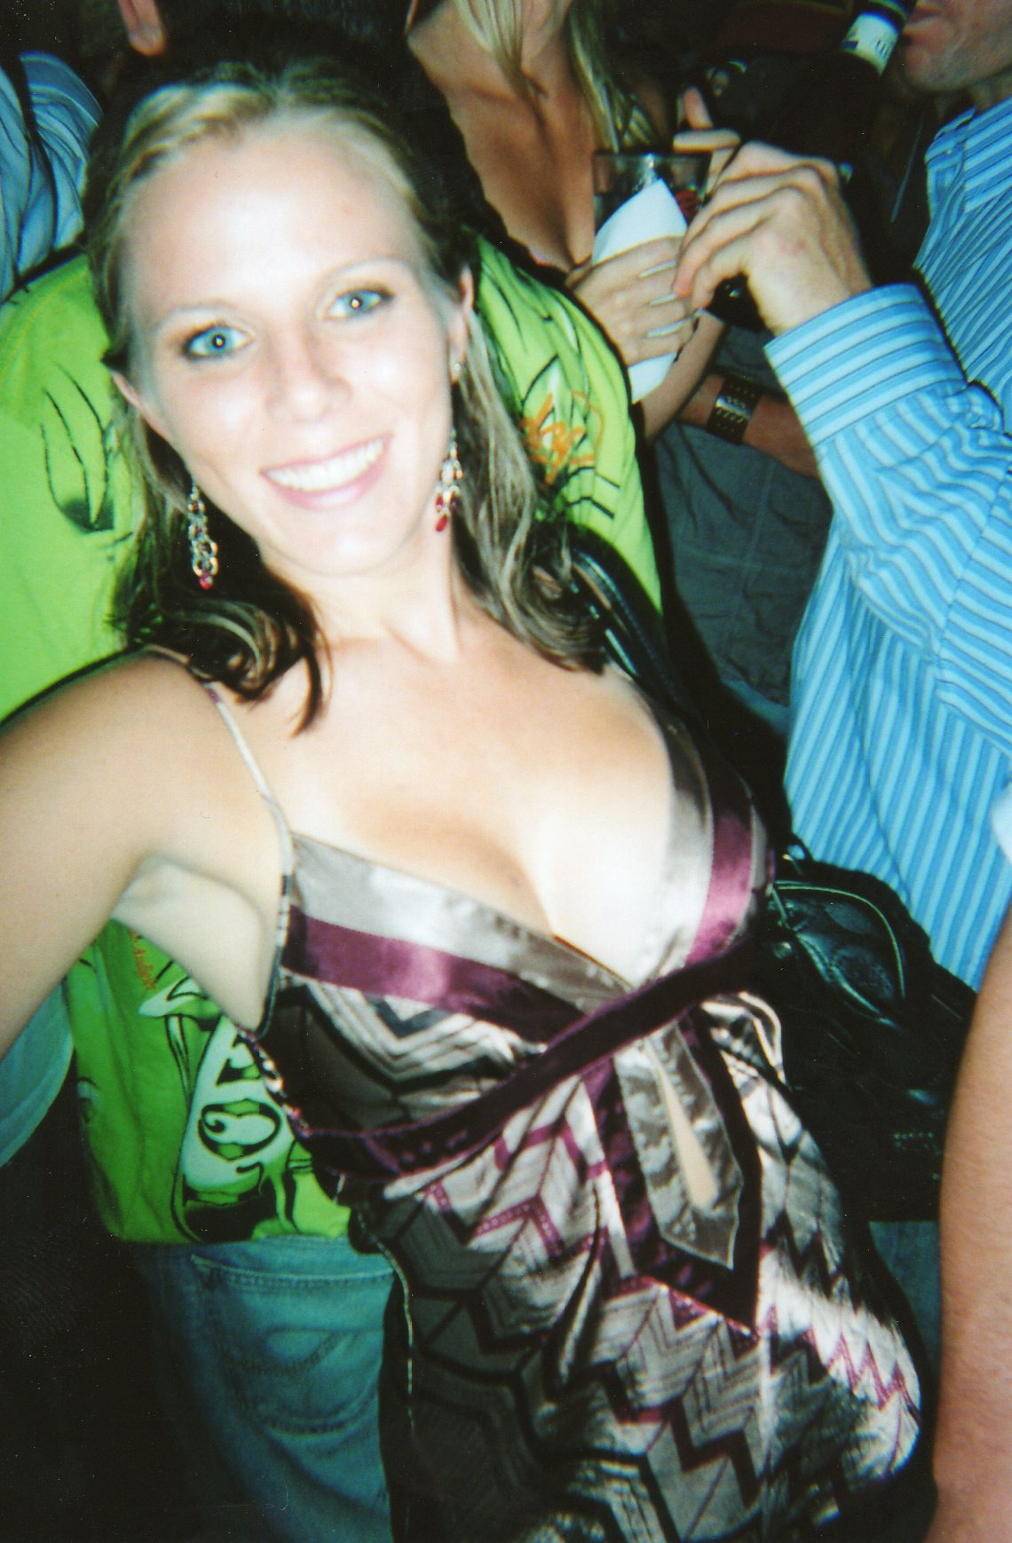

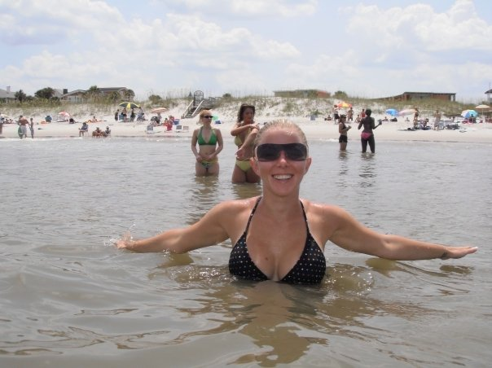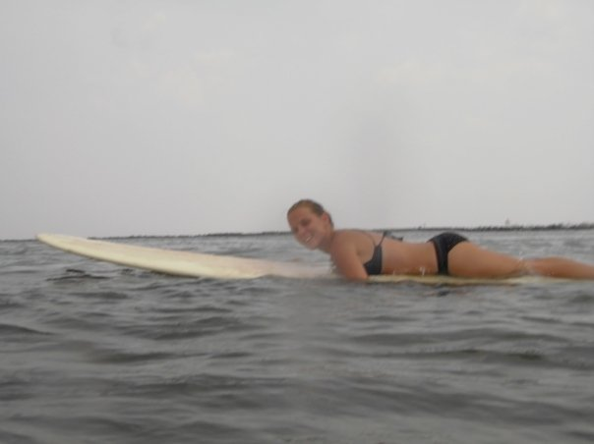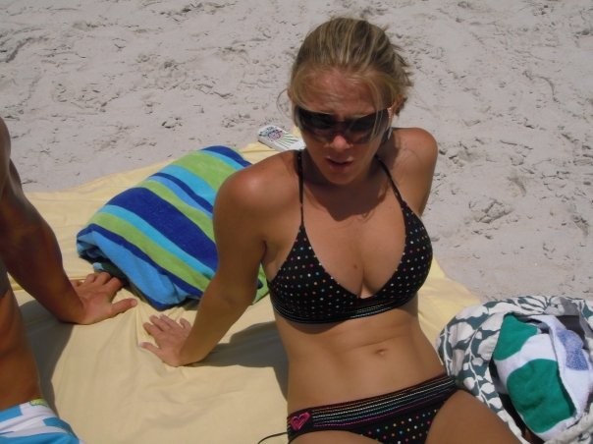

Natasha Roseanna Boykin -King
February 5, 1985 – November 11, 2009

