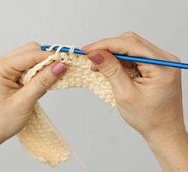 Crocheted Ripple 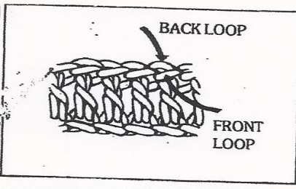
Size: Shawl-approx 22"x64" (lap afghan: approx 34" x 48")
Materials: Worsted weight yarn-approx 22-24 oz both styles
crochet hook size "K"
Instructions: Cast on 85 sts (101sts). Foundation Row: (right side): Double crochet in third chain from hook, double crochet in each of next 5 chains. 3 double crochets in next chain, double crochet in each of next 7 chains,* skip next 2 chains, double crochet in each of next 7 chains, 3 double crochets in next chain, double crochet in each of next 7 chains; repeat from * across.
Pattern Row: Chain 3, turn. Skip first 2 double crochets, double crochet in back loop only of each of next 6 double crochets, 3 double crochets in back loop only of next double crochet, *double crochet in back loop only of the next 7 double crochets, skip next 2 double crochets, double crochet in back loop only of each of next 7 double crochets, 3 double crochets in back loop only of next double crochet; repeat from * across, ending with a double crochet in back loop only of each of next 6 double crochets, skip last double crochet, double crochet in top chain of turning chain. Repeat Pattern Row until piece measures approx 64" (48") or desired length. Finish off. Fringe.

