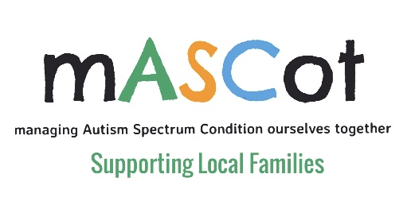

As well as writing your parental statement for your child’s EHCP, you may also wish to write an education report based on your findings whilst home educating your child during Covid19 lockdown.
All other professionals who have an input in your child’s learning will be asked to contribute to the assessment to help make up a clear picture of your child’s needs,
You now have valuable information to feed back on your child learning over the past several months so this should be included.
If you wish to do a report, here are some bullet points to help you put together all the information you need.

- Child Name
- Your name
- Tutored for the period from: Date – Date
- Where resources came from: school /online/ parents
- How you structured the day
- What goals if any you set
- Childs approach to learning
- How your child coped with home learning
- What they found achievable
- What they found hard
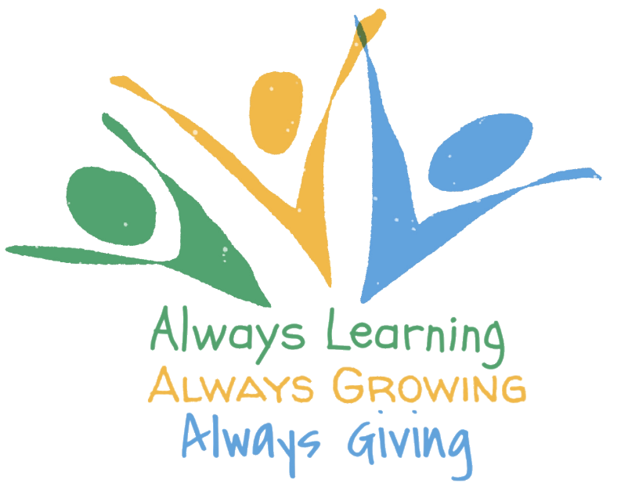
- How did you find their learning differed from when at school
- Did you have to differentiate the work to suit your child
- Did taking regular breaks help your child learn
- What would have made it easier for your child

This is only a guide of what you can possibly put in the report, just make sure you give them as much information as possible.

