GENERAL PUBLICATIONS ORDER FORM

February 2023

(Association members should use the current special offer publications order form, available by emailing: [scottishrecordsassociation@gmail.com](mailto:scottishrecordsassociation@gmail.com))

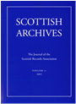 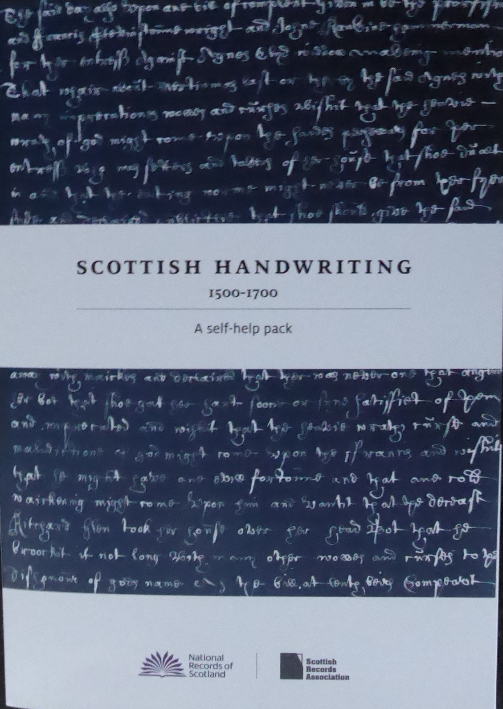

The Scottish Records Association (SRA) is a forum for users, owners and custodians of records. The Association’s journal, *Scottish Archives*, features papers from conferences as well as commissioned and submitted articles focusing on Scottish archives, historical sources, their use and interpretation.

A contents list for each volume from 1 to 25/26 can be found at: [www.scottishrecordsassociation.org/scottish-archives](http://www.scottishrecordsassociation.org/scottish-archives), where pdf versions of the articles (without illustrations) are available for volumes 17 to 25/26.

Volume 27 of *Scottish Archives* is the 2021 issue, and is only available to full individual members and institutional members of the SRA. The following issues of *Scottish Archives* are available in hard-copy: volumes 1 to 10, 14 to 16 and 18 to 25/26.

**The cost for non-members of the SRA (including postage and packing) is:**

* Volumes 1 to 10, 14 to 16 and 18 to 23: **£15** (UK), **£20** (overseas)
* Volumes 24 to 25/26: **£25** (UK), **£30** (overseas)

The SRA (in conjunction with National Records of Scotland) publishes *Scottish Handwriting 1500-1700: a self-help pack* (edited by Alison Rosie). For details of how to order this, see: [www.scottishrecordsassociation.org/publications](https://www.scottishrecordsassociation.org/publications)

**To order publications, please use the order form overleaf and return to:**

Scottish Records Association, c/o Anne Cameron,

University of Strathclyde Archives and Special Collections,

Andersonian Library (Curran Building), 101 St James Road, Glasgow G4 0NS

To find out how to make payments, please email: [scottishrecordsassociation@gmail.com](mailto:scottishrecordsassociation@gmail.com)

Please send me the following publications:

|  |  |  |  |
| --- | --- | --- | --- |
| ***SCOTTISH ARCHIVES***  (The journal of the Scottish Records Association) | | | |
|  | **Price,**  **including postage and packing** | **Number of copies** | **Cost** |
| Volume 1 | £15 (UK) / £20 (overseas) |  |  |
| Volume 2 | £15 (UK) / £20 (overseas) |  |  |
| Volume 3 | £15 (UK) / £20 (overseas) |  |  |
| Volume 4 | £15 (UK) / £20 (overseas) |  |  |
| Volume 5 | £15 (UK) / £20 (overseas) |  |  |
| Volume 6 | £15 (UK) / £20 (overseas) |  |  |
| Volume 7 | £15 (UK) / £20 (overseas) |  |  |
| Volume 8 | £15 (UK) / £20 (overseas) |  |  |
| Volume 9 | £15 (UK) / £20 (overseas) |  |  |
| Volume 10 | £15 (UK) / £20 (overseas) |  |  |
| Volumes 11 to 13 | **SOLD OUT** | **SOLD OUT** | **SOLD OUT** |
| Volume 14 | £15 (UK) / £20 (overseas) |  |  |
| Volume 15 | £15 (UK) / £20 (overseas) |  |  |
| Volume 16 | £15 (UK) / £20 (overseas) |  |  |
| Volume 17 | **SOLD OUT** | **SOLD OUT** | **SOLD OUT** |
| Volume 18 | £15 (UK) / £20 (overseas) |  |  |
| Volume 19 | £15 (UK) / £20 (overseas) |  |  |
| Volume 20 | £15 (UK) / £20 (overseas) |  |  |
| Volume 21 | £15 (UK) / £20 (overseas) |  |  |
| Volume 22 | £15 (UK) / £20 (overseas) |  |  |
| Volume 23 | £15 (UK) / £20 (overseas) |  |  |
| Volume 24 | £25 (UK) / £30 (overseas) |  |  |
| Volume 25/26 | £25 (UK) / £30 (overseas) |  |  |
| Volume 27 | **ONLY AVAILABLE TO SRA MEMBERS** | | |
|  |  | **TOTAL COST:** | |

**Please provide your contact details below**:

Name Address

Telephone

Email