Amelia-Nottoway Technical Center News 1/8/2021
ANTC STUDENT SPOTLIGHT!
Ally Powell, ACHS Senior
Medical Assistant I
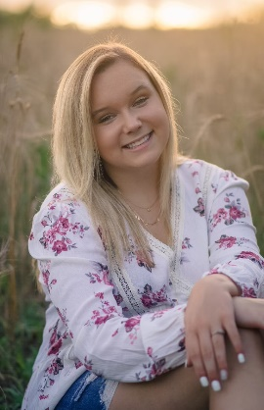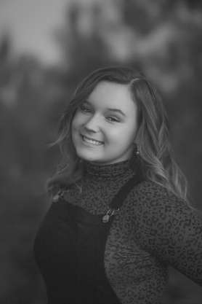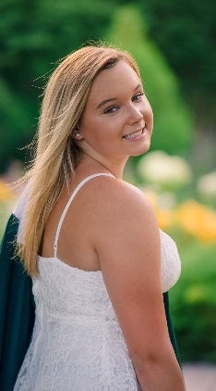
What brought you to ANTC? I came to ANTC to take Medical Assisting.
What is your dream job? My dream job would be to become a Registered Nurse.
What is your favorite class that you have taken so far? Why? My favorite class so far is Medical Assisting because Mrs. V. is such a great teacher and she is fun.
What is the best advice you have been given by your instructor at ANTC? One piece of advice I have gotten from my teacher is, “Mistakes are proof that you are trying.”
What is your favorite memory at ANTC? My favorite memory at ANTC is learning to take blood.
What was the first feeling you had when you attended ANTC? At first, I was nervous, but still curious.
What words of wisdom do you have for other students? I would tell other students to never give up.
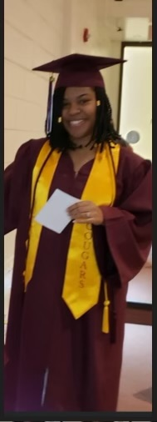

ANTC ALUMNI HIGHLIGHT!
Breanna Lewis
High School: Nottoway High School 2020
ANTC Program: Cosmetology
Current Career: Due to COVID-19, she is currently
working in a medical office taking appointments and checking
in patients.

Future Plans: Breanna will take her State Board
exams this spring. Eventually, she
wants to open a salon!

Celebration
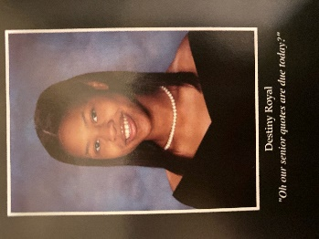
Congratulations to ACHS 2020 graduate Destiny Royal who
gained employment with CJW Medical Center as a Patient
Safety Screener! Destiny and Mrs. Vronek, YOU ROCK!

ANTC Programs: Cosmetology I & II, Medical Assistant I & II, and Auto Body I & II
Amelia County High School, Cumberland High School, and Nottoway High School

All ANTC programs are currently fully virtual!

