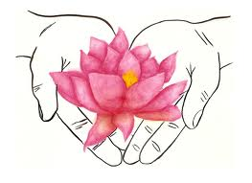
Integrative Psychotherapy
Welcome.
It is a courageous thing to choose to come to therapy. I would like to honor your courage and express my willingness to be your partner in healing. It is an honor and privilege to bear witness to your journey, and I am very hopeful together we can find the solutions and growth you seek.
Whether you have had a successful experience with therapy in the past, or whether this is your first time in therapy, beginning with a new therapist can be anxiety producing. Let me support you by telling you a bit about the process.
In the first few weeks we will be getting to know one another. I will be learning about you, and you will be deciding if you can risk trusting me and if I am a good fit for you. I will also be assessing how I can assist you best. I will be asking questions, and listening closely to your answers.
Next we will discuss what outcomes you are hoping for, and discuss some ways to get there. Then the work begins.
Psychotherapy is not always a comfortable process, and often the presenting problems may seem to worsen for awhile before they get better. You will be challenging yourself, finding new insights and trying on new skills. You may find parts of yourself or feelings long forgotten, left behind, or who have hidden themselves away. You may experience painful parts of your history—but you will learn new and healthy ways to cope and comfort yourself along the way.
You will often have moments and experiences of break through, when you see yourself in a whole new light, and feel amazed by your progress.
My goal as your therapist is to support the natural healing process that is ever present, ever trying to promote wholeness and health in each one of us. My goal is to understand you, support you, and help you find your way.
It will be very important for your growth-- to tell me when you are uncomfortable. If there is anything you are unsure of, or don’t understand, or plain old don’t like. If we are to be partners in your healing process—please do not hold anything back. This is a time and place for YOU.
Welcome here.

