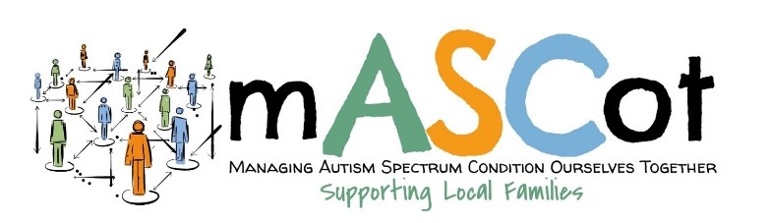

MENTAL HEALTH RISK ASSESSEMENT

School need to create their own based around the same template as a physical risk assessment.
look at the things that are specifically difficult for that child, like
going into school
- Is it’s too busy and socially unstructured in the morning.
-Does the child need to go in a little earlier or later to miss this stressful time.
Sitting in class
-where they sit, etc
key worker
-Do they know who to go to if note coping
-How do they access this help
General
-That the child wears a sunflower lanyard if you feel some staff are not taking into account their extra needs.
-That all staff are notified of the things that are being put in place.
-Have they got access to a quiet place
-Dose the child follow the distancing rules and guidance? Are they being explained everything at a level they understand.
Add any of your own things specific for Lucia

Literally write a list of things that may cause Lucia stress or triggers her anxiety and sit with the school and write solutions for them.
Maybe set it out as
1) transition/situation/part of day
2) known stress/anxiety triggers
3) potential stress/anxiety triggers
4) ways to reduce/remove triggers

