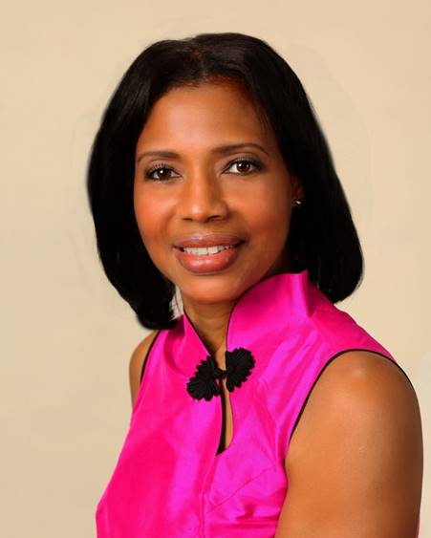
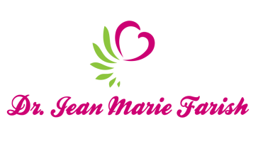

LOVE LIGHT NewsLetter

I am excited to host my VoiceAmerica Empowerment Show-LOVE LIGHT with amazing Guests to cultivate a lifestyle of love and wholehearted connections through worthiness. My show is aligned with my mission to live an altruistic and heart centered life.

MEET GUEST Barre Morris II

February 28, 2020

“LOVE AND FATHERHOOD”

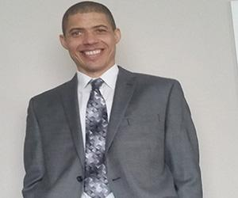

ABOUT Barre Morris II

Barre Morris II is a certified Project Management Professional with the Project Management Institute and has maintained a career over twenty (20) years in Information Technology (IT). He enjoys learning about new technologies while maintaining IT programs, projects and leading project teams. Barre is a former Microsoft IT Sr. Program Manager and Solution Specialist for the Energy Industry and presently leading healthcare IT teams for one of the largest not-for-profit health care systems in Texas, Memorial Hermann Healthcare System.

Barre has prevailed over many of life’s most stressful and life-changing events. His success in overcoming odds such as a near-death auto collision; incarceration; his own family relationship experiences with marriage, separation; re-uniting after separation and divorce; and raising his own interracial children - a teenage son with autism, whom he raised almost entirely as a single dad has made him a leading author, speaker, and inspiration for parents and families seeking to thrive! Barre contends, “The love, affection, support and active involvement of a father, or lack thereof, may answer, and present solutions to some of the most alarming and detrimental problems plaguing American society and families today.”

Learn more about Barre Morris II:

Website: https://barremorrisii.com

Barre Morris II –The New Millennium Dad_FinalEssay.pdf – Google Drive
https://drive.google.com/file/d/1x5nTlv21ySEZ3ypfrmwRq8UrWBknSz/view

Partnership with DePelchin Childrens Center, as sub-committee member of Fatherhood programs offered in Houston, TX.
https://www.depelchin.org/fatherhood/

Partnership with National Conference of State Legislators as a panel speaker addressing state policies impacting fathers and families, specifically impact of fatherhood on children prenatal to 3 years old.

Resources: National Fatherhood Initiative https://www.fatherhood.org

“An empowered self is a loving self, and keep your love light shining”

