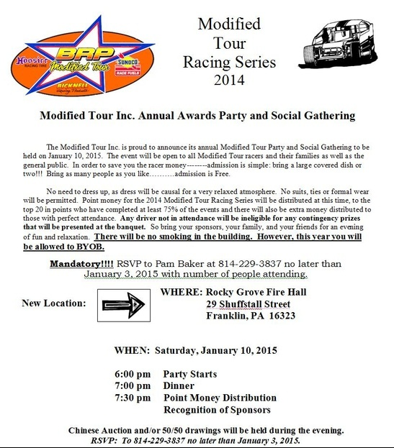
Please fill this out and turn it in so that the website can get updated with all of your information. If at anytime your information needs fixed or updated, please print off this paper, fill out the section that needs updated, and submit it to the Modified Tour. Thanks for helping us with keeping the most up-to-date information on our webpage.

Driver Name: ____________________________________________________________
Hometown:______________________________________________________________
Birthday:________________________________________________________________
Car #:___________________________________________________________________
Chassis: ________________________________________________________________
Car Owner:__________________________________________________________ ____
Major Sponsors (Top 5):____________________________________________________
________________________________________________________________________________________________________________________________________________________________________________________________________________________
Website: ________________________________________________________________
Twitter: @_______________________________________________________________
Career Wins:_____________________________________________________________

