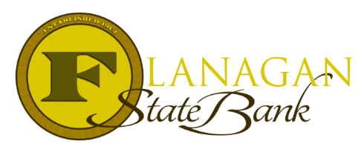
Mortgage Tidbits

Keeping you informed and in the know….

Gift Funds 101: Documenting Gift Funds for FHA Loans

When receiving an FHA loan, the agency prefers to know where the gift money is coming from and not just being pulled out of thin air. This is why they require documentation & transfer of gift funds. Here are some general guidelines regarding this topic:

Documentation of Gifts:
- A gift letter will be needed. The gift letter must be signed by both the donor and recipient. In addition, it must include the following:
- The donor’s name, address, & telephone number
- The donor’s relationship to the borrower
- The dollar amount of the gift
- A statement that no repayment is required/expected.
- A bank statement from the donor will be required that shows the withdrawal of the gift funds from their account. A 30-day statement will be required.
- An updated statement from the Borrower will be needed to show the deposited funds for the gift. The Borrower should make this deposit separate from any other deposited funds to keep it easy to identify. A 30-day statement will be needed.
- Any large deposits that are not identifiable as payroll must be sourced (pictures of what is deposited) and a letter of explanation provided to help us understand what the deposits are covering. This will be applicable for both the donor statement and the borrower statement.
- Gift funds can only be provided by a relative of the borrower.

Cash on hand is not an acceptable source of gift funds

Call us today for the best answers to the mortgage questions!
Insert photo here or delete box when ready to use
~ Provided to you by ~
Name: Phone:
Title: Email:
Address: City, State, Zip
Apply Now Link:

