Avoyelles Animal Welfare Society, Inc.
Federal Tax ID #72-3232772 Incorporated: 2/12/2007

P.O. Box 492, 1170 Prison Road, Cottonport, LA 71327
Tel: 318-876-2068 Fax: 318-876-2060

[Type a quote from the document or the summary of an interesting point. You can position the text box anywhere in the document. Use the Text Box Tools tab to change the formatting of the pull quote text box.]

Heartworm Addendum

The canines that are being housed at the Avoyelles Animal Welfare Society at 1170 Prison Road in Cottonport, LA have not been tested for heartworm and are not being treated with a heartworm preventative.

It will be up to the adopter to start the course of heartworm treatment on the adoptive canine.

Avoyelles Animal Welfare Society will not be held liable if the adoptive canine tests positive for heartworm.
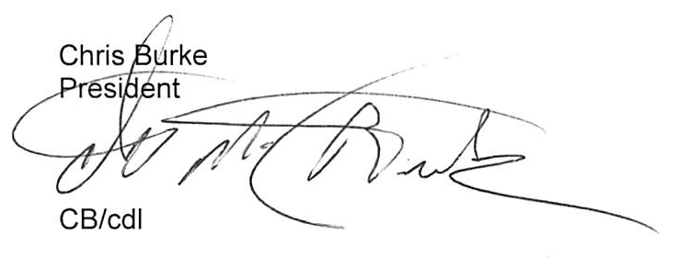

    - I will not hold Avoyelles Animal Welfare Society (A.A.W.S.) liable if the adopted animal tests positive for heartworm disease.

____________________________________ ___________________
Name Date

