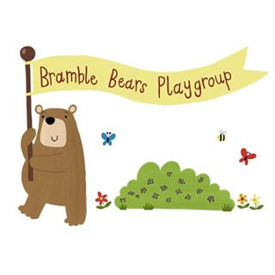  
Bramble Bears Playgroup-Preschool,

Ashwellthorpe Village Hall, The Street, Ashwellthorpe, NR16 1AA

Charity No: 1072656 OFSTED Reg No: 253964

07847225093

bbsupervisor01@gmail.com

**GDPR - Changes in data protection May 2018**

Due to recent changes in law (GDPR), we now need you to confirm how you would like your child’s data and information treated. Please rest assured, all of the sensitive information we hold about you or your child is either stored in a locked filing cabinet or on password protected and encrypted devices. What is GDPR? Find information online at <https://en.m.wikipedia.org/wiki/General_Data_Protection_Regulation>

We would be grateful if you could take the time to complete this form of consent. Please sign next to each statement to confirm you give consent. If you are unsure about any of these, please speak to Laura, our Playgroup Leader.

About your child - I give consent for:

1. My child’s photographs to appear on the Bramble Bears website

*Signed _______________________*

1. My child to have a Tapestry account

*Signed _______________________*

1. My child’s photographs to appear on their own Tapestry account

*Signed _______________________*

1. My child to appear in the background of photographs appearing on other children’s Tapestry accounts *Signed _______________________*
2. My child’s work to be on display at Ashwellthorpe Village Hall

*Signed _______________________*

1. My child’s first name to be on their coat peg, information pocket and on the birthday board

*Signed _______________________*

1. My child’s name to be displayed on snack pots and drinks on the lunch table

*Signed _______________________*

1. My childs name to appear in nappy and toilet changes records

*Signed _______________________*

About you – I give consent for:

1. Bramble Bears to have my email address (for Bramble Bears correspondence only)

*Signed _______________________*

1. Bramble Bears to have my telephone number, stored both on the playgroup mobile phone and on file

*Signed _______________________*

1. Bramble Bears to hold my address details, contact telephone numbers and names

*Signed _______________________*

1. Bramble Bears to pass my details onto Early Years finance (to allow them to process funding)

*Signed _______________________*

1. Bramble Bears staff to use iPads and the supervisors laptop for Tapestry, policies, funding and invoices to be completed.

*Signed _______________________*

You may, at any point, ask for a copy of our policies and procedures how we keep information safe and confidential. You may also withdraw your permissions for any of the points listed above at any time. To do so, please speak to Laura, our Playgroup Leader.

Thank you

On behalf of Bramble Bears Playgroup