Massage Client Intake Form

PLEASE PRINT LEGIBLY

Name _________________________________________ Email _________________________________

Phone: Home_______________________ Cell__________________________ Birthday ___/___/___
___
Occupation _________________________ Referred to This Office By ___________________________

In Case of Emergency Please Contact ______________________________Phone_________________

General and Medical Information

Y | N | Have you ever had a professional massage? | If yes, how often?
Y | N | Are you pregnant? If yes, how far along are you?
Y | N | Are you sensitive to touch/pressure in any area? Dislike?
Y | N | Are you allergic or sensitive to any oils (essential oils, nut oils, scents)? If yes, please list:

List of current medications and reason:

List of surgeries (type and date):

Indicate Areas of Pain/Tension:

On a scale from 1-10, 10=highest, rate your levels of: Stress __ ____ Pain ___ ___ Energy ___ ___

How did your symptoms begin and when did they start?

________________________________________________________

________________________________________________________

What have you done for relief? _________________________

Is the condition getting better/worse? __________________

Please check all that apply:

- Skin condition-rash, warts, hives, skin cancer, other ___________________

- Lymphatic condition-swollen gland, nasal congestion, lymph edema

- Joint problems/stiffness-arthritis, sacroiliac problems, TMJ, other

- Bone Condition-osteoporosis, fracture, other ______________
- Headaches
- Recent injury or accident-whiplash, sprain, bruise,
other _______________
- Circulatory Condition-high blood pressure, varicose veins, blood clots

- Numbness/Tingling, Sciatica
- Tendonitis, Bursitis
- Diabetes

Please mark in the diagram above any areas where you have pain or discomfort.
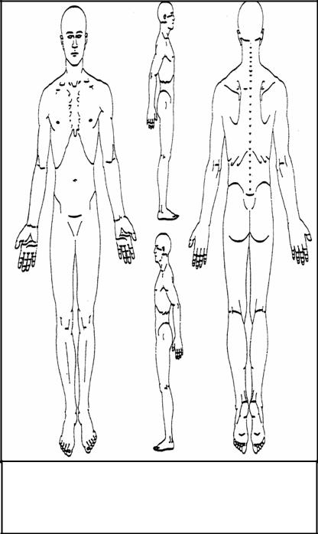

Massage Client Waiver Form

Please take a moment to read and initial all of the following statements:

If I experience pain or discomfort during the session, I will immediately inform my therapist so that pressure/strokes can be adjusted to my level of comfort. I will not hold my therapist responsible for any pain or discomfort I experience during or after the session.

_____

I understand that the services offered today are not a substitute for medical care. I understand that my therapist is not qualified to perform spinal or skeletal adjustments, diagnose, prescribe, or treat physical or mental illness.

_____

I affirm that I have notified my therapist of all known medical conditions and injuries. This intake form is confidential and information will not be shared without my written permission.

_____

I agree to inform the therapist of any changes in my health and medical condition. I understand that there shall be no liability on the therapist’s part should I forget to do so.

_____

By signing this release, I hereby waive and release my therapist from any and all liability, past, present, and future relating to massage therapy, cupping therapy and bodywork.

_____

I understand that should I cancel an appointment less than 48 hours before the scheduled time or “no show” an appointment, I am subject to a fee equal to the cost of the missed appointment. If the appointment was booked under a gift certificate, it will be voided in lieu of the fee.

_____

Information and Suggestions

- Prior to your massage, please remove contact lenses (your preference) and all jewelry. Pull long hair back with a clip or band.
- In general, massage is given while you are unclothed. However, you may choose to wear undergarments or a swimsuit. You will be covered with a top sheet throughout your session (men have option of waist towel). This is your massage and you should be as comfortable as possible.

- Feel free to ask your therapist any questions before, during, or after the session.

I have received the policy statement, and have read and agree to the policies therein.

Client name:____________________________________________________________________

Client signature:_______________________________________________ Date:_____________
Therapy Notes Only:

