Drama Policy
2017+

Board of Management Scoil Bhríde Nurney
2017+

Scoil Bhríde

Drama Policy

Introductory Statement
This is the whole school Drama plan for Scoil Bhríde Nurney Co Kildare. The following plan was developed in 2000 and reviewed again in 2017. A collaborative approach was adopted when writing this plan to ensure that all the staff shares a sense of ownership in the planning process.

Rationale
It is hoped that this school plan will be a useful tool for teachers providing them with clear guidelines in the teaching of language and ensuring consistency and continuity in practice throughout the school. At Scoil Bhríde Nurney we believe that Drama provides children with rways to explore our cultural heritage and new dimensions of our changing world. It also helps children to explore their own emotions and how they relate to the world around them. Language plays a critical role in drama. The Drama curriculum contributes to developing the child's confidence in English, Gaeilge and also in other languages.

Vision

We are committed at Scoil Bhríde Nurney to the all-round development of each child in our care. We hope through Drama to help the child develop confidence and enable each child to explore their emotions and engage with their environment in a safe and creative manner.
Aims

We endorse the aims of the Primary School Curriculum for drama:

- To enable the child to become drama literate.
- To enable the child to create a permanent bridge between make-believe, play and the art form of theatre.
- To develop the child's ability to enter physically, emotionally, and intellectually into the drama w-orld in order to promote questioning, empowering and empathetic skills.
- To enable the child to develop the social skills necessary to engage openly, honestly and playfully with others.
- To enable the child to co-operate and communicate with others in solving problems in the drama and through the drama.
- To enable the child to understand the structures and modes of drama and how they create links between play, thought and life.

This Drama Plan will be addressed under the following headings:
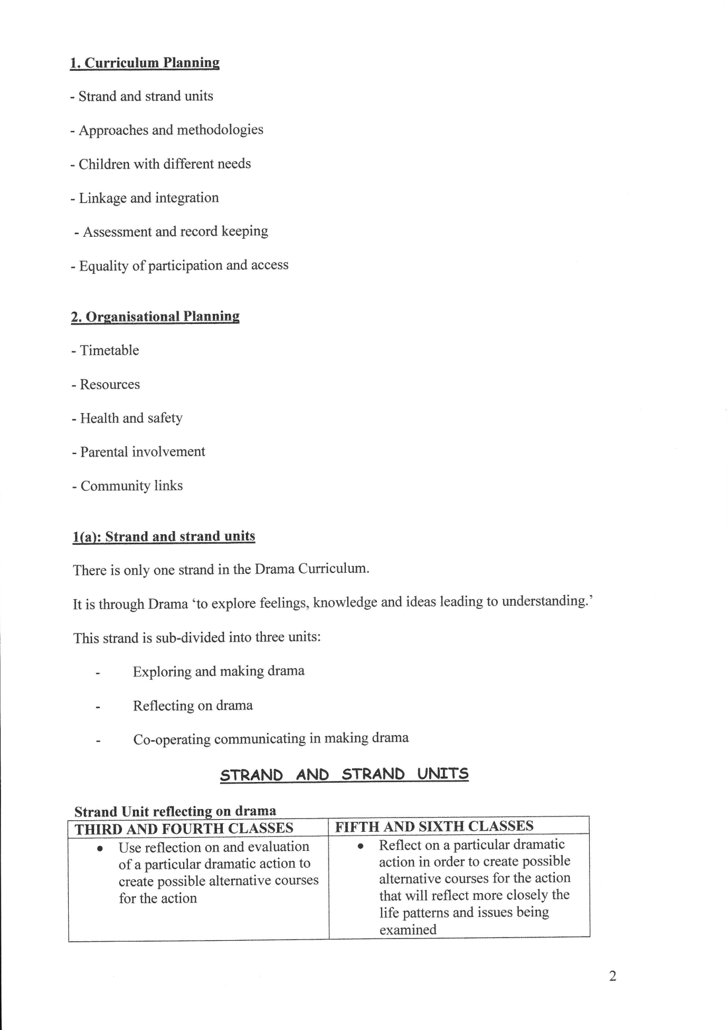
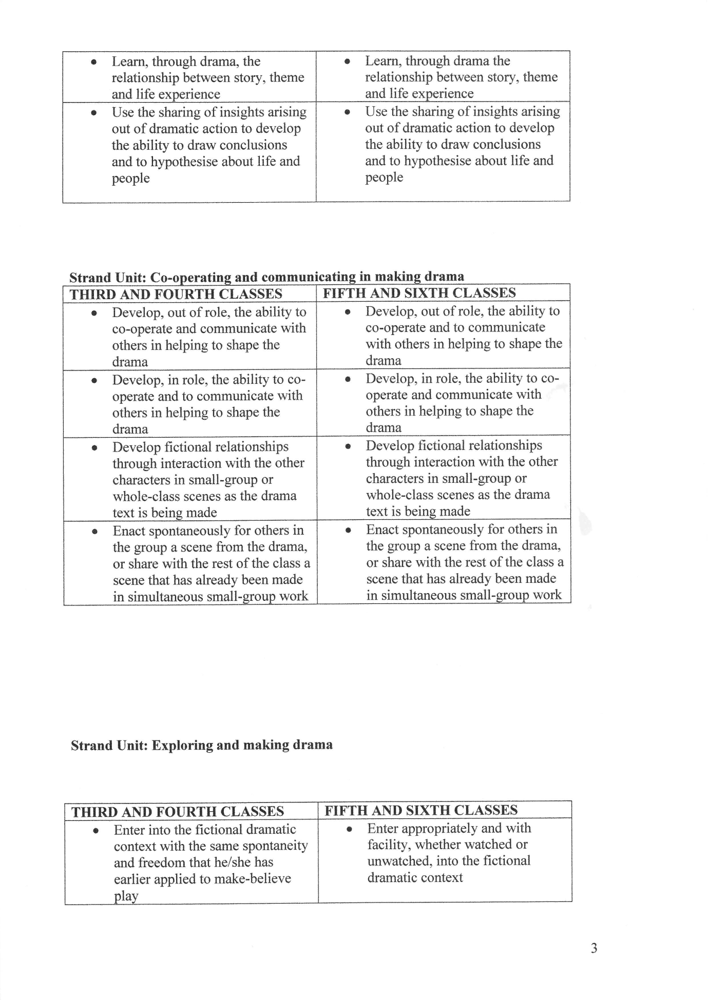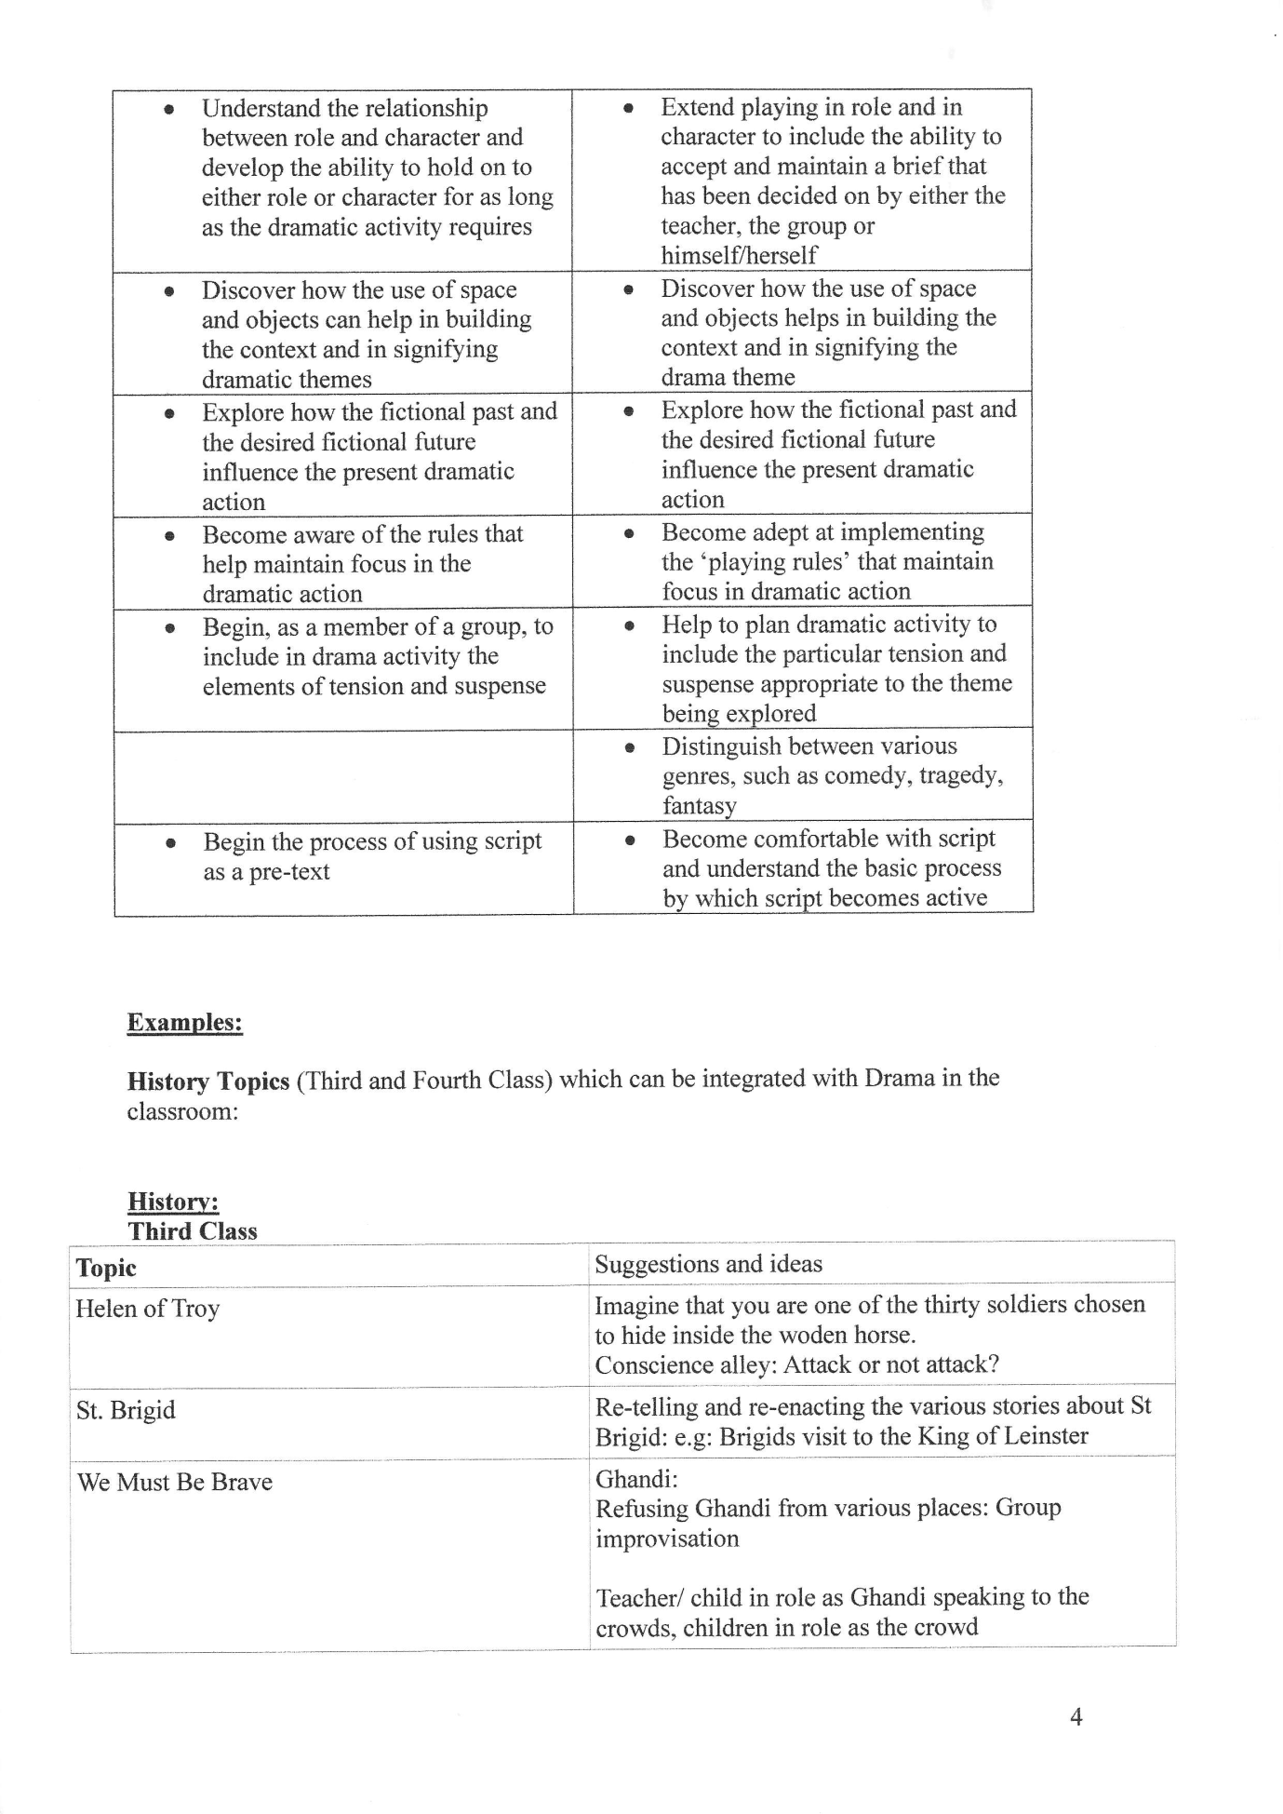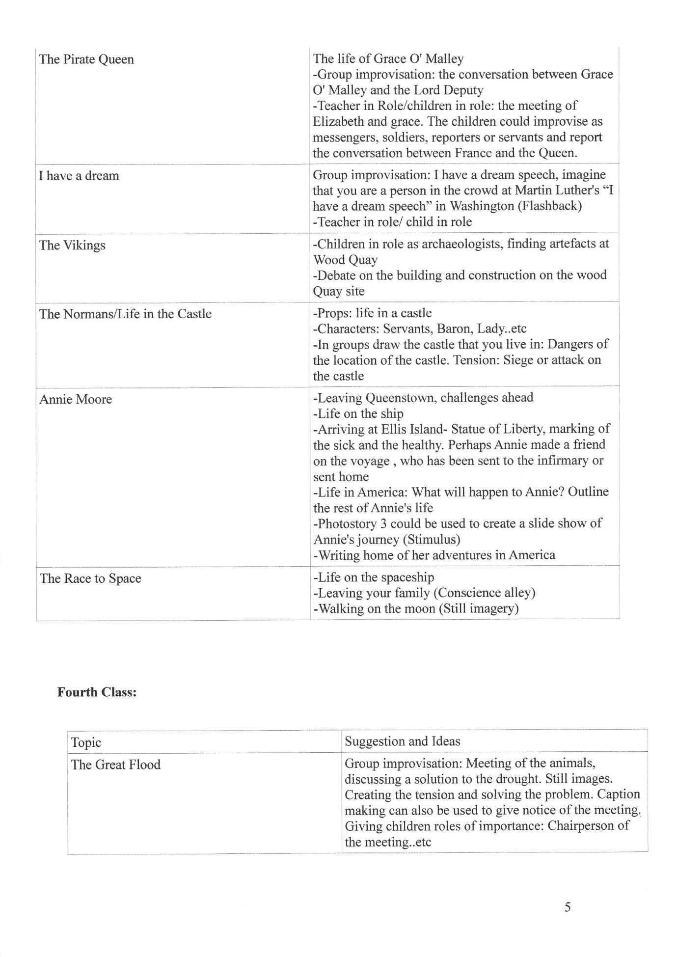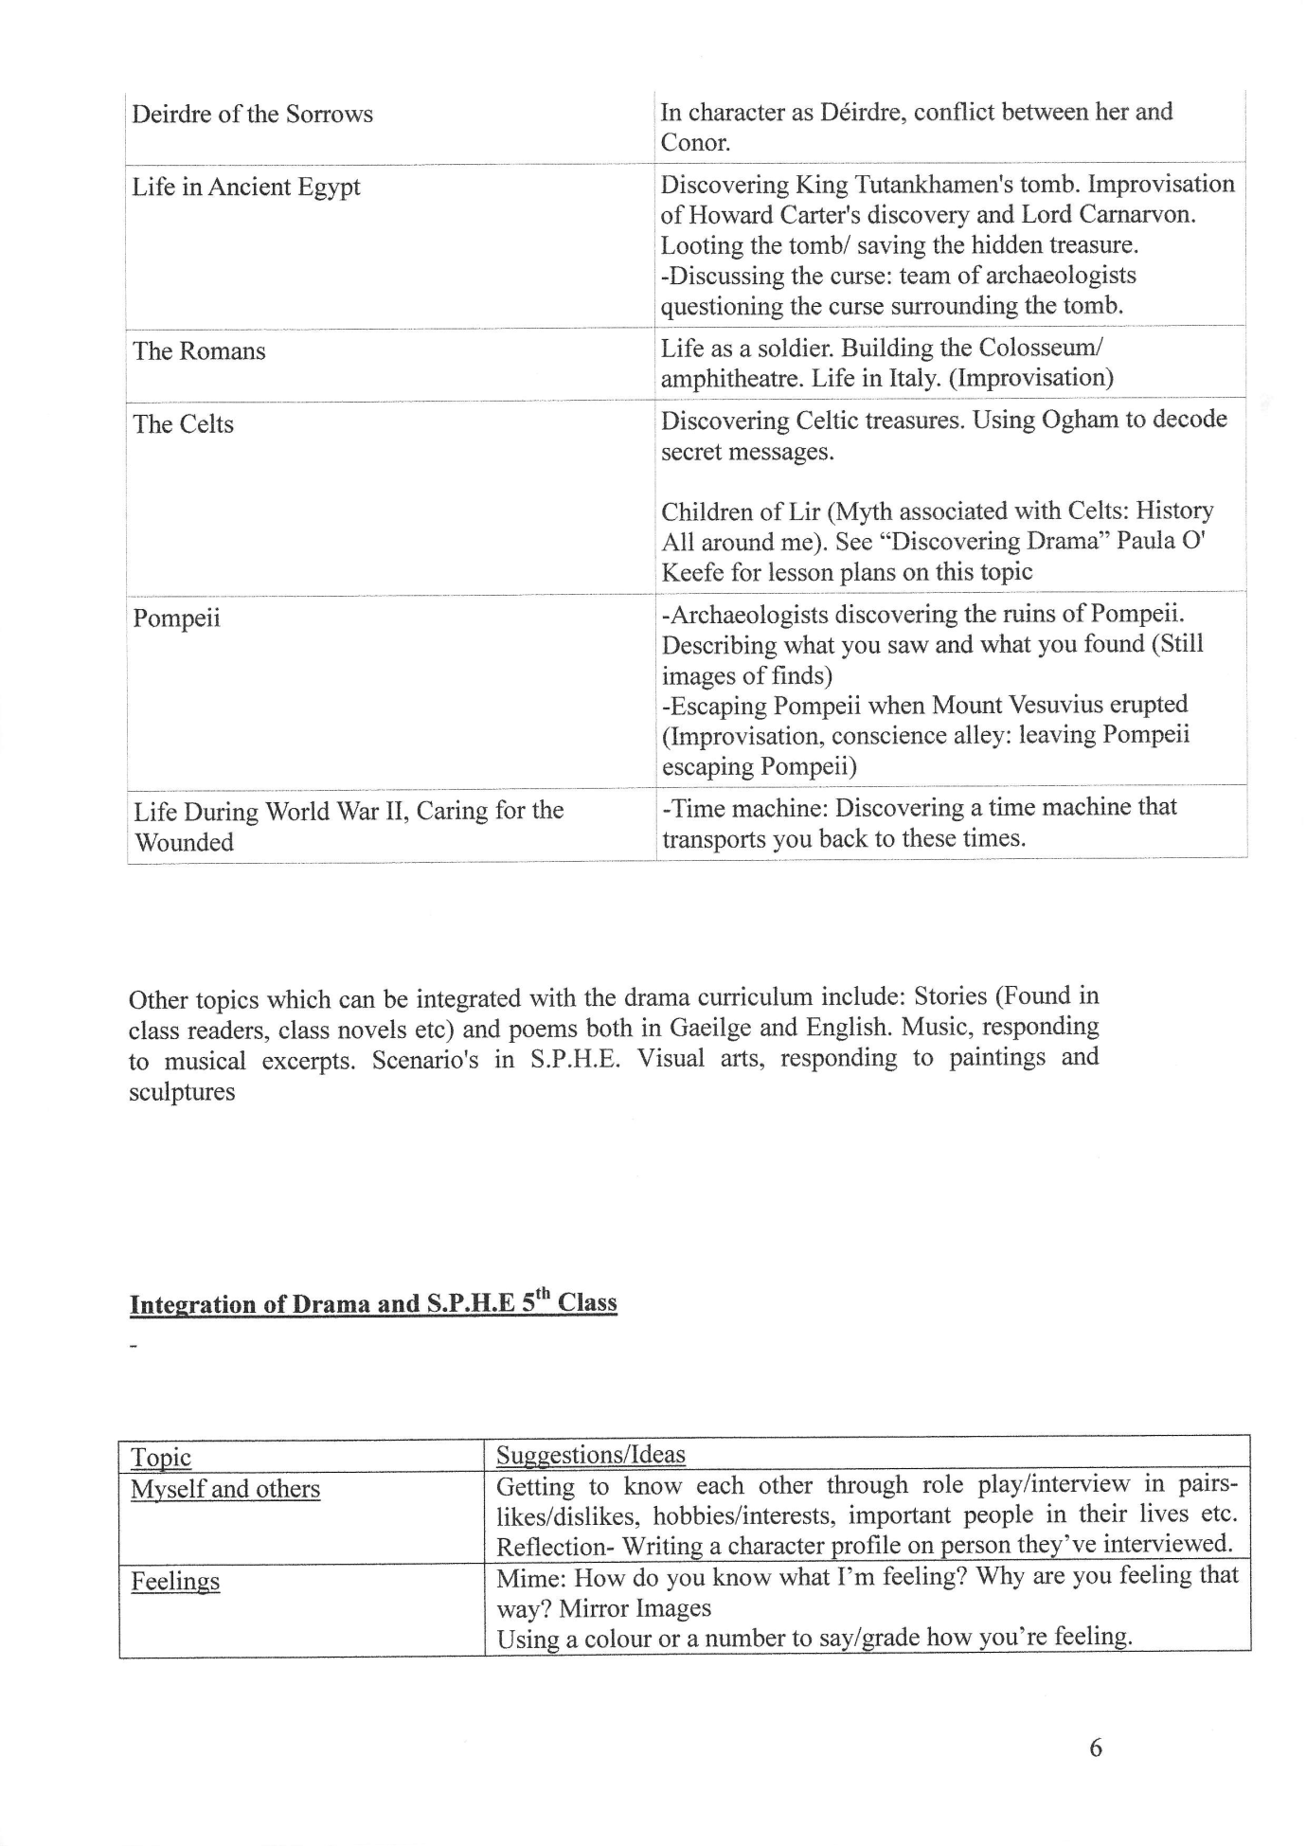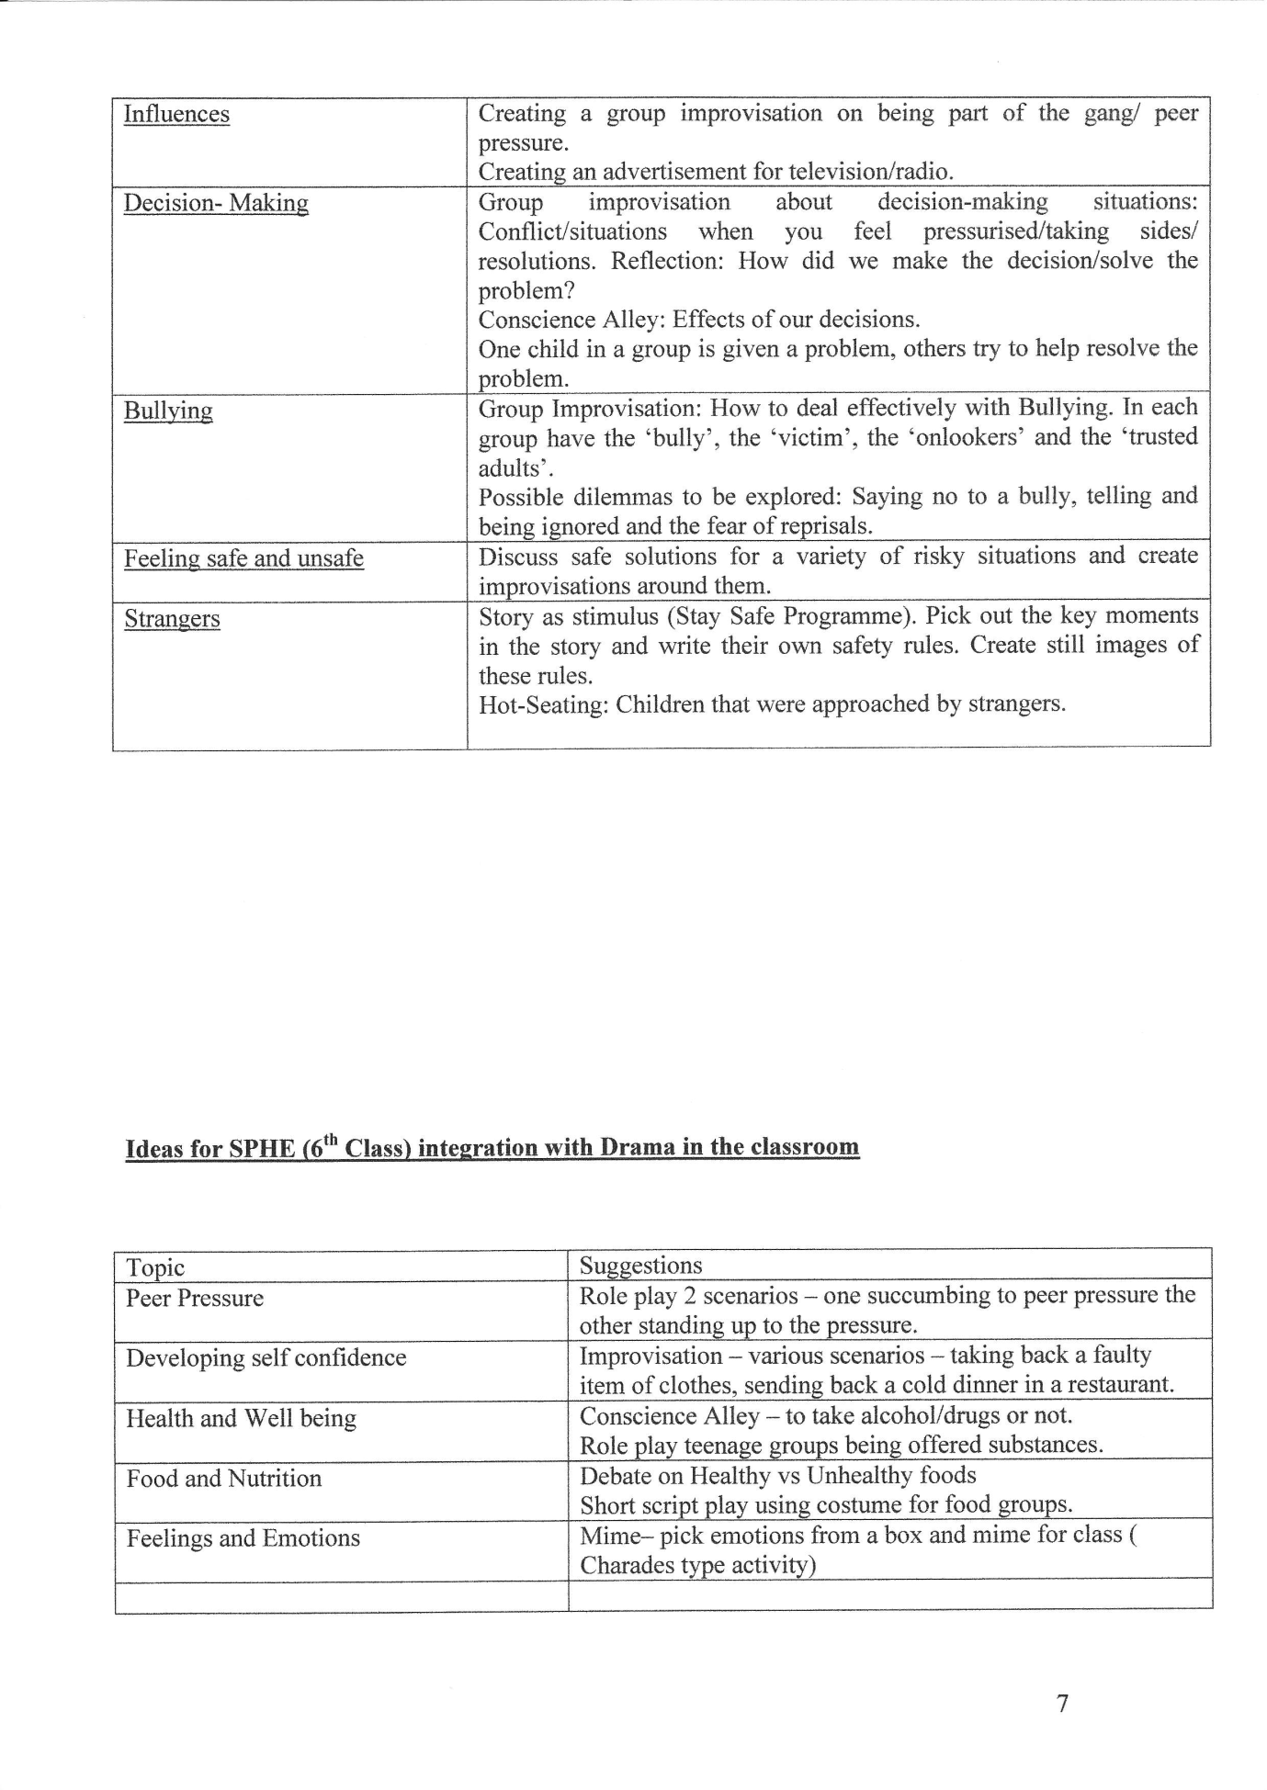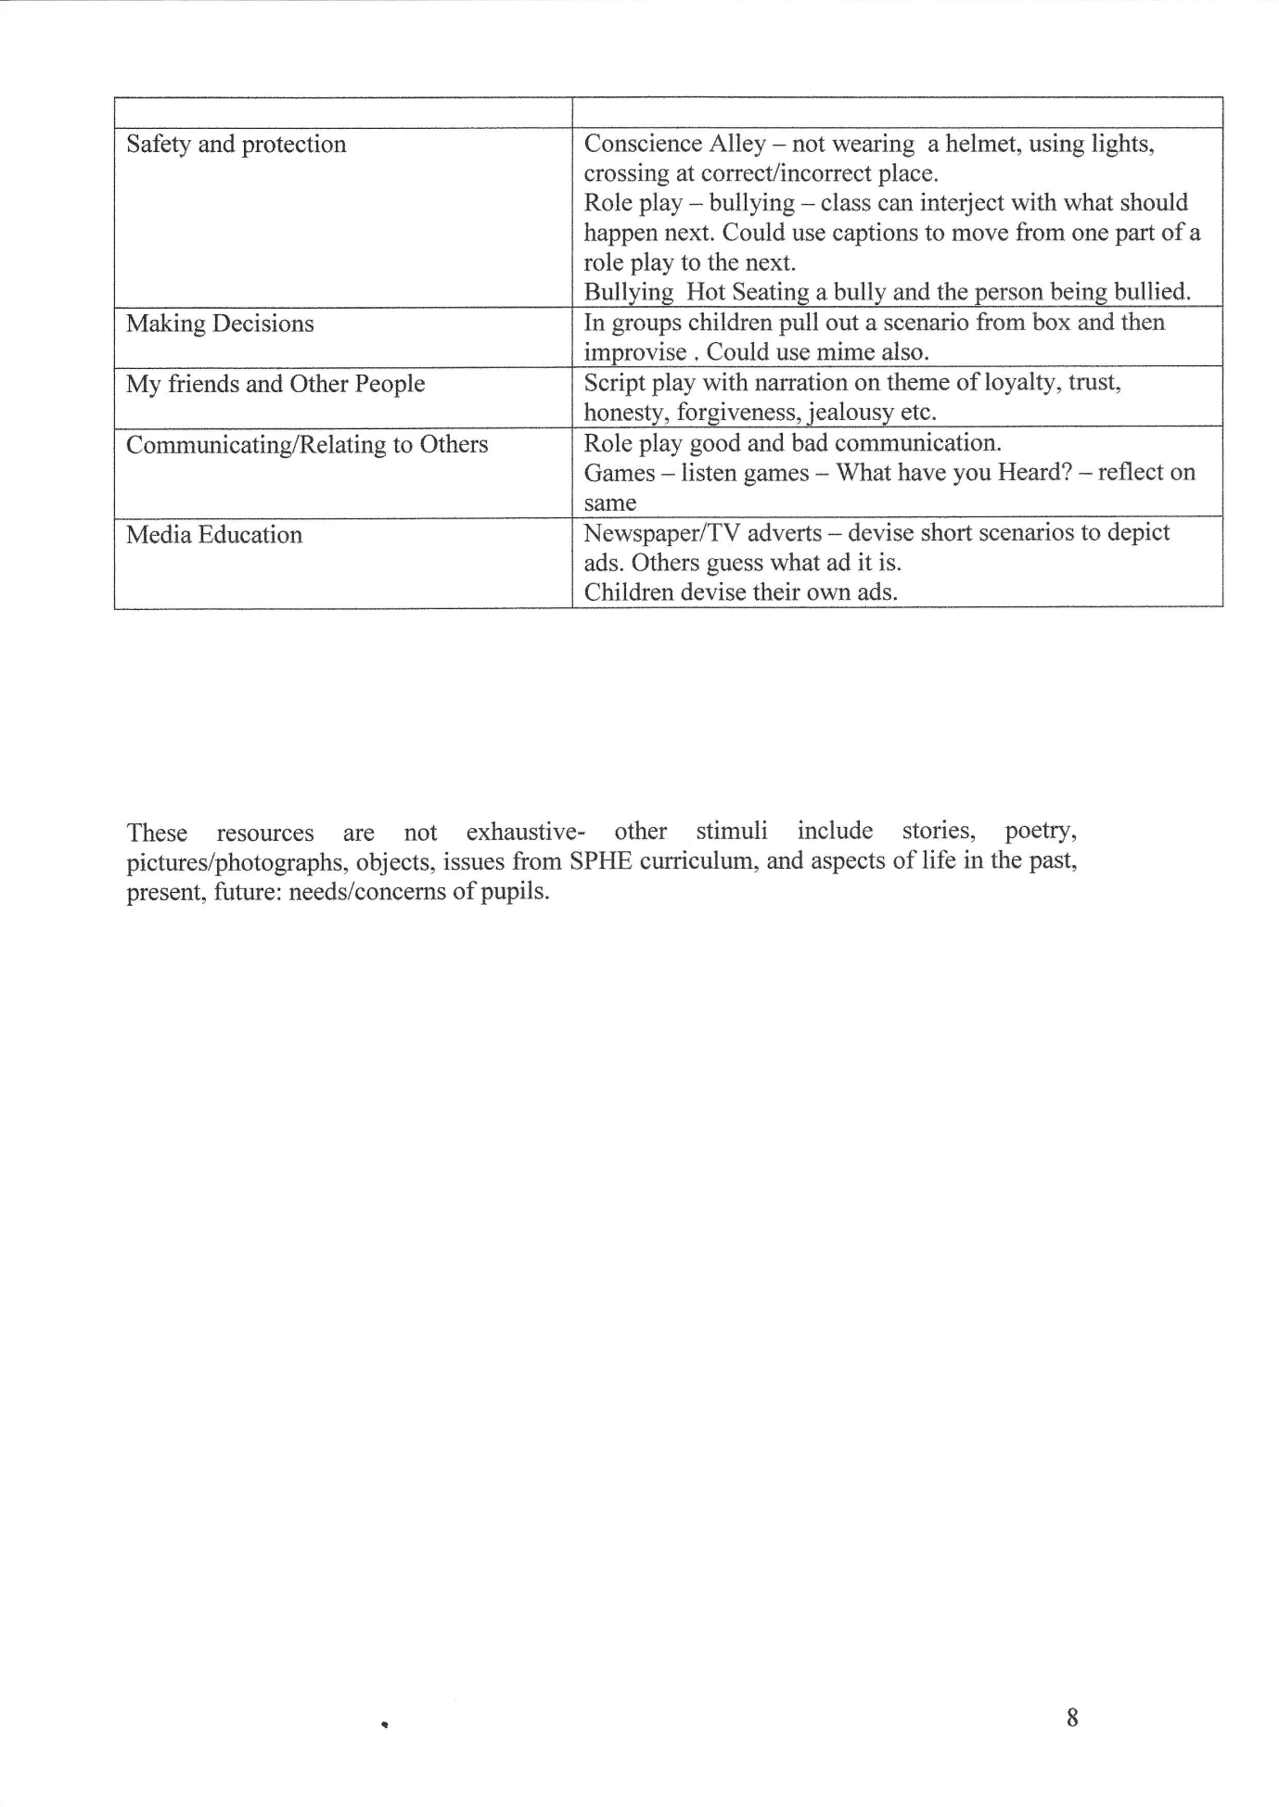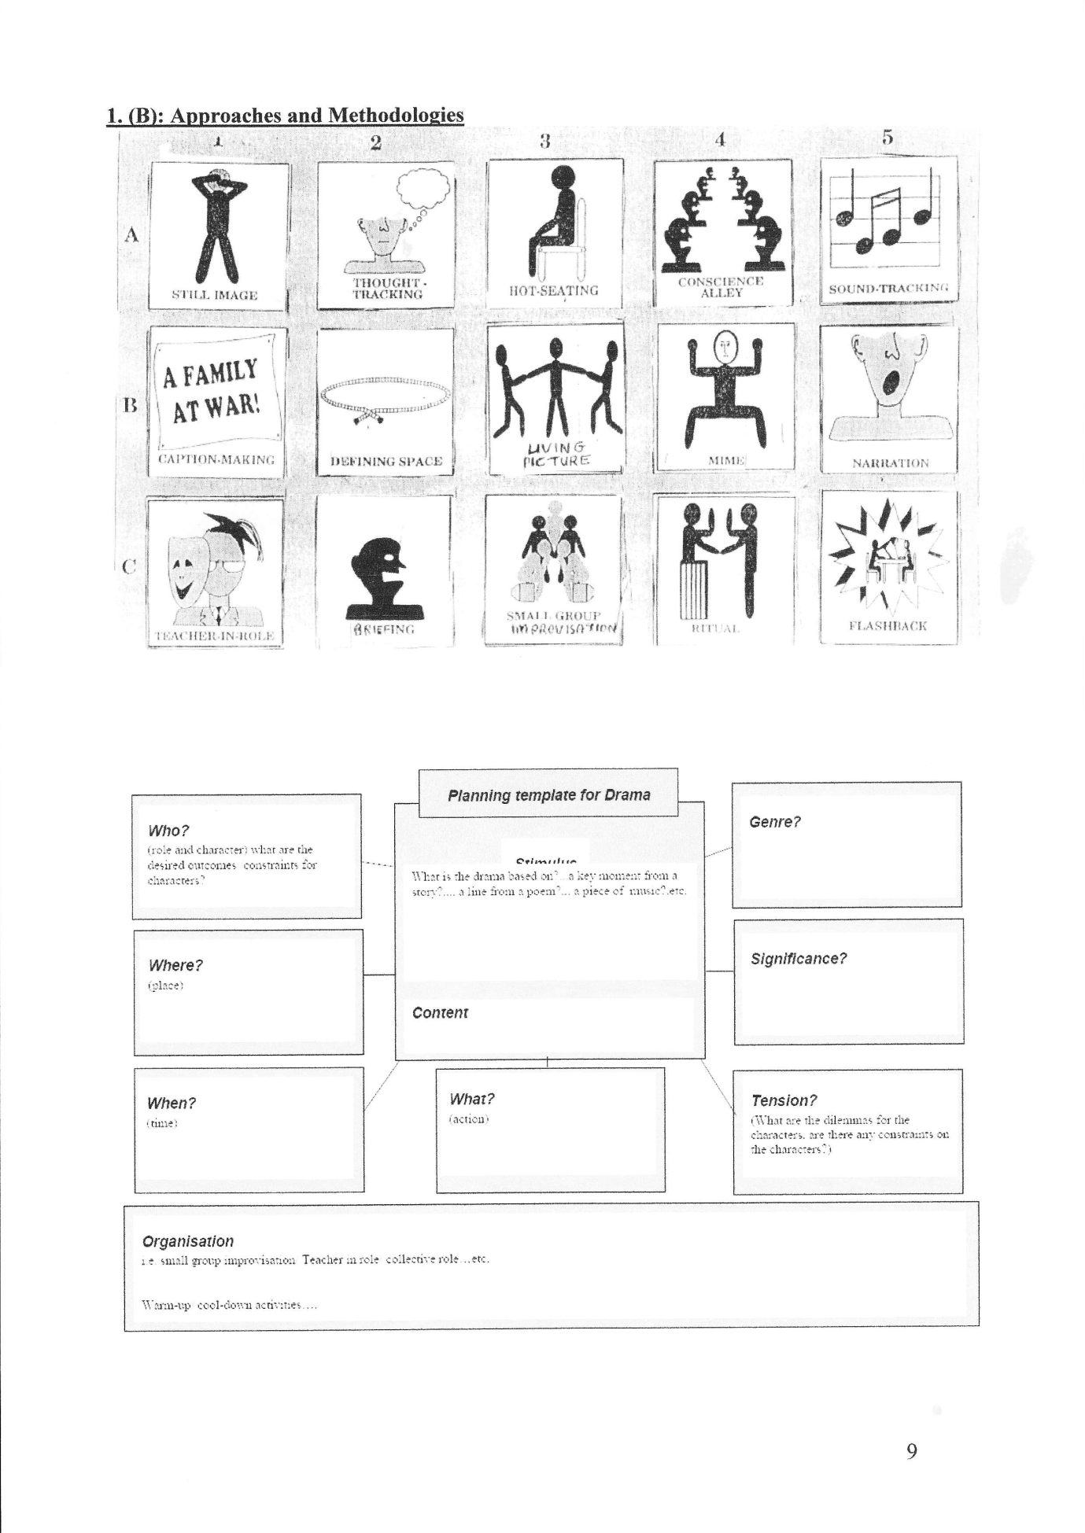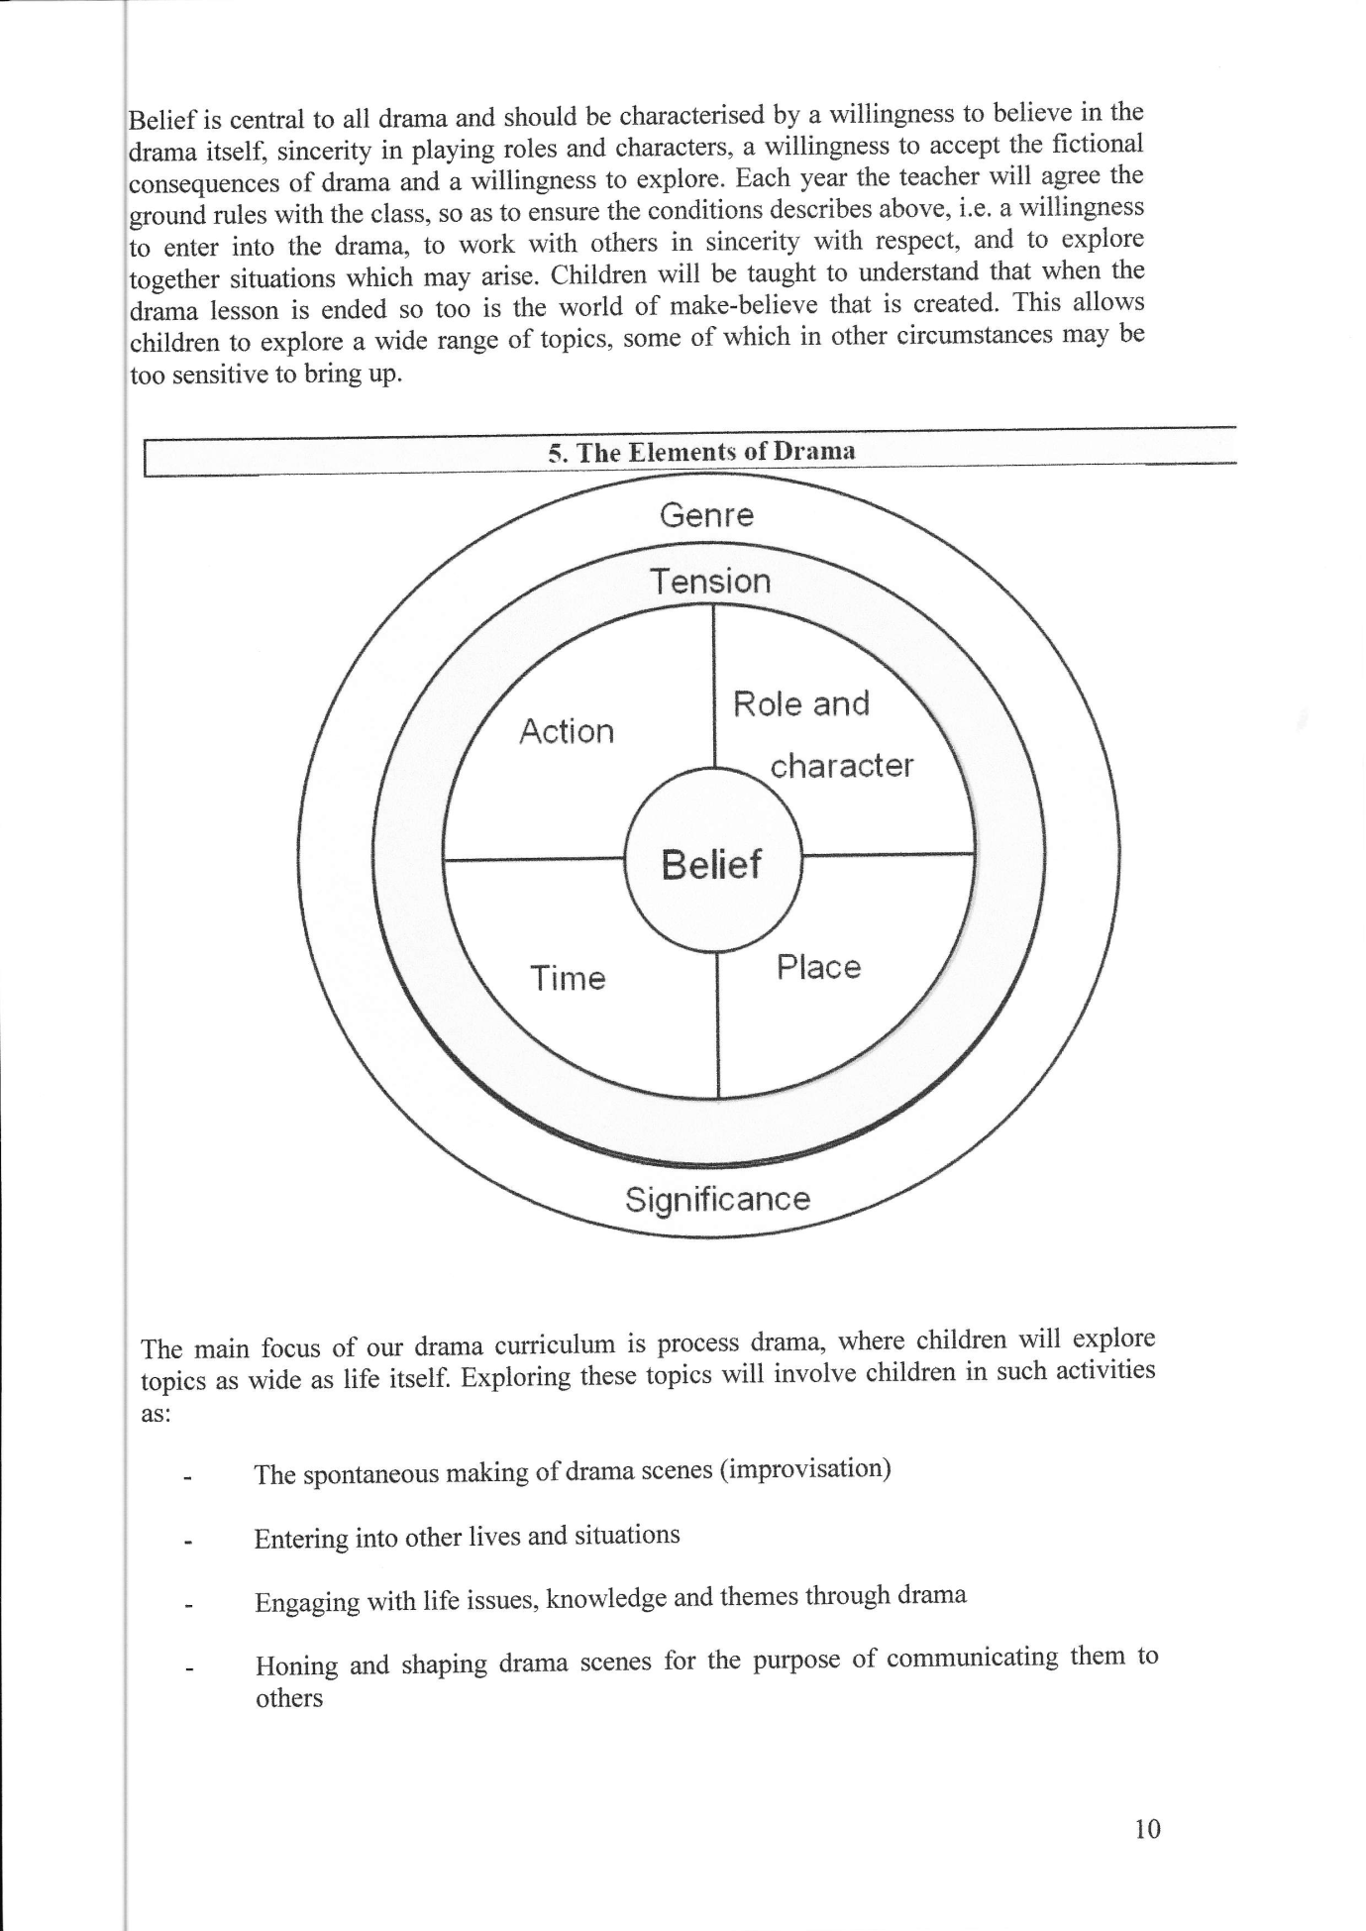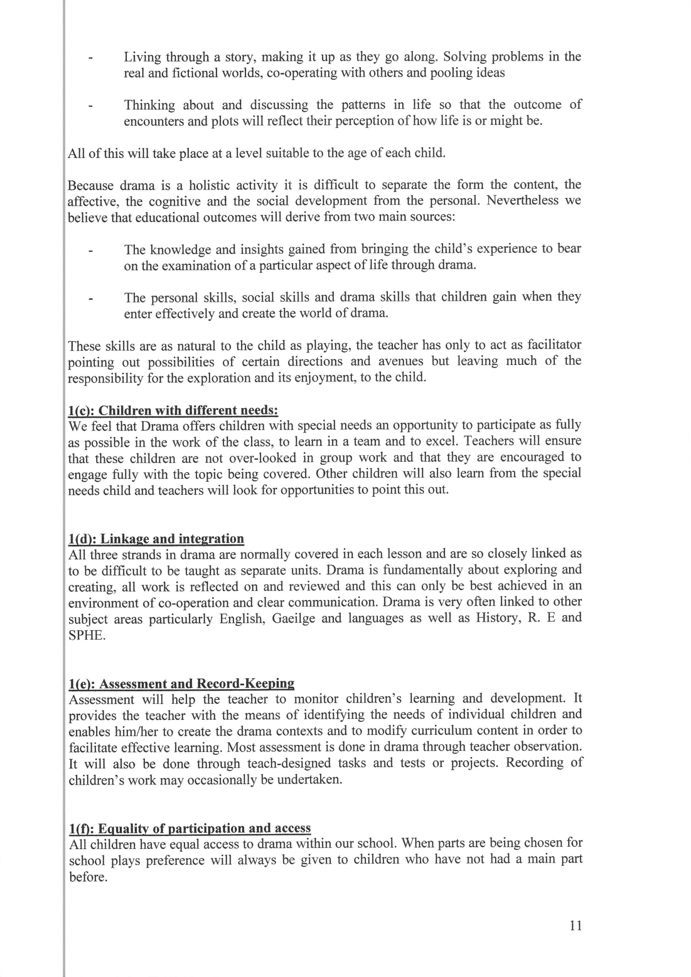

2. Organisational Planning:

2(a) Timetable
Each class is time-tabled to have an hour formal teaching time in Drama each week. However this has been adjusted in light of the new circular on the Literacy and Numeracy Strategy. Please refer to the school’s ‘Time spent on each subject policy’. In addition to this, Drama is integrated into the Curriculum in English, Irish, History, R.E. and SPHE.

2(b) Resources
We sometimes invite touring companies into school and attend drama productions.
Materials on the effective teaching of Drama are available on the PDST website.

2(c) Health and Safety
The safety and well-being of our children is, as always, of paramount concern. Children are never unaccompanied while on stage, there is always a teacher present, and no child may attempt anything in drama which might a pose to his/her own health or that of anyone else.

2(d) Staff Development
Teachers work closely together and share talents and strengths generously with each other, something which enriches practice throughout the school.

2(e) Parental Involvement
Parents provide an amazing and very appreciative audience for drama.

2(f) Success Criteria
This plan will be deemed successful when all classes enjoy drama and all children have the opportunity to explore their world in a safe creative manner. We believe that Drama helps to create confident children and success is evident in the children themselves.

Roles and Responsibilities
The responsibility for implementing this plan lies with every teaching member of staff.

Ratification of Drama Policy

This policy was adopted by the Board of Management on _________________

Signed: _________________________ Signed: __________________________
Chairperson of Board of Management Principal

Date: __________________________ Date: __________________________

Date of next review: __________________

