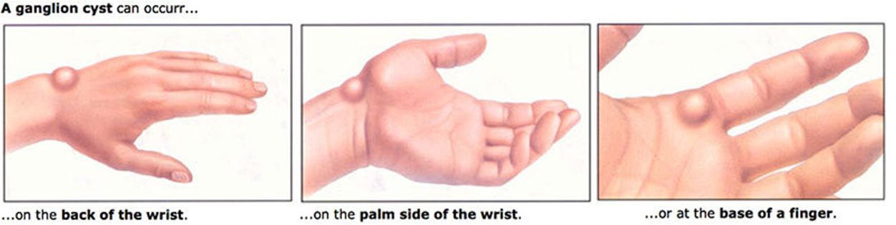
Ganglion Cyst

- A ganglion (GANG-lee-on) cyst is a firm, fluid-filled lump that can suddenly appear on the front or back of the wrist or at the base of a finger.
- These cysts grow from normal tissue in the wrist and fingers, and range in size from a pea to a peach pit. Although ganglion cysts are common, they don’t spread, and they don’t become cancerous.
- They can occur after an injury.
- Ganglion cysts can be painful if they press on a nearby nerve. Their location can sometimes interfere with joint movement.
- Ganglion cysts can change in size, and may go away on their own.
- A ganglion cyst is sometimes painful, especially when it first occurs. Constantly using your hand or wrist can make the cyst enlarge and hurt more. Some hand and wrist movements, such as grasping things, may also be difficult.

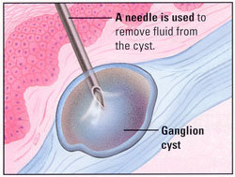
Your wrist and hand are made up of many small bones that meet at joints. Tendons attach muscles to the bones at the joints. The tendons allow the joints to bend and straighten. Both tendons and joints are lined with tissue called synovium. This tissue produces a thick fluid that keeps the joints and tendons moving easily. Sometimes the tissue balloons out from the joint or tendons and forms a cyst. As the cyst fills with fluid and grows, it appears as a lump you can feel.

To shrink the cyst your doctor may massage the fluid back into the surrounding tissue,
or remove (aspirate) the fluid with a needle, but this does not address the cause.

Topical Support:
- Shaklee Joint & Muscle Pain Cream
- Shaklee Herbal Blend Cream
Supplements for Natural Help:
- Optimize Vitamin D3
- Optimize Essential Fatty Acids: Fish Oils & Lecithin
- Alfalfa tablets (30 daily)
- VitalMag
Homeopathic Help:
- Arnica
Other Modalities:
- Accupuncture
- Hand Massage to support better circulation
Sometimes when the Cyst has become advanced and hard, surgery may be necessary to remove it.

