TRINITY UNITED METHODIST CHURCH
Pastor Doug Benton ___ Minister
July 25, 2021 Color: Green
NINETH SUNDAY AFTER PENTECOST
"We welcome you to our service this morning and pray that your time with us will be a blessing to you"
THE ORDER FOR WORSHIP
Prelude Eddie Welborn
Let us silently prepare our hearts and minds for worship.
Welcome and Announcements Grady Senn
Chiming of the Hour Eddie Welborn
Candle Lighting and Processional
“Stool Time with Pastor doug”
Call to Worship Pastor Benton
Opening Prayer Pastor Benton
Children’s Time Pastor Benton
Hymn of Adoration: “Beneath the Cross of Jesus” Page 297
*Apostles Creed Page 881
*Gloria Patri: “Glory Be to the Father”
Praises, Concerns and Prayers Grady Senn
Pastoral Prayer/Lord’s Prayer Pastor Benton
Tithes and Offering Ushers / Grady Senn
*Doxology: “Praise God From Whom All Blessings Flow”
*Hymn of Preparation: “Where He Leads Me” Page 338
First Reading: 2 Samuel 11:1-15 Dixie Waldrop
Second Reading: Psalm 51:1-12 Dixie Waldrop
Sermon Scripture: John 6:1-26 Pastor Benton
Transitional Music
Sermon: “How doubt can bring belief” Pastor Benton
*Hymn of Service: “Take Up Thou Cross” Page 415
*Returning of the Light

*The Benediction Pastor Benton

*Three-Fold Amen Eddie Welborn
*Going Forth Eddie Welborn
*Stand if able. God’s altar is open to you following the sermon.
Technician: Bryan Waldrop

The Altar Flowers are to the Glory of God.

Next Sunday – August 1

Altar Flowers: Clarissa & David Hendrix; Greeter: Clarissa Hendrix; Scripture Reader: Frieda Kesler; Technician: Josh Pitts

Our Faithfulness

Worship Attendance for July 18, 2021: 43
Total Budget for 2021: $ 149,647.00
Weekly Offering Needed: $ 2,877.83
Offering Received July 18, 2021: $ 740.00
2021 Average Weekly Offering YTD: $ 2,204 .00

The Concerns of Trinity
Our Known Hospitalized:
Recent Hospitalizations and/or Surgeries:
Nursing Home: Gloria Brehmer (Springfield Place), James Poag (White Oak)
Health South Rehabilitation Hospital: Jeannette Poag,

Continued Member Prayers: Shirley Berry, Robert Pollard, family of Crystal Waldrop on the passing of her mother, Linda Johntson, family of Robert and John Pollard on the passing of their brother Tommy Pollard.
Family and Friends of Trinity: Blake Hendrix, Phillip Sanders, Wilson Bowles, Charlotte Berry, Megan Wainwright, Diane Merchant, Neil Thomas, Francis Leopard,
Sal Welborn, Lilly Martin

Thank You
Trinity would like to recognize John Pollard for the new sign and Harry Longshore for the church’s new cross. Thank you for all you do for Trinity.

2021 Altar Flowers
If you would like to place altar flowers in the church, please sign the flower chart located on the wall in the narthex. Please notify Peggy Bogart with the wording you wish to have printed.

Vacation Bible School 2021
Thank you to all who contributed to the success of VBS 2021 – Barnyard Roundup: Jesus Gathers Us Together. Check the screen out before the service for photos from VBS. Full coverage in the next Trinity Times Newsletter.

WELCOME VISITORS

Thank you for coming today! We are delighted you are here! We hope
you will join us again as we continue to discover the difference God’s love makes in our lives. If you have questions or desire to become a member of Trinity UMC, please speak to pastor. We are blessed because you’re here.

Trinity United Methodist Church Please visit our website for bulletins & newsletters:
1160 Trinity Church Road www.trinityumcnewberry.net
Newberry, SC 29108
Rev. doug benton, Pastor
803-276-1245 (Church Office)
803-768-7687 (Church’s cellphone)
803-543-0082 (Pastor’s Cell)
dobenton@umcsc.net
Upcoming Events at Trinity

August 2: Trinity Women’s Club – 6:30 pm
August 4: Trinity Men’s Club – 7:30 pm
August 9: Administrative Council meeting – 6:30 pm in the Fellowship Hall

Trinity
United
Methodist
Church

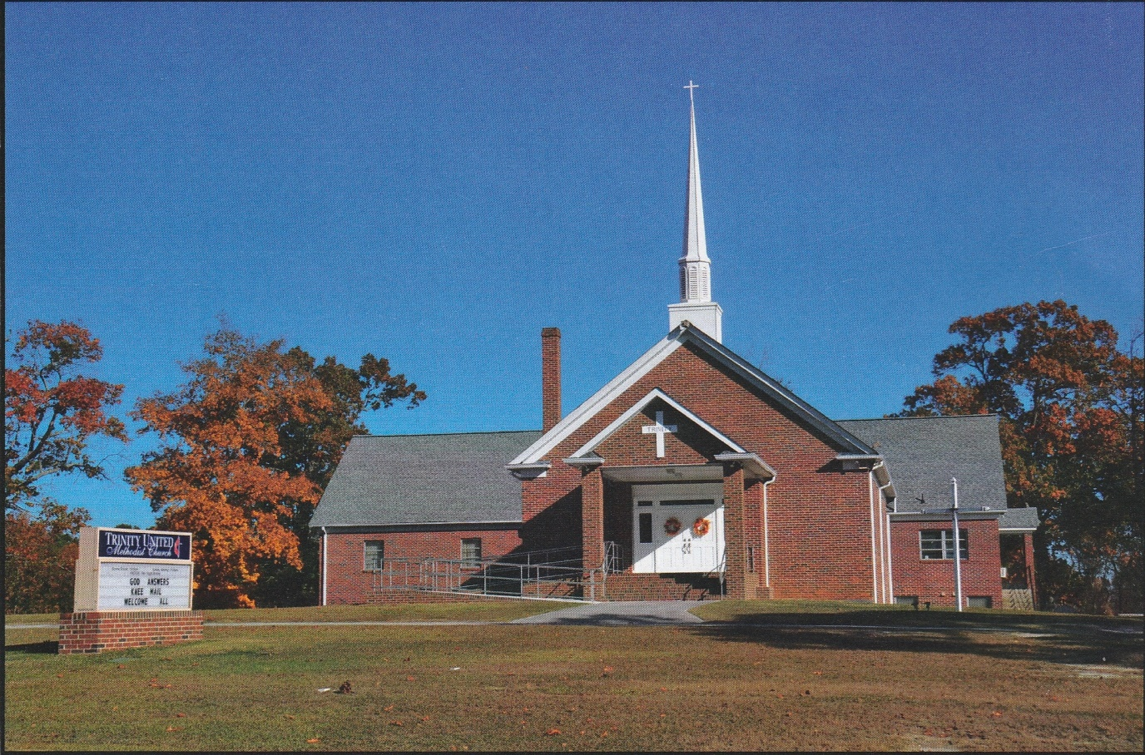

1160 Trinity Church Road
Newberry, SC 29108
Trinityumcnewberry@gmail.com

