**FUN GEOLOGY FIELD TRIP!**

**LOCATION:** 400 Main St, Aurora, NC 27806 (4 ½ hours from Charlottesville)

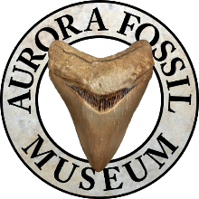

Questions? [info@aurorafossilmuseum.org](mailto:info@aurorafossilmuseum.org)

Website: <https://aurorafossilmuseum.org/>

My family recently visited the Aurora Fossil Museum and had an amazing time. The museum has **free**

**admission** and the two large fossil pits across the street are free to dig in. My son and I found 150 fossil teeth in 1 ½ hours. It was amazing and so much fun. The fossil pits contain fossils, dirt, small stones from the local phosphate mine, which they replenish from time to time. This is such a great family field trip since the museum is free as well as digging for fossils!

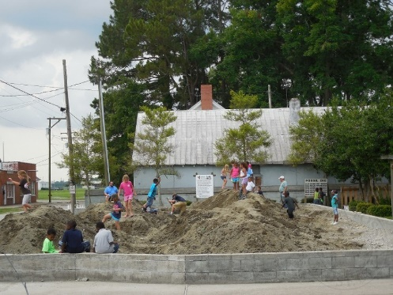

*One of the fossil pits*

The staff at the museum is very helpful. They sell 12x12 screens to use for sifting through the small rocks and fossils for $13 each. Take small six-inch garden shovels to dig with & a few sandwich bags to put the shark’s teeth in. The website for the museum has some great educational information on the phosphate plant. Pack a lunch—the town is small and there isn’t anywhere to pick up lunch there.

Want an added bonus while you are in the area? Take the free ferry across the Pamlico River from Aurora to Bayview. It is a 30-minute ferry ride and is very fun. Drive your car onto the ferry and you can get out of your car to walk along the decks and check out the view of the river. If you are staying in Bayview, you can take the ferry over to Aurora to the fossil museum. Check their website for times.

