MAY / JUNE, 2022

Goodbye May….Hello, June!

While summer has not quite arrived yet, the
weather is beginning to warm up! We hope you are now making plans for outdoor activities and then enjoying what you planned, as the season is just too short!! Let us know how you will be “coping”!

Sadly, this newsletter reports the passing of another member of the Class of ‘67:

Blaise Amato, 73, passed away in mid-May, 2022. Blaise loved music. At 16, he was lead singer of “Bobby & The Belmonts”, a very popular band that never lost a “Battle of the Bands” probably due to his amazing voice & stunning personality that held the band together back in the 60s. During his time at GHHS, he participated in A Cappella Choir, singing tenor. He was also one of six fellows that formed “The Naturals”, an R&B band, and was its lead singer. He especially enjoyed performing & entertaining with them.

After graduation, he worked for 45 years in sales & eventually in management, for the Montrose Auto Group, a company that featured 14 brands of vehicles at 12 locations throughout Ohio.

He is survived by his wife, Margie, step-father of two, and grandfather of four. He was also the dear brother of two sisters, Marlene & Rosalie.

Our sympathies are extended to Blaise’s families and friends. He will certainly be missed!

*********************************

With plans moving forward for our 55th reunion, we want to reach out to as many alumni as we can about attending. Some of our mail to alums have already been returned; therefore, those folks are currently “missing in action” within our data base. Please review the names listed below and if you have any details or knowledge about the location of a missing alum, we would appreciate knowing about it so that we can attempt to reach them once again in order to keep them in our “class loop”.

Those Alumni “Missing In Action”
Joy Adamo Roy Alford Jan Bramwell Moranick Shirley Chmielewski Reinoehl
Bruce Christopher Marian Chuma Frank Dantimo* John Dobrovic
Kathy Evans Page Vickie Egle Hayes Donna Frisky Balwas Jo Ann Hawkins
Tom Hershey Janice Horvath Kowalski Lee Horvath Robert Kane* (in TX but no address)
James Kidwell David Lacher Tom Leggin Charles Galvin McGuire “Cal”
Robert Jagel John Malone Barbara Masters Mary McNeeley Pekar
Richard Milligan Keith Monteleone (still in KY) Frank Murawski
Cindy Murray James O’Bryan Kathryn Portzer Robert Quinn
Rose Sabo Kathleen Sandor Bill Schumacher Barb Setla Karpathakis
David Sminchak John C. Smith (card returned 55th) Charlene Sorci Hogle
James Szabo* Martin Zastawnik Jerry Celebucki*
*an email address that doesn’t appear to be working

Also needed for the reunion: LOOKING FOR BAKERS OR BAKERY BUYERS!!

Check your recipes for cookies, cupcakes or dessert bars.

----OR----

You can purchase scrumptious cookies, cupcakes or dessert bars.

Please plate your delicacies on disposable plates. We will have a dessert table which will hopefully serve 100.

Please email Lora Finocchi Garrett at LGar7649@aol.com if you can add to our table.

Thank you!

*********************************************************************************



Our Traveling Alumni: Attempts to travel seem to be working. Some of those doing so are: Georgiann Roberts Christiansen & hubby, Steve, cruised for 12 days along the Rhine River the end of April, and ended their cruise in Prague in early May.

Nancy Levis Knowlton was in Florida the end of April, Linda Wike Calkins flew to San Antonio, Texas, to visit family & friends early May. Rhea Jones Ashmore had a fave camping spot along the Olympic Peninsula June 1st. Floyd Konet with wife, Gayle Glowick Konet, enjoyed some beautiful sunsets in the Outer Banks of NC in early June. Ruth Mendala Thompson plans to be attending a wedding in Rhode Island June 25th, and Gail Russler Meyer with husband, Barry, will be cruising at the end of June to Alaska to celebrate their 30th wedding anniversary. While on the “West Coast”, they will also stop in Oregon to visit long time friends and then to California to visit, for the second time, their 6-month old granddaughter.

Kudos to: Jean Alesci Ford & husband, Dick, who celebrated their 42nd wedding anniversary on April 30th, and Bill Sprengel & wife, JoEllen, upon their 48th wedding anniversary on May 4th.

Congratulations to Helen Steblinski Cejer who became a grandmother to twin grandbabies on April 8, 2022; to Janet Benedetti upon the graduation of her grandson from MSU on May 10, 2022, in computer science engineering. He already has a job at GM!

And to Linda Maciaszek Fauble upon going to Kansas City the weekend of May 20th to attend the ceremony of her grandson’s high school graduation. While grandson, Jeremy Sharp, lives with his parents in Roseville, MI, he was recruited by the Sporting Kansas City Academy, a Major League Soccer team, in 2020. Jeremy attended Olathe East High School in Olathe, KC, for his junior & senior years and graduated May 22nd. He has committed to Michigan State University this fall to play soccer and to further his academic endeavors.

In Our Thoughts & Prayers: Susan Said has been in & out of the hospital for several months. She is currently in home hospice suffering with heart failure. She is now totally off all heart medications. Bottom line is the heart will continue to get weaker until it cannot pump blood anymore, then a hospice institution will receive her.

Condolences To: Karen Bene Godenschwager upon the passing of her husband, Peter, age 72, on April 27, 2022, from a four-year battle with esophageal cancer. Peter graduated from Valparaiso University in Indiana in 1971 followed by 40 years of service to the National Labor Relations Board in Cleveland. He was an avid runner & golfer even into the late stages of his cancer. Peter is survived by his wife of 50 years, Karen, his son, Peter, his three granddaughters, as well as his mother, Dorothy, and sister-in-law, Linda.

Our prayers are certainly with you and your extended family!
“Death leaves a heartache no one can heal. Love leaves a memory no one can steal.”

Newsy Reflections & Tidbits: The Lady Bulldogs met for lunch on April 30th at the Oak Barrel restaurant and at Danny Boy’s restaurant on May 21st. Those who attended are pictured below. If you are interested in attending a lunch, RSVP to Audrey Sopko at asopko@sbcglobal.net. Our next lunch is June 25th at Danny Boy’s. Consider joining us for a discussion about future lunch venues.

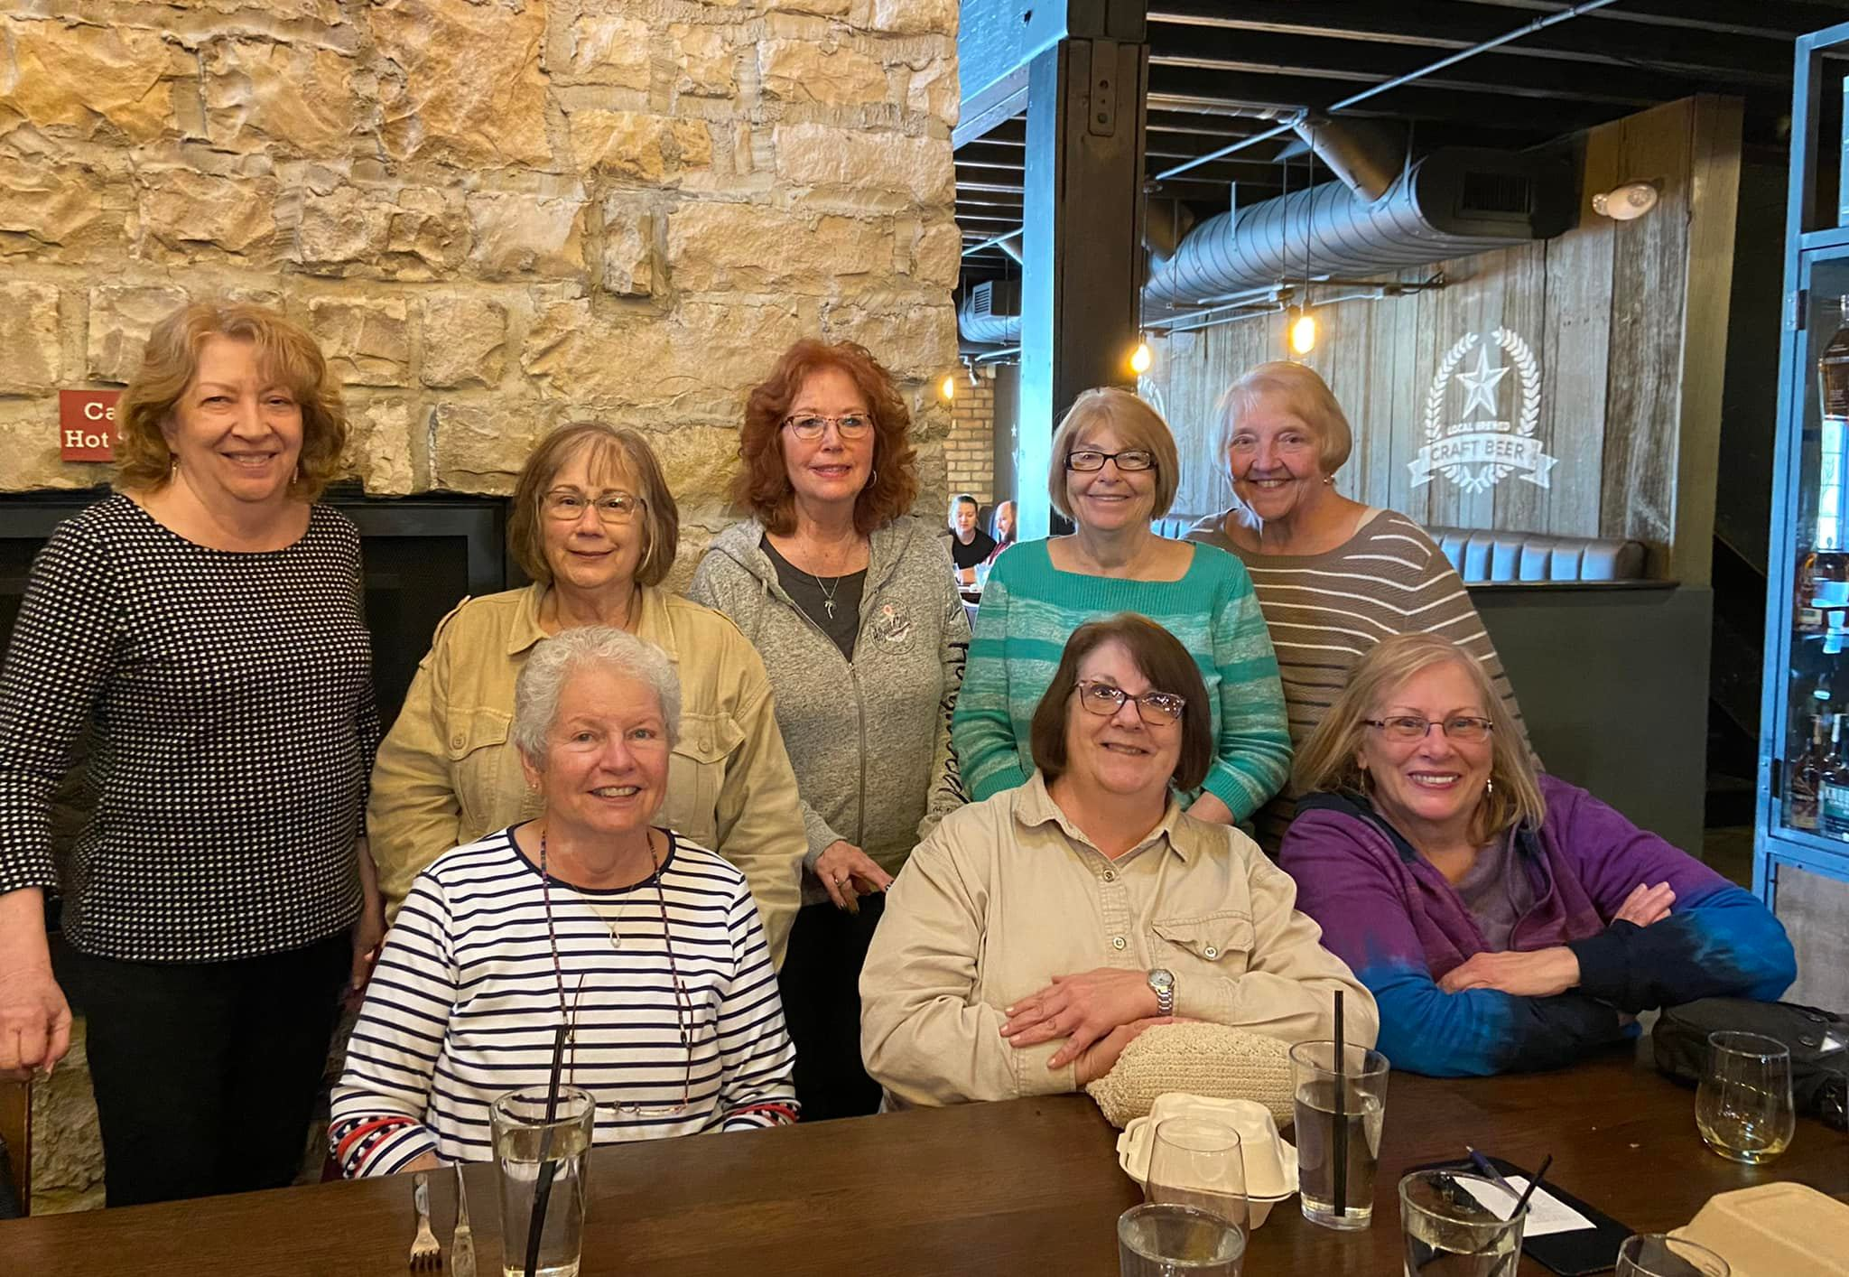
April Luncheon:
Sue Baranovic Slesnick, Karen Soika Palker, Linda Wike Calkins, Jan Wroblewski Hola, Sharon Travagliante Weitzman, Diana Trego, Ruth Mendala Thompson, & Kathy Schneider Nowack.

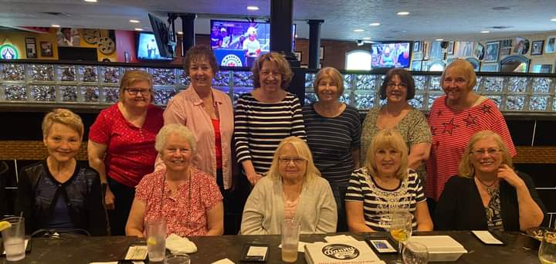
May Luncheon:
Leslie Mroz Readinger, Sue Baranovic Slesnick, Amy Roman Kostka, Helen Steblinski Cejer, Linda Wike Calkins, Karen Parhamovich Felon, Audrey Sopko, Jan Wroblewski Hola, Ruth Mendala Thompson,
Karen Soika Palker, & Kathy Schneider Nowack.
******************************************

Audrey Sopko doesn’t normally suggest that financial advice be offered in our newsletter, but the following information may prove to be too good to be true.

The government has a 30-year bond program that is tied to inflation. In February the interest rate on these bonds was 7%. Because of rising inflation, as of May, it is over 9%. And being a government program, it is as secure as cash can be. One must keep the bond for at least a year. After that, the penalty to cash in the bond is one quarter’s interest rate (so if you have $10k for a year and cash it in, the penalty is $240).
Here is the website for inflation-driven government bonds.
Individual - Series I Savings Bonds (treasurydirect.gov)
As you can see in the highlighted red box, current interest rate is 9.62% until October 2022.
Just click on the underlined word “buy” to purchase a bond. I think you can buy one for as little as $25, but the maximum the government allows is $10,000.
Your financial advisor will not be able to buy them for you. They must be purchased through the website. Still, talk to him/her so that you feel comfortable making the purchase.

☺ ☺☺ ☺ ☺☺ ☺☺☺ ☺☺☺ ☺ ☺☺☺ ☺☺☺ ☺☺☺ ☺☺

From Nico Bujak comes these “words of wisdom” & Senior History:

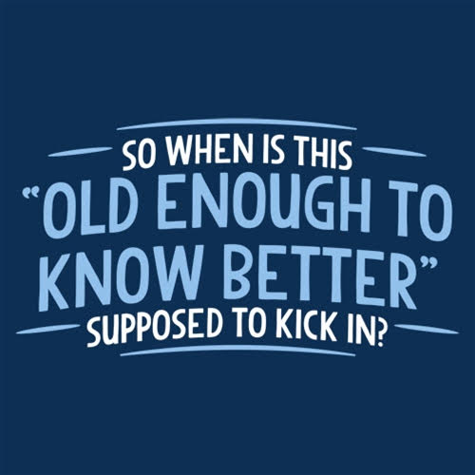

And that’s the round-up of this issue! Go Bulldogs!!!

Your loyal editor,
Gail Russler Meyer

