Amelia-Nottoway Technical Center News 1/22/2021
ANTC STUDENT SPOTLIGHT!
Joshua Berry, ACHS Senior
Auto Body II
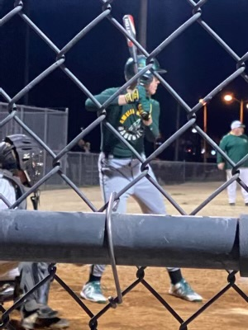 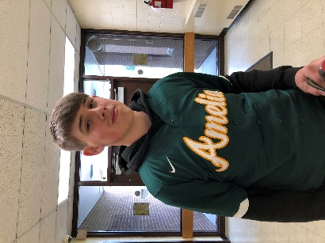 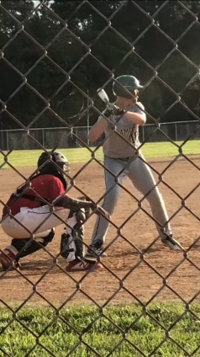 What brought you to ANTC? I came to ANTC to take Auto Body.
What is your dream job? I would like to own a Bar and Grill for active and retired military and first responders.
What is your favorite class that you have taken so far? Why? My favorite class is Auto Body because its fund and I am learning a lot.
What is the best advice you have been given by your instructor at ANTC? Mr. Spradlin told the class, “Don’t use tools for something they ain’t made for.”
What is your favorite memory at ANTC? My favorite memory is the endo the of the year cookout and cornhole tournament.
What was the first feeling you had when you attended ANTC? I was nervous.
What words of wisdom do you have for other students? I would tell other students, “Don’t screw up or you’ll kick the bucket.”

Celebration
Congratulations to Brenna Lewis and Chalie Scott for passing their Theory Cosmetology Exam. Both young ladies are 2020 Graduates of NHS and were unable to take their State Board Exam due to COVID-19! HOWEVER, these tenacious young ladies participated in review sessions with Mrs. Rajah at ANTC to prepare for the exam! Breanna, Chalie, and Mrs. Rajah, YOU ALL ROCK!!!
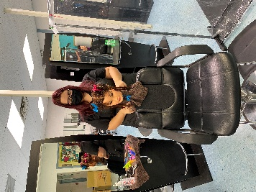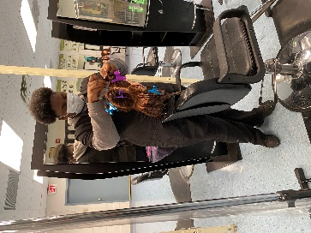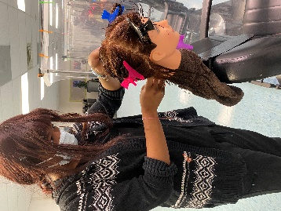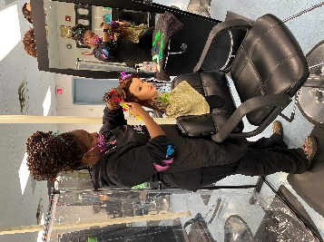
Program: Cosmetology I & II
Amelia County High School, Cumberland High School & Nottoway High School

Cosmetology I: In this introductory course, students study hair, skin, and nails and their related care. Students are grounded in theory as they prepare to practice procedures in a clinical lab setting or classroom, using manikins for manipulative skill practice. The first-year course emphasizes personal safety, professionalism, and sanitation and disinfection of equipment and facilities. Students develop skills in shampooing and conditioning hair, as well as styling and cutting hair. They are introduced to chemical texture services and develop skills in manicure and pedicure procedures.

Cosmetology II: In this continuing course, students build their theoretical foundation of general sciences and practices in cosmetology to increase proficiency in hair cutting and styling on live models, with attention to professionalism, client consultation, safety, and infection control. Students are trained in safe chemical processes related to permanent waves, relaxers, lightening, and coloring hair. In addition, students learn to care for skin, hands, and feet, developing experience in providing facials, manicures, pedicures, and nail enhancements. Students will be introduced to a business management unit with a focus on managing the salon.

Program: Medical Assistant I & II
Amelia County High School & Nottoway High School

Medical Assistant I: Students gain foundational knowledge in basic anatomy and physiology, medical ethics, medical asepsis, terminology, medical mathematics, and legal responsibilities. Students also develop basic skills and techniques to assist the healthcare provider and/or other medical professionals in patient examinations, basic emergency care, simple laboratory tests, and administrative duties. Additionally, students explore medical assisting career pathways through Health Occupations Student Association (HOSA) and potential on-the-job clinical instruction and/or observation in a healthcare facility.

Medical Assistant II: Students apply and implement medical-assisting skills and techniques learned in Medical Assistant I. They also learn management of health records; cardiopulmonary resuscitation; care and use of equipment; collection and analysis of laboratory specimens; special diagnostic testing related to basic diseases and disorders, treatment, and medication; and job preparedness skills. Advanced on-the-job clinical experience in a healthcare facility is a part of the course. Successful completion of the program may lead to employment in a healthcare setting and an industry credential.

Program: Auto Body I & II
Amelia County High School & Nottoway High School

In the global automobile collision repair industry, there is a growing demand for qualified auto body technicians. In this course, students are taught damage analysis, estimating, customer service, non-structural analysis, damage repair, and welding. Students work with a variety of materials, using metal finishing and body filling techniques to prepare surfaces and repair panels. Students who successfully complete this program sequence may be eligible to take the Automotive Service Excellence (ASE) Student Certification examinations.
Auto Body Technology I/II are closely aligned with the 2016 ASE Education Foundation collision repair and refinish program standards.

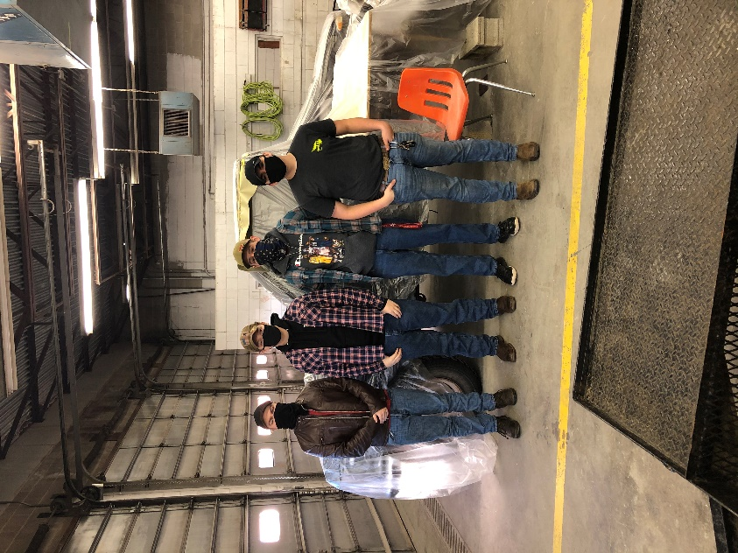

ASE Accreditation in Damage Analysis/Estimating/Customer Service, Painting and Refinishing

