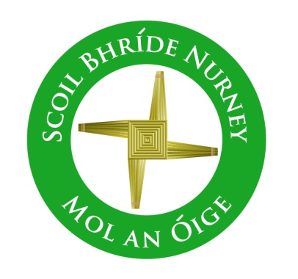
Scoil Bhríde,
Nurney,
Principal – Vinny Thorpe
Dep. Principal – Catherine Owens

County Kildare.
Te/Fax: (045)526767
Email: sbnurney@gmail.com
www.nurneyns.com
Roll no: 16345A

To whom it may concern,

I/We, the Parent(s)/Guardian(s) of _______________________________________ (insert child’s name), authorize Scoil Bhríde Nurney to provide details of ______________________‘s (insert child’s name) __________________________________ (insert what specific information/results e.g. MIST, Sigma-T, Micra-T, Behaviour, IPLP, IEP etc.) to ____________________________________ (insert the recipient’s name e.g. HSE, Primary Care, Pediatric Occupational Service, NEPS etc.)

The information above which I/We authorize for provision, I/We am/are aware will be used to inform assessment.

Signed: _____________________________________________ (Parent(s)/Giuardian(s))

Date: _______________________________________________

