THE BOUDINGAIT

Job Title: Responsible to: Role:

Bar & Restaurant Manager. Proprietor/Manager
Management of the Bar and supervision of the staff, to provide the highest possible standard of service to Visitors.

Main Duties/Responsibilities:

Cellar management and stock control.
- Leading, training, motivating and supervising of bar staff to ensure they meet and maintain the required standards of service, health and safety and hygiene.
- Producing staff rotas in the absence of the Proprietor and cleaning schedules.
- Ordering stock as necessary, while ensuring that stock levels are maintained.
- To receive and check all bar deliveries and·ensuring that all relevant paperwork is completed and passed to the office for payment.
- Ensuring that stock is correctly rotated and stored, to maximise revenue and minimise wastage to include keeping detailed records.
- Orderly storage of bar deliveries ensuring that all goods are stored within HSE guidelines.
- Ensuring that items in the Bar are displayed and ready for sale during opening times.
- Safe storage and disposal of empty bottles, Plastics and Cans and Cardboard.
- Liaison with suppliers and representatives.
- To provide cover for bar staff during absence or illness (sometimes at short notice).
- Management of floats, handling cash and cashing up the tills at the end of each shift and reconciling the necessary paperwork.
- To tidy and undertake cleaning duties, to ensure that the Bar, Cellar and Bar storage areas remain clean and tidy at all times.
- To arrange and supervise the cleaning and maintenance staff.
- To maintain hygiene practices.
- Promote initiatives to improve revenue.
- Setting up and arranging the layout of the B & Restuarant
- Ensure the Bar's dress code is adhered to.
- Keeping up to date with licensing legislation.
- To act as a role model to other staff and an ambassador for the Business, providing a wann, :friendly and welcoming service.

PERSONAL QUALITIES (DESIRABLE}

- Be friendly, smiley, sociable and welcoming to our customers, to create a great atmosphere
- Remain calm, patient and polite, if receiving customer feedback
- Be helpful and go out of your way to help our customers
- Be confident and self-motivated
- Demonstrate a passionate commitment to the business
- Welcome and embrace change, With a positive attitude
- Be able to work unsupervised in a busy environment
- Be able to prioritise duties
- Be honest and reliable
- Be trustworthy and respectful
- Be immaculately dressed
- Maintain excellent time-keeping and attendance
- Be professional at all times
- Always be a good team player
- Build and maintain good relationships with all team members
- Work together With the team to ensure that the pub is the best it can be
- Be willing to take on jobs to balance the team workload
- Be able to communicate well with people of all levels
- Be motivated to leam and develop self
- Seek feedback and invest time in personal development
- Supervise, train and develop others
- Support, encourage and motivate others
- Coach, guide and give feedback to others
- Welcome and embrace change, With a positive-attitude
- Understand the need for change
- Look for opportunity to improve areas of the pub and business
- Communicate clearly to colleagues and customers
- Gain commitment of others by using own knowledge
- Act as a role model
- Understand information quickly and accurately
- Resolve problems using current guidelines
- Be able to work independently and know when to escalate issues
- Manage both good and poor performance
- Be accountable for meeting and exceeding objectives
- Be able to identify when objectives are not going to be delivered and take action to ensure that targets are met .
- Be effective in planning own time
- Make work fun

Manager Application Form

Your Details
Surname

Forename(s) _

Criminal convictions
Do you have any unspent criminal convictions or cases
pending? Yes No
If 'Yes please give dates and det.alis

litle Mr/Mrs/Miss/Ms/Other _

Address

Bank details

Postcode. Tel no.(home) _
Mobile no. _

Emad Address _
National Insurance no. _
Personal Licence no.

Absence from _work

Name & address as it appears on personal licence Please st.ate the number of days you were absent from
work, through illness, in the last 2 years: _ What were the reasons for the absences?

Right to work

Please note you will be required to produce
your UK Passport/EU or European ID card and proof of NI IJUmber and Personal Ucence at your interview.

General education and training
(Please tell us the level and grade which you attiflined and the subjects taken.)
(Please continue on aseparate sheet, if necessary.)
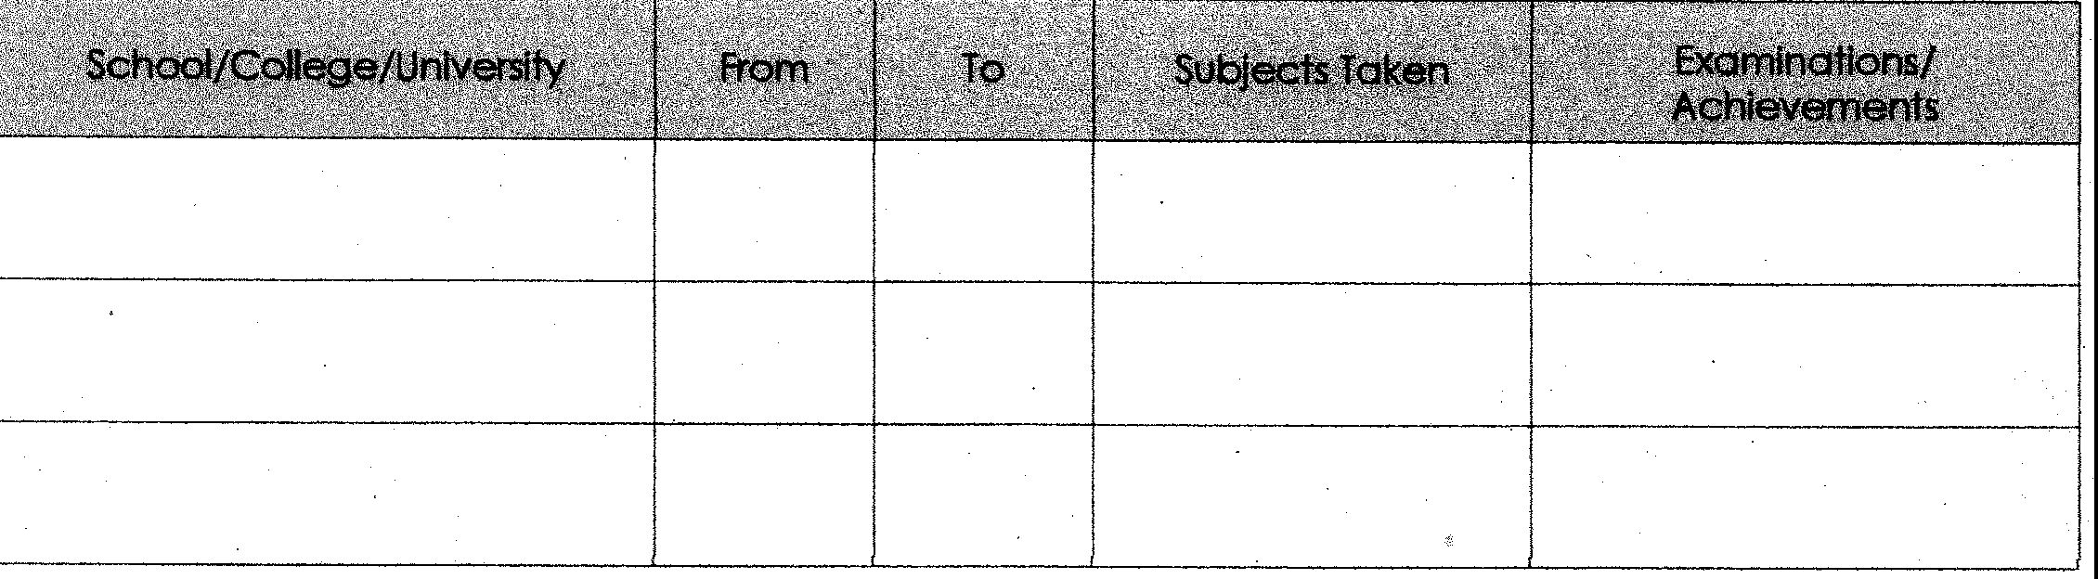

Manager Application Form

Current & Previous Employment Previous Employment

From. .
To
From. To

Em oyer Address
Em oyer Address

Job Title
Job Title

Main Responsibilities _

Main Responsibilities _

Reason for leaving _

Reason for leaving ,.--

Previous Employment
From To Em oyer Address

References
Please provide details of two referees. These must be your most recent em oyer and previous em oyer. If self­ employed, ease give a business reference. References will be ap ied for, covering the last five years of
em oyment.

Reference 1
Name Company
Head-office address-..-----------

Job Title

Main Responsibilities _
Telephone _ Email address _

Reference2
Name

Company
Head-office address _

Reason for leaving_. _ Telephone
Email address _

Equal Opportunities
(our commitment)
The Boudingalt is committed to being an equal opportunities employer, ensuring that candidates from
all ethnic backgrounds and those with disabilities can compete equally with all other applicants. To help us to monitor the effectiveness of our policy, please complete the details below: ,

THIS INFORMATION WILL NOT FORM PART OF OUR RECRUITMENT DECISION
Do you consider yourself to have a disability? Yes No
If 'Yes', please give details

Do you think that adjustments to our recruitment process or to the job role may be required to accommodate your disability? Yes No ·

(If 'Yes', a member of our team will contact you to discuss your requirements.)
If you are Invited for an Interview, do you require special access into the buffding, any special equipment or arrangements to assist with any disability? Yes No
Please indicate your ethnic origin:
Black - African Black - cartbbean
Black- Other (inc. mixed parentage) White (inc. Greek, Turkish)
Irish Chinese Indian Pakistani Bangladeshi
Other (inc. Arabian, Iranian, other mixed origin) please specify _

Declaration
I confirm that the information given on this application form to join The Boudingait is correct to the best of my knowledge. I understand that any engagement entered into is subject to a satisfactory probationary period, references satisfactory to the company, documentary evidence of my National Insurance number, Personal Licence details and my right to work in the UK and, if necessary, a medical examination. I verify that the information provided is accurate, true and complete.

I understand, if I am appointed and this information is found to be inaccurate, untrue or incomplete, that this will be treated as gross misconduct and may render me liable to dismissal. I understand that the information which I have provided will be used in accordance with the Data Protection Act 1998 for the purpose of my application for employment with The Boudingait. I understand that this information will be used to process my
application, report on equal opportunities and for all other areas of personnel and staff administration necessary to
promote The Boudingait business.

Signed Date _
As I am sure that you will appreciate, we receive a high volume of applicatiOns and endeavour to reply to them personally. However, If you have not received a response within 14 days, then your application has unfortunately been unsuccessful.

