WeBoost Whole Home Cell Boost Systems
by Northern Neck Satellite Services

No more annoying dropped calls or poor call quality!
*With up to +65 dB gain of power, it greatly enhances 5G, 4G LTE, 3G and 2G cell
service for all your wireless cellular devices (smartphones, tablets, notebooks,
hotspots, etc.) on any carrier in US.
*There are no monthly fees nor does it need to be connected to any internet
source (wifi or landline) to work. It simply amplifies your existing in-building
cellular service up to 32X for better talk, text, and faster internet.

EXPECTED INDOOR COVERAGE:
up to 5,000 sq. ft. with 5 bars outside signal
up to 3,000 sq. ft. with 3-4 bar (-90dB) outside signal
up to 1,000 sq. ft. with 1-2 bar (-100dB) outside signal

Which phones and carriers work with my cell signal booster?
weBoost cell boosters are compatible with all North American carrier networks and work on all cellular-connected devices; including phones, tablets, and hotspots.

WORKS ON EVERY NETWORK, INCLUDING 5G, ON ANY CARRIER.

SYSTEM W/PROFESSIONAL INSTALLATION $1,100.00
(Manufacturer suggested retail price installed $1,200.00)
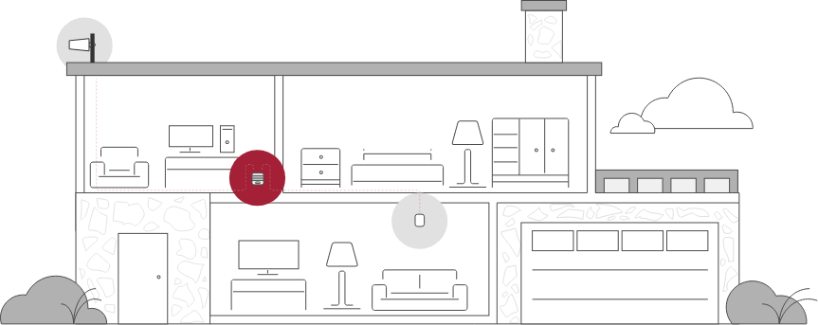
1

OUTSIDE ANTENNA
The outside antenna communicates back and forth with nearby cell towers.
2

BOOSTER
The signal booster amplifies any cell signals it receives from the outside antenna.
3

INSIDE ANTENNA
The inside antenna broadcasts these signals for use throughout your home or vehicle.

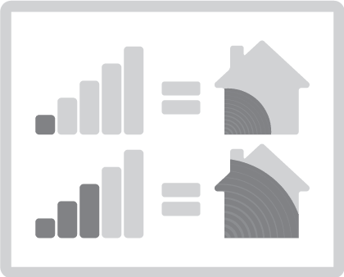

How outside signal strength influences booster performance
The stronger the outside signal strength, the more effective a cell phone signal booster will be at amplifying the signal strength indoors. Remember, the signal bars on your phone only provide a relative measure of the existing signal strength in your area. It’s possible for one phone to show full signal bars while another phone shows two signal bars while receiving the same signal from the nearby cell tower.

