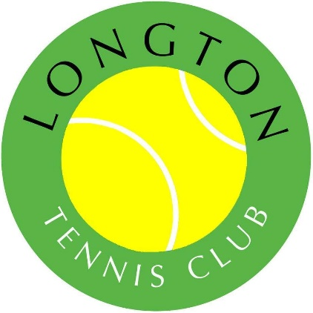

Longton Tennis Club
Rules for using the tennis courts

- Suitable sportswear and footwear (i.e. trainers or tennis shoes) must be worn at all times on the courts

- No bicycles are to be taken onto the tennis courts & must remain outside the courts at all times

- When more than eight members are present (usually on social nights), doubles sets must be played

- All members who want to play tennis, must book the court. Failure to do so, may result in not being able to play (due to other bookings)

- All members must look after the clubhouse and courts e.g. appropriate use of nets, benches, courts, litter to be taken away/put in the bin and lock the gate after playing

- Guests may be taken on the courts on payment of £2.00 per visit, per guest, payable online. Guests are limited to 3 visits, then if you wish to play again, you must join the tennis club

- All tennis club members and visitors to the club, must comply with the code of conduct

- Where a tennis court has been booked, the booking has priority over someone who has not booked a court.

- Team tennis will take priority over individual bookings. There may be times when we need to ask you to re-arrange your individual booking, so that matches can be played by league deadlines, but this will be a last resort

