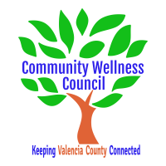
Board Meeting
February 6, 2019
1:00pm-3:00pm Wellness Center

1:00PM-1:10PM

- Call Meeting to Order
- Welcome Guests
- Agenda
- Consent Agenda
  - Minutes of 1/14/19
  - Treasurer Report January
  - Coalition Reports
- Social Media/Website Report
- Consent Exemptions
Business
- Ann Edenfield-Sweet--bringing Wings to Valencia County (Ann) 1:10pm-1:25pm
- Coordinator’s Report (Noelle) 1:25 PM-1:35 PM
- Grant, Grant deliverables/Activities Update (Diana/Noelle) 1:35 PM-1:45PM
- Life Skills Mini Grant Request (Noelle) 1:45pm-1:55pm
- Proposal for CWC mini grant for Youth Center Gold Tourney Seed money (Diana/Noelle) 1:55PM-2:05PM
- Anna Age 8 Community Planning Meeting Next Steps (All) 2:05PM-2:20PM
- KAH Co-Community Event (All) 2:20PM-2:35PM
- KAH Local Trainings (Noelle) 2:35pm-2:45PM
- Update on County Resolution presentations ect. (Diana) 2:45pm-2:50pm
- Review of Activities/Time Line/Action Items 2:50PM-3:00PM

Additional Items of Discussion
- Adjourn

