What will YOU choose?
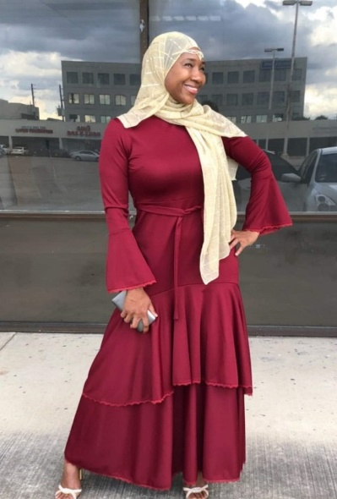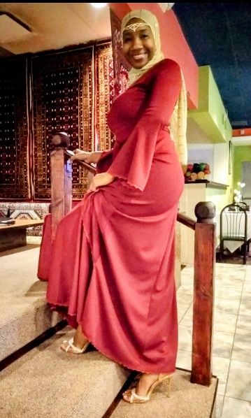
It took me a good long while to step into my identity as QUEEN👑 in the Kingdom of God. I was too busy out in the world trying to live life on my own terms..and you already know how that typically turns out. It came to the point where I had to make a choice. It was the world and everything in it or God. Well, I chose God. On that day I finally stepped back into my God given identity. It was during this time that I was able to throw off my robes I had gained in the world...my false identities created by what I went through ( hardships, trials), keeping God on the outskirts of my life...Pain, Anxiety, Insecurity, Depression, Anger and the list goes on. This was not my true identity, but when you are one with the world, the enemy will create an identity for you that looks nothing like your true role in the kingdom. I now know and understand that I am a Queen in the kingdom. With me stepping into my full identity this means I don't have to beg for a spot because if it's meant for me God's favor will place me there. I don't have to chase a relationship, the right one is mine no matter what it looks like. I don't have to "hussle," for money, as God is my provider. I don't have to compete for worldly acceptance because the Lord of all the worlds has already accepted me and given me value. I don't have to fight my own battles because he goes before me and makes the crooked places straight before I even get there. I now know rejection is only Gods protection. I have gained a friend that I can fully trust, never leaves me, forsake me, backstabs me or judges me. HE protects me and never lets anybody overcome me.
Just keeping in mind your role as a King or Queen in the Kingdom, let me ask you a question.... Are you tired of just living in this world taking the bread crumbs that are thrown to you; or having to run yourself in the ground and compromise your entire being and relationships just to get what God has already promised to you in the kingdom? Are you ready to step into your beautiful robe God is holding onto especially for you, accepting whole heartedly that you can't live this life without HIM. You don't have to be perfect, just willing to put God before all of the temporary worldly pleasures that will eventually destroy you and leave you empty handed..plus do nothing for you in the next life. We are getting close to that time y'all, where it will be too late to make a choice. Are you ready? What will you choose?
[36] For what shall it profit a man, if he shall gain the whole world, and lose his own soul? [37] Or what shall a man give in exchange for his soul?
Psalms 37:29
The righteous shall inherit the land, and dwell therein forever.

