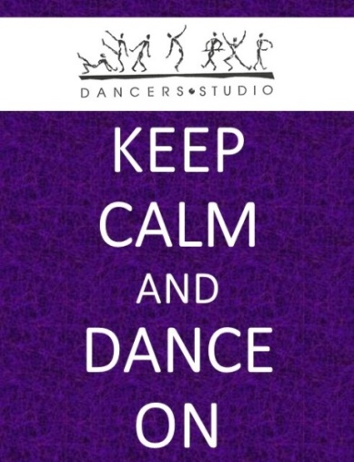
Virtual Dance Classes!
Our studio is turning virtual! We are bringing your dance classes to you through Zoom.

Please see below our schedule starting Monday March 30th. All registered dancers can access their class through the online parent portal.

In addition, we are excited to offer all dancers the opportunity to join in on an extra class free of charge. Email us the extra class you are interested in and we will register you so that you can access the class link. Classes that are unavailable are highlighted in grey.

In addition, we have four bonus classes highlighted in yellow. The links for these classes can be found on our website at www.dancersstudiomidland.com

Day | Time | Virtual Class | Teacher | Original Class(es)
Monday | 9:00 – 10:00 am | Junior Company Jazz | Ms. Jordyn | Junior Company Jazz
Monday | 9:15 – 10:15 am | Int. Company Jazz | Ms. Jordyn | Int. Company Jazz
Monday | 10:30 – 11:30 am | Teen Company Jazz | Ms. Jordyn | Teen Company Jazz
Monday | 10:45 – 11:45 am | Senior Company Jazz | Ms. Jordyn | Senior Company Jazz
Tuesday | 9:00 – 9:55 am | Int., Senior Ballet | Ms. Jordyn | Int., Senior Ballet, Tuesdays
Tuesday | 10:00 – 10:30 am | Pointe | Ms. Jordyn | Beg. and Sr. Pointe
Tuesday | 1:00 – 2:00 pm | Open Class | Various | Open to All
Tuesday | 4:00 – 4:40 pm | Modern/Lyrical | Miss. Emilie | Modern, Tues, 4:00 pm  Lyrical, Wed. 6:15 pm
Tuesday | 4:45 – 5:25 pm | Jazz/Hip Hop, 9-12 | Miss. Emilie | Jazz/Hip Hop, Tues, 4:45 pm
Wednesday | 4:00 – 4:40 pm | Ballet, Beg/Int. | Miss. Emilie | Ballet, Wed. 4:00 pm  Ballet, Tues. 5:30 pm
Wednesday | 4:45 – 5:25 pm | Jazz/Hip Hop, Beg/Int. | Miss. Emilie | Jazz/Hip Hop, Wed. 4:45 pm
Wednesday | 5:30 – 6:10 pm | Tap, Beg/Int. | Miss. Emilie | Tap, Wed, 5:30 pm
Wednesday | 7:00 – 7:40 pm | Commercial Jazz | Miss Ryann, Ms. Carlee | Commercial Jazz, Wed 7:00 pm
Wednesday | 7:45 – 8:25 pm | Hip Hop | Miss Ryann, Ms. Carlee | Hip Hop, Int., Wed 7:45 pm  Boys, Fri., 7:45 pm
Wednesday | 8:30 – 9:10 pm | Advanced Hip Hop | Miss Ryann, Ms. Carlee | Advanced Hip Hop, Wed 8:30 pm
Thursday | 5:00 – 5:40 pm | Beginner Tap | Ms. Fiona | Beg. Company Tap  Tap, Fri. 5:30 pm
Thursday | 5:45 – 6:25 pm | Intermediate Tap | Ms. Fiona | Intermediate Company Tap
Thursday | 6:10 – 6:50 pm | Advanced Tap | Ms. Fiona | Advanced Tap
Thursday | 7:00 – 7:45 pm | Adult Jazz | Ms. Fiona | Adult Jazz, Thurs. 7:00 pm
Thursday | 8:00 – 8:45 pm | Adult Tap | Ms. Fiona | Adult Tap, Thurs. 7:45, 8:30 pm
Friday | 11:00-11:45 am | Stretch and Strengthen | Miss Emily | Open to All
Friday | 12:00-1:00 pm | Open Class | Various | Open to All
Friday | 4:00 – 4:40 pm | Song and Dance | Ms. Leanne | Song and Dance, Fri, 4:00 pm
Friday | 4:45 – 5:25 pm | Jazz/Hip Hop, 7-9 | Miss Miriam | Jazz/Hip Hop, Fri, 4:45 pm
Friday | 5:30 – 6:10 pm | Musical Theatre | Ms. Carlee, Miss Miriam | Musical Theatre, Fri, 6:15 pm
Friday | 6:15 – 6:55 pm | B-Boys Mini Hip Hop | Ms. Carlee, Miss Miriam | B-Boys, Fri, 7:00 pm
Saturday | 10:45 – 11:25 am | Ballet and More | Ms. Teri-Lynn | Mommy&Me, Ballet and More
Saturday | 1130 – 12:10 pm | Jazz/Hip Hop, 5-8 | Ms. Teri-Lynn | Jazz/Hip Hop, Sat. 5 to 8
Saturday | 12:15 – 12:55 pm | Ballet, Beg/Int. | Ms. Teri-Lynn | Ballet, Sat. 12:15 pm  Ballet, Tues. 5:30 pm
Sunday | 12:00 – 12:30 pm | Dance Games | Miss Michelene | Open to All

