SENIOR SPOTLIGHT!
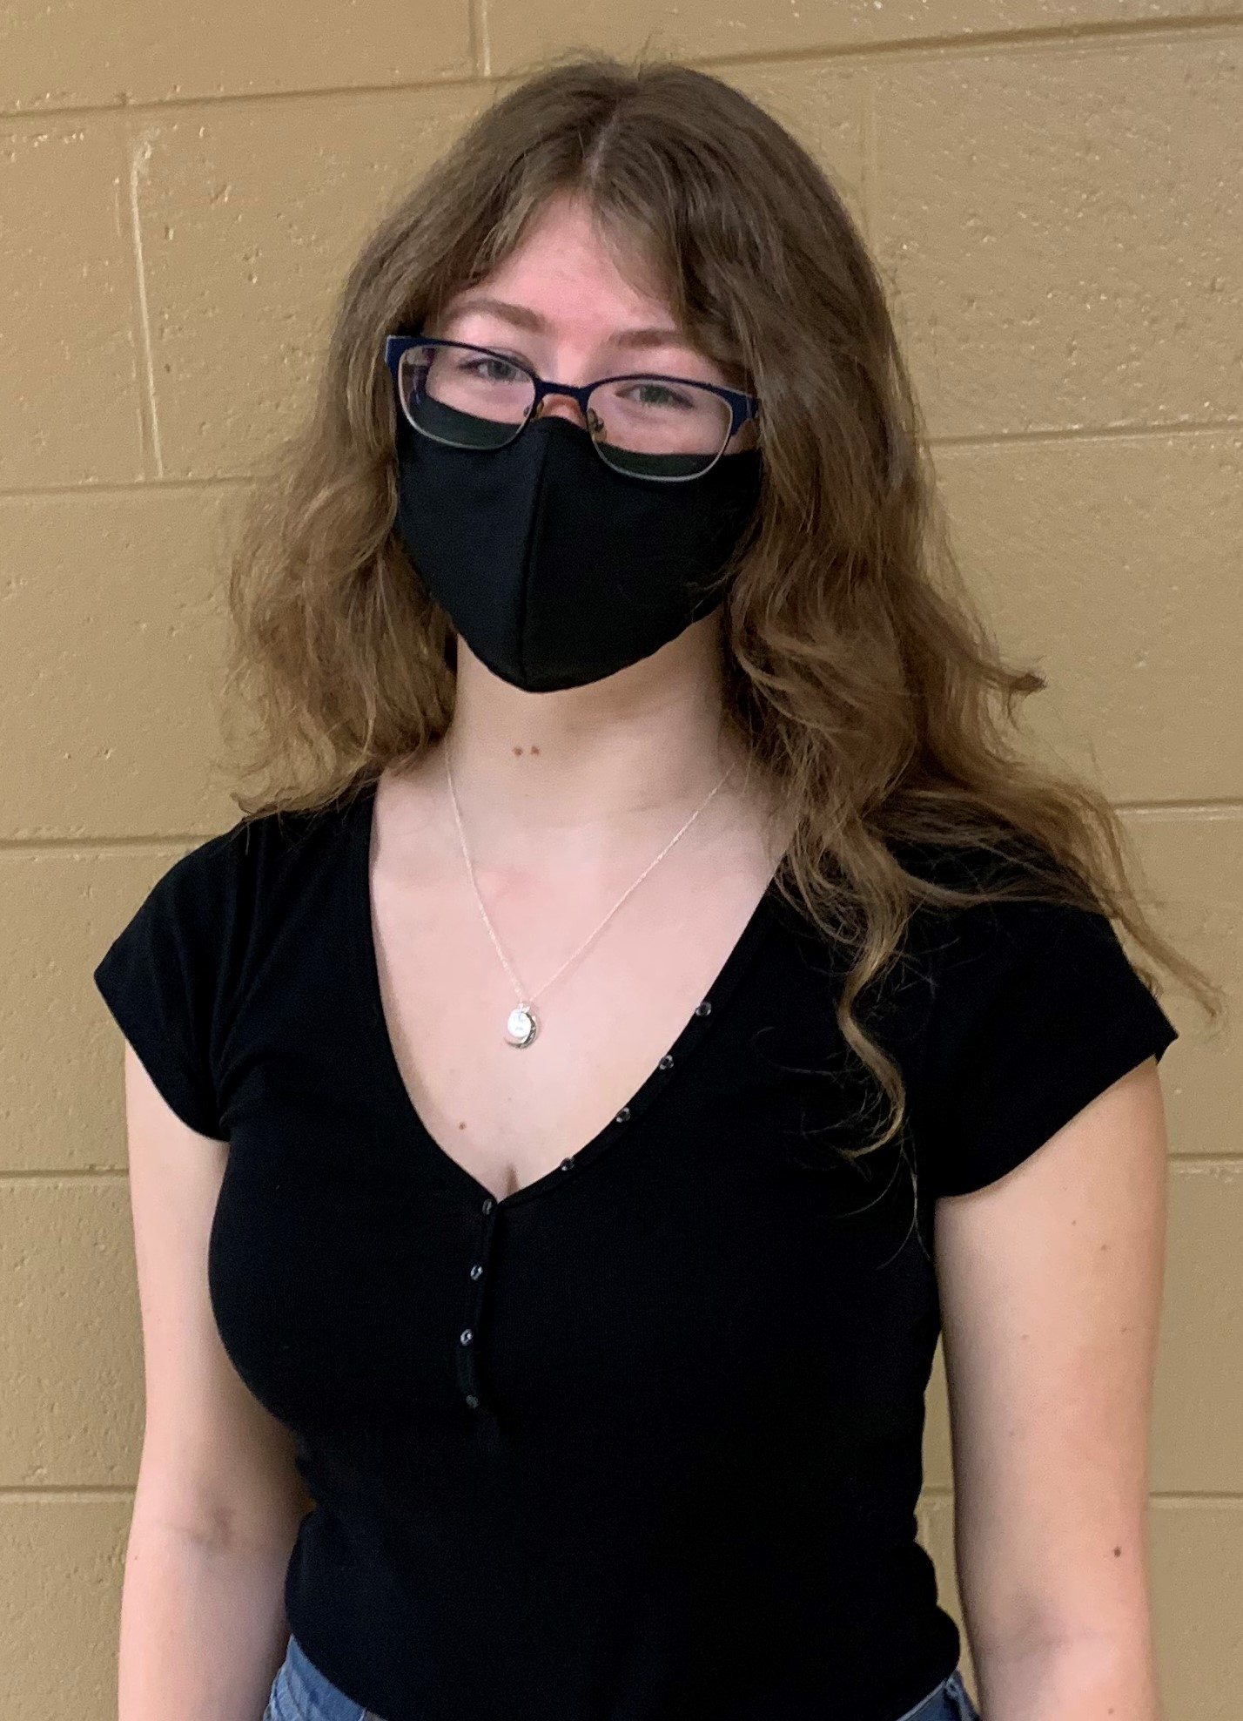
Elizabeth Harrison
Amelia County High School
Medical Assistant

What brought you to ANTC? I wanted to get out of school.
What is your favorite class that you have taken so far? Why? Horticulture, it allowed me to get out of the classroom.
What is the best advice you have been given by your instructor at ANTC? Always wear gloves
What is your favorite memory at ANTC? My first time using the butterfly needle
What was the first feeling you had when you attended ANTC? Anxiety
What words of wisdom do you have for other students? Go to college or marry rich
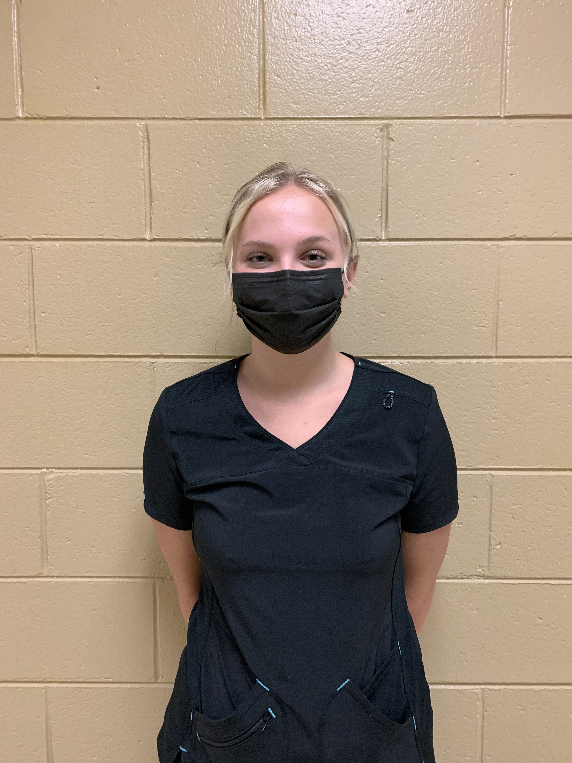
Autumn Bryant
Amelia County High School
Cosmetology

SENIOR SPOTLIGHT!
What brought you to ANTC? Cosmetology Program
What is your dream job? Hair Stylist
What is your favorite class that you have taken so far? Why? Cosmetology class because I want to do hair and I get to do it every day.
What is the best advice you have been given by your instructor at ANTC? Everything! Mrs. Rajah gives great advice.
What is your favorite memory at ANTC? All the “mistakes” mad in the salon. We all laugh and have a good time.
What was the first feeling you had when you attended ANTC? Excitement
What words of wisdom do you have for other students? Listen, communicate; it will make your experience easy and comfortable.
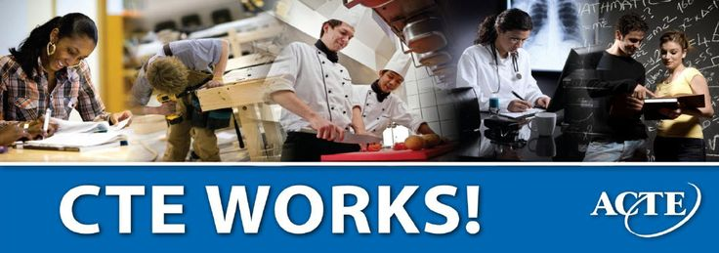

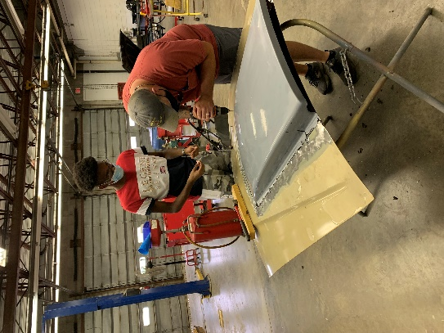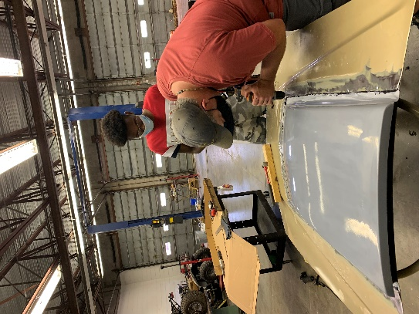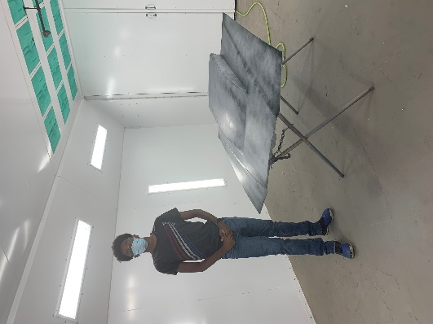
COSMETOLOGY - Thank you to Joint Board member, Mr. Bill Outlaw for visiting our Cosmetology Lab. Senior, Autumn Bryant (Cosmetology II) had the pleasure of cutting his hair.
AUTO BODY – Auto Body II learning fabrication of metal, shaping metal, and learning how to shape and apply fillers.

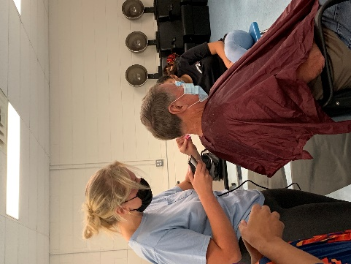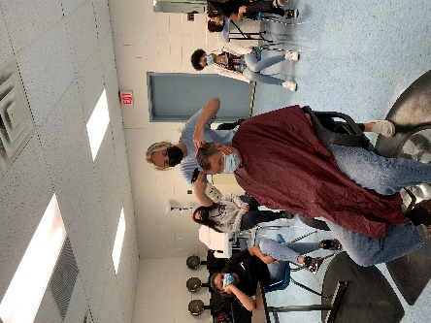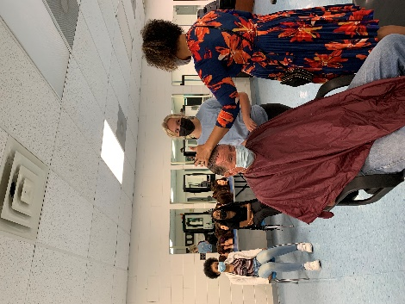

MEDICAL ASSISTANT – Proper PPE is essential in health care professions. ANTC students wearing proper PPE.
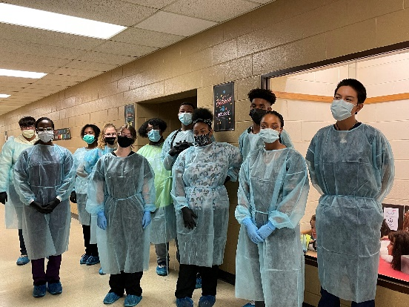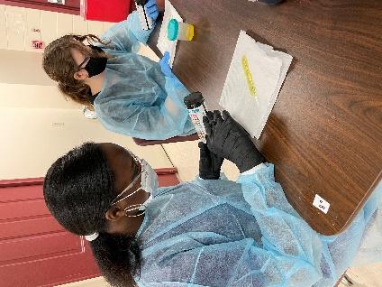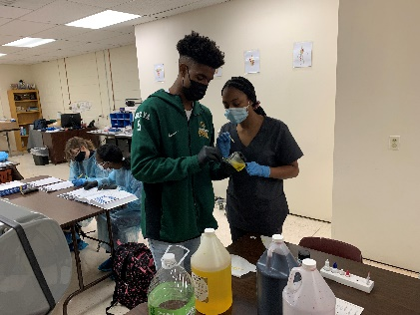
Specimen Collection & Skills Practice
CERTIFIED NURSE AIDE – CNA students scanning the ANTC Skills Lab to find thirteen things that would affect Infection Control.
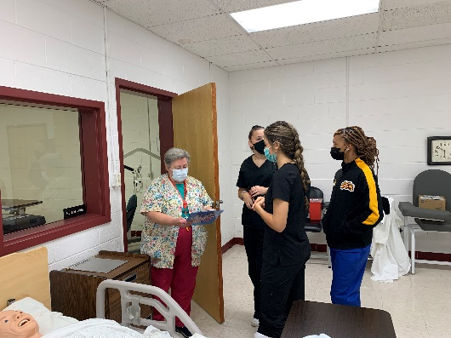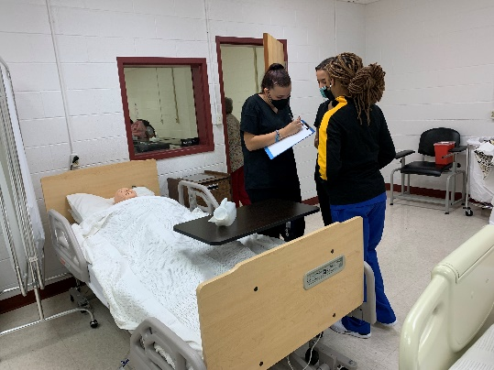

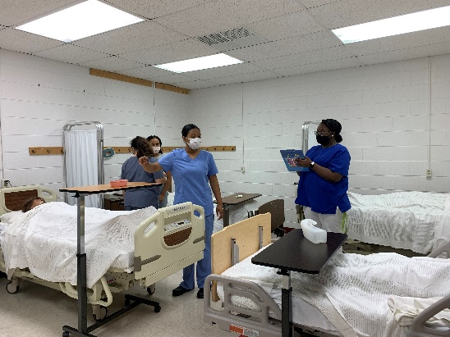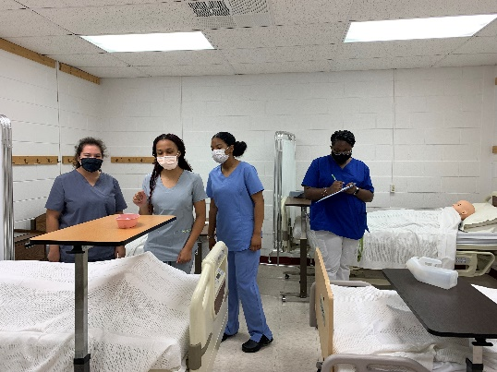

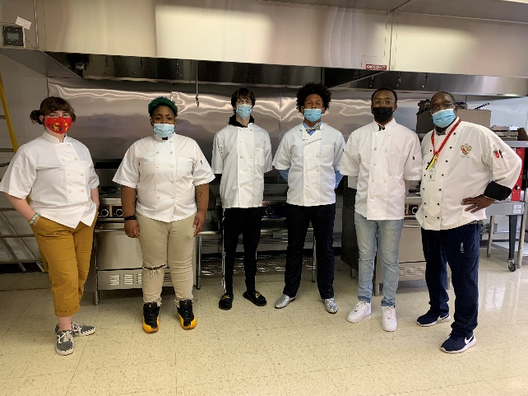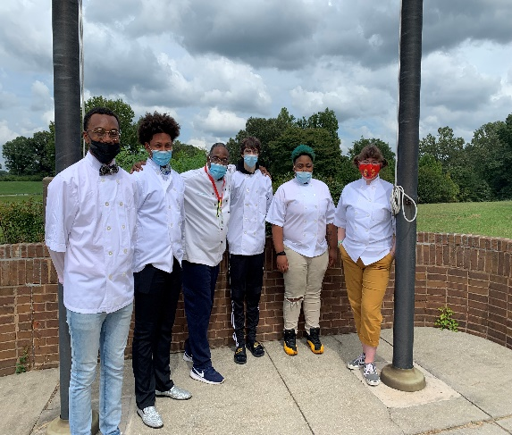
CULINARY ARTS – IT IS OFFICIAL! The Culinary Art Kitchen is complete and ready for our students to begin learning the fine art of cooking. Congratulations to Chef Carrington and the culinary students.
Guest Speaker:
Piedmont Health District,
Health Inspector
Culinary Arts II
