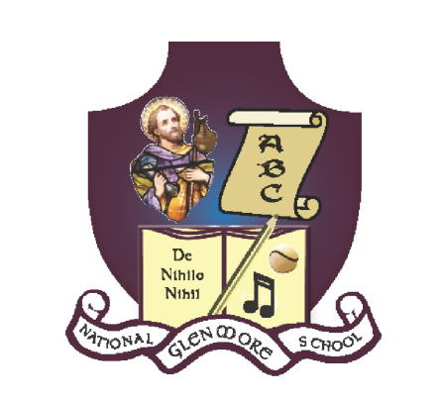
GLENMORE NATIONAL SCHOOL
S.N. SEAMUS NAOFA
GLENMORE, CO. KILKENNY
051 – 880269 glenmorens@gmail.com 18158L

Healthy Eating Policy

This Healthy Eating Policy was drafted as a whole school staff and ratified by the Board of Management in 2008.

Aim
The goal of this Healthy Eating Policy is to encourage children to have lunches which are healthy and balanced in nutritional value. We aim to promote better health in our school and community.

Little Break
This is a very short break. We encourage the children to have a small snack for this break. Some possible suggestions are:
- A piece of fruit, a yogurt, chopped vegetables.
Big Lunch
For healthier school lunches, some possible suggestions are:
- A sandwich, fresh fruit/vegetables, pasta.
Please note: There are a lot of processed foods that masquerade as ‘healthy options’; cereal bars, crackers etc. Parents are asked to exercise their discretion in this regard.
Treat Foods:
Healthy lunches each day with ONE treat on Fridays only/
- Please be advised that some children have nut allergies. If this is the case in your child’s class, please do not put nuts in your child’s lunchbox.
We appreciate your help and cooperation in implementing this policy.

