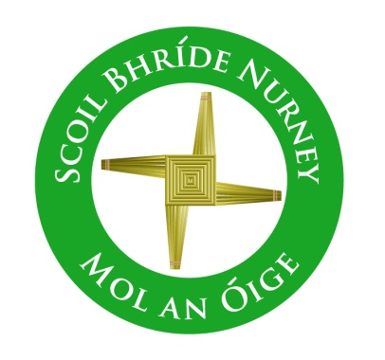
Scoil Bhríde,
Nurney,
Principal – Vinny Thorpe
Dep. Principal – Catherine Owens

County Kildare.
Te/Fax: (045)526767
Email: sbnurney@gmail.com
www.nurneyns.com
Roll no: 16345A

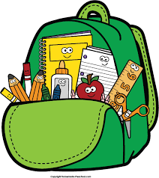
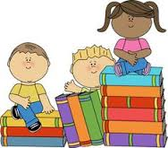
2nd Class 2021 – 2022
Book List

- To aid with the cost of school books there is a Book Rental Scheme in operation in our school. Please check our school website www.nurneyns.com on how to pay the annual membership and sign up to this cost saving scheme each year. If however you decide not to pay the annual membership and sign up to this cost saving scheme, listed below is the 2nd class school books you will need to purchase for your child for this school year.
- New Wave Mental Maths 2nd Class (Prim-Ed)
- Starlight Core Reader 2nd Class (Folens)
- Céim ar Chéim Reader – Cairde le Chéile (Fallons)
- Starlight Skills Book 2nd Class (Folens)
- Starlight Combined Reading and Skills Book 2nd Class (Folens)
- Busy at Maths 2 (Fallons)
- Céim ar Chéim 2 (Fallons)
- Small World – History, Geography and Science – 2nd class (Fallons)
- Jolly Phonics Grammar 2 Pupil Book (Folens)
- Ready to Write 2nd Class (Edco)
Please label all of your child’s belongings, stationery, uniform and tracksuit tops, coats etc.

PLEASE NOTE: ‘Book rental’ books will only be ordered for and issued to your child if you choose to fully fill in the Book Rental Membership Form and return it to the school office with your full Book Rental Payment.

Thank you for your co-operation and looking forward to a great year ahead!

___________________
Class Teacher

