The Easiest Creative Writing Curriculum for a Struggling Learner
May 17, 2016 by Sarah Shelton
My oldest daughter is bright, creative and witty. She is also dyslexic and didn’t start reading fluently until the 4th grade.
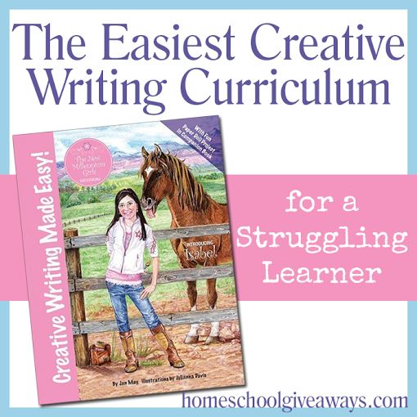It has been so difficult to get my daughter to read that I hadn’t even considered any sort of writing curriculum. We were just working on learning how to read without getting frustrated and being able to just simply enjoy books without any tears! This has been a long, hard road for us, but I am happy to say that last year, at 10 years old she was reading fluently without any help from me. I encouraged her with simple books and we slowly worked our way up to to harder chapter books. I found she enjoyed any books about animals and horses the best. So that is what she read the most of!
Carrie knew that my daughter adored horses, so at the beginning of the school year she gave me her copy of Isabel’s Secret, which is the novel that was created as the spine for the Creative Writing Made Easy Curriculum from New Millenium Girls Books. My daughter was so excited just by the cover of the book! She immediately started devouring this novel! She finished it within two weeks which is a huge accomplishment for her! After seeing how much she enjoyed the story, I thought that it would be a great time to introduce the creative writing portion of the curriculum.
I ordered the digital version of Creative Writing Made Easy along with the companionIsabel’s Closet Paper Doll and Craft Book. I chose the digital version because I have 3 girls and I wanted to be able to reuse this with my other girls as they get older. It was also easier for me to send the files to the UPS Store with my teacher discount card and pick up a nice, bound copy. I printed the paper doll book at home so we could print the dolls on cardstock and laminate them. We store our dolls and doll clothes in a pendaflex folder that we pull out during the craft time.
To get the most out of this curriculum I recommend the complete set:
Creative Writing Made Easy:
Your students will be guided step by step in creating an adventure where both the student and her characters grow in faith towards God. Each of the 12 lessons will teach the basics of creative writing such as:
- Developing Characters
- Sensory Settings
- Punch up Dialogue
- Create Plots that build Christian Faith
Each Lesson has three sections:
- Learning Time
- Writing Time
- Craft Time
Isabel’s Closet Paper Doll and Craft Book:
Each lesson contains a paper doll project where the students design their own paper doll clothes, make a bedroom folder closet, and draw illustrations to complete their story.
What my 11 year old, fifth grade daughter thought of this curriculum:
She absolutely adores this curriculum! I never had to schedule this into our school day. Writing is her favorite part of the day now! Every day when we were finished with school she would pull her Creative Writing Made Easy book out and she would get to work! She would read her lesson all on her own and start doing the exercises. I have no set schedule with this curriculum, I just let her work on it at her own pace. Sometimes she will read the lesson and do a little bit of the writing and save the rest of it for another day, sometimes she will do an entire lesson in one setting.
I asked her what her favorite part of the writing has been and she loved the lesson on Creating a Plot. She really enjoyed using her imagination to write down the sights, sounds, smells and tastes of things you could experience in the town she was writing about. She also enjoyed the story webs. Here is a sample of her first story web. Please ignore the transposed letters and spelling. I am not pushing her on these right now and just letting her enjoy writing. Editing will come later.
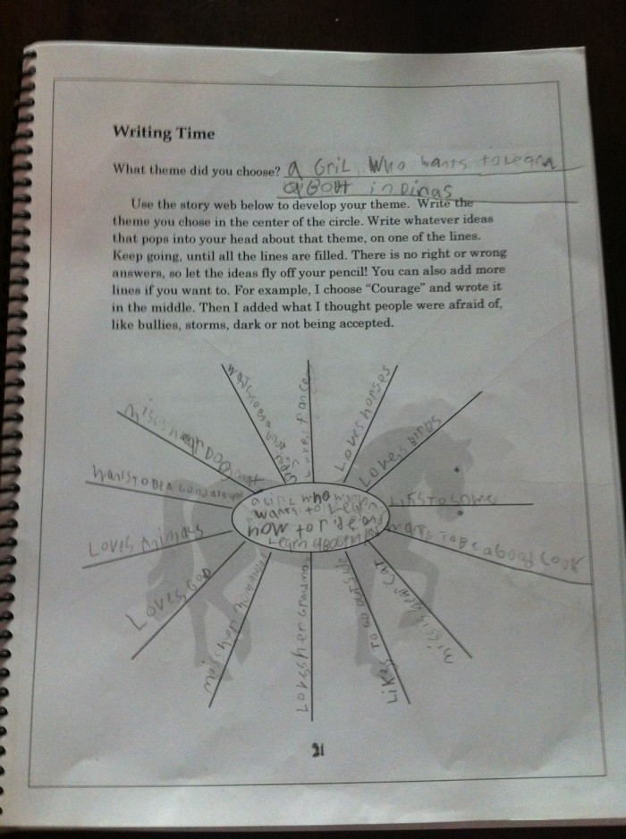
Isn’t the horse the cutest? It is found on pages throughout the entire book!
The craft time has become a sweet time with all of my girls. My oldest gets the paper doll book out and she shares it with my 8 yo and 5 yo. They all work together to color and design the clothes and create the scenes.
My thoughts:
I never even considered that my daughter was ready for writing. She has had many struggles with reading, with still reversing her letters, and awful spelling. I just didn’t even think a real writing curriculum was an option. We have always done verbal narration and dictation because writing and reading was so stressful for her. I am so impressed with Creative Writing Made Easy. It really is EASY! My daughter has OWNED this curriculum. She has made it completely her own and taken it upon herself to make sure she is working on it at a pace that is comfortable for her learning style.
I also love the independence of this curriculum. I usually dread writing because it is so time consuming to teach. With multiple children, and working from home I have to use things that my children can do independently. Other than reading the wonderful stories she writes, I have had to do nothing with it. When she brings it to me to show me her work I am so pleased with how well she is writing. The text is written in such an easy to understand and gentle way. There have been no tears with this writing curriculum. There has been nothing but smiles and great joy!

Sarah is a wife, daughter of the King and Granola Mama to 4 children ages 16-5. She is a Charlotte Mason style homeschooler and has been homeschooling for 13 years now. She is still trying to find the balance between work and keeping a home and says she can only do it by the Grace of God, Coffee and Green Smoothies!

