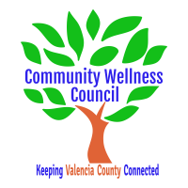
Board Meeting
March 6, 2019
1:00pm-3:00pm Wellness Center

1:00PM-1:10PM

- Call Meeting to Order
- Welcome Guests
- Agenda
- Consent Agenda
  - Minutes of 2/6/19
  - Treasurer Report February
  - Coalition Reports
- Social Media/Website Report
- Consent Exemptions
Business
- Coordinator’s Report (Noelle) 1:10 PM-1:25 PM
- Grant, Grant deliverables/Activities Update (Diana/Noelle) 1:25 PM-1:35PM
- Anna Age 8 Community Planning Meeting Next Steps (All) 1:35PM-1:50PM
- KAH Co-Community Event Debrief and follow up (All) 1:50PM-2:05PM
- KAH Local Trainings (Noelle) 2:05pm-2:15PM
- Next CRUNCH (Noelle) 2:15-2:30PM
- Upcoming Health Fair Rio Communities (Bart/all) 2:30-2:45pm
- Review of Activities/Time Line/Action Items 2:45PM-3:00PM

Additional Items of Discussion
- Adjourn

