Readers contributions to the magazine are always welcome. Hard copy (hand written if easier) to the Rectory address or by email: to : st.marysstockport@gmail.com
Editorial discretion with regard to content and space available will apply.
St Mary’s in the Marketplace
St Mary’s Rectory, 24 Gorsey Mount Street,
Stockport, SK1 4DU.
0161 429 6564 www.stmarysinthemarketplace.com.
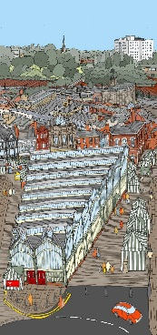
St Mary’s in the Marketplace
50p
Parish Magazine
October 2013
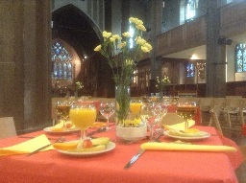

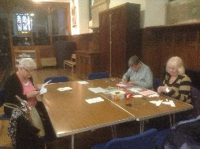

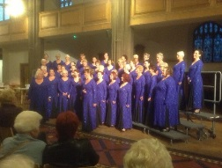

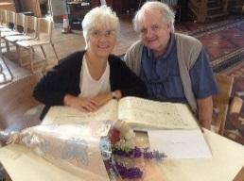

From the Rector’s “ i-pad”
Dear Reader .
"On the wall" .
The other day I was sitting on the wall which runs along the churchyard of St .Mary's church, in the Market place of Stockport's historic town centre.
Churchgate, as the road is known, is now a busy thoroughfare both for pedestrians and for traffic, especially since the Borough Council ended the practise of closing the road to traffic on Market days a fact still mourned by some. .
Sitting on the wall, in between gardening sessions, is something I have found very productive in recent years. Not only does one gain a good impression of the dynamic life flow of the town centre, witnessing at first hand the constant to and fro of people and vehicles, but it also gives one the opportunity to meet people who, in the normal course of things " we would never have meet", in the words of one passer by.
Over perhaps a period of two hours ,mostly spent pruning the buddleia, a verdant shrub, which if left to its own devices would take over the place, I must have stopped working, sat down on the wall, and talked to more than a dozen good folk, some from Stockport, but others from far further afield. ..12th December
Without divulging the content of any particular conversation, I can honestly say that the chats I had were as wide ranging as you could wish to imagine. Obviously the state of the church and of the world came up, as did people's own state of mind. .
At one point, while still standing and working I was asked if the plant I was cutting down was a weed Sounding like a member of the
The Parish Share

It will come as no surprise at all to most of you to know that we are still unable to meet our “Parish Share” payments. The amount we receive in the “planned giving” envelopes and by direct debit, together with our general income, is nowhere near the amount we need to keep St Mary’s/St Andrew’s going on a day to day basis and we continue month by month to underpay the Diocese. At this time of “harvest giving” perhaps time for a gentle reminder to review just what “we” are giving” at St Mary’s.
The Parish Share is a contribution by parishes in the Diocese towards the cost of the provision and support of Parish mission and ministry.
The amount requested of each parish is calculated on the basis of the cost of one priest and support services; this amount is known as the standard parish share. The amount requested is this figure adjusted for clergy numbers and socio economic factors.
The middle half of parishes with average ability to pay contribute 105% of this adjusted figure; ie a small contribution. The parishes with above average ability to pay contribute greater amounts up to 145% of this figure, while the least able to pay contribute smaller amounts down to a minimum of 35%. By this, the 25% of parishes with least ability to pay are supported by the 25% with greatest ability to pay.

Is St Mary’s paying its way? Well in a word “no”. In simple terms we have been asked to pay £44,564.00 for 2013 (£3,713.66 per month). In reality we will be paying just £18,000.00 (that is £1,500.00 per month). Our arrears continue to increase by £2,213.66 per month / £26,563.92 for this year alone.
Thursday Christmas Craft Group
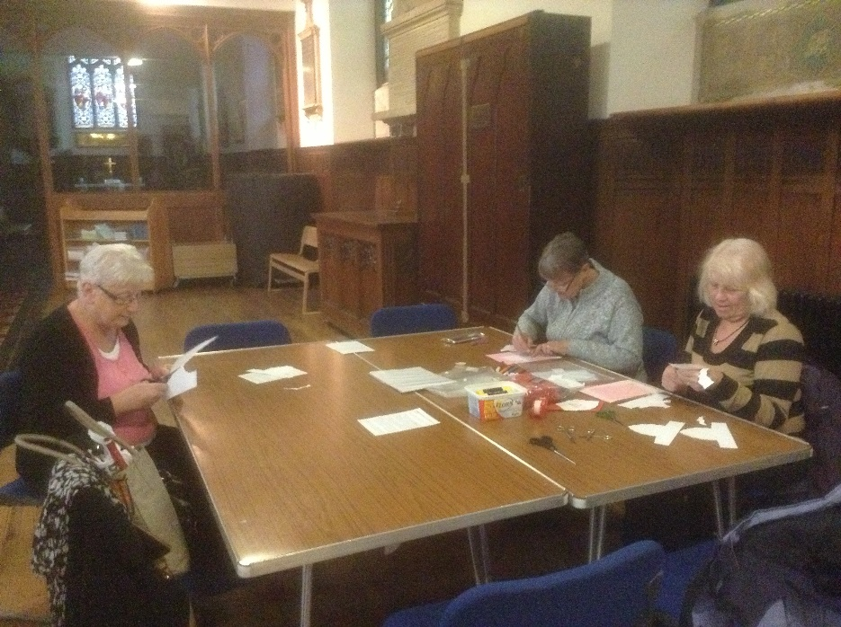

Our first craft session took place on the 19th September and already we have items ready and waiting to be sold at the Christmas Fayre to be held on the 14th December at St Mary’s. We are planning a weekend to remember, but St Mary’s needs your help…… please come and spend some time at the Craft Group – Thursdays 11am – 3pm (drop in as you wish or attend the full session). If you can’t attend, then donations of craft items for the stall are always appreciated or donations towards the purchase of materials.

Gardeners Question time Panel, I sat down on the wall, and gave the passer by a brief description of buddleia (though sadly I do not know the Latin name!), ending by saying that "the butterflies love it, and hasn't it been a good year for butterflies!" And I'm pleased to say that the enquirer was quite satisfied with my answer and ,as they used to say " went on her way rejoicing"! .
So in case you were thinking that all my conversations must have been deeply spiritual, this incident, I hope , proves you wrong! Having said that, I would like you to know, dear Reader that some of my most engaging spiritual and pastoral moments, encounters if you like, have been just there, just like that, sitting on the wall!
I would like to conclude by saying that as much as I like pruning and weeding in the churchyard , there are other ways I could use my time, pastorally. So if there is someone reading this either in the Magazine, or on line, who would like to offer their time, and dare I say, far greater knowledge of gardening than I have, then there is a lovely opportunity for an enthusiastic volunteer to take on this little task! And a lovely wall to sit on, with many delightful people passing by ,with whom one could spend many happy minutes, by just " sitting on the wall"
Your Rector and Church Gardener .
Roger Scoones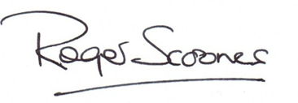

Across
1 Tertullus, who presented the high priest’s case against Paul in his trial before Felix, was one (Acts 24:1) (6)
4 As balm (anag.) (6)
8 Having explored Canaan, he and Joshua urged the Israelites to take possession of it (Numbers 13:30) (5)
9 On becoming king of Judah, he had all six of his brothers killed (2 Chronicles 21:4) (7)
10 ‘Even the — has found a home, and the swallow a nest for herself’ (Psalm 84:3) (7)
11 Banishment(Jeremiah29:1)(5)
12 ‘And now I will show you the most — way’(1Corinthians12:31) (9)
17 ‘Titus did not exploit you, did he? Did we not —— the same spirit and follow the same course?’ (2 Corinthians 12:18) (3,2)
19 Mice den(anag.)(7)
21 How Egypt is often described in the Old Testament: ‘the land of — ’ (Exodus 13:3) (7)
22 One of the first Levites to resettle in Jerusalem after the exile in Babylon (1 Chronicles 9:15) (5)
23 ‘As a sheep before her shearers is —,so he did not open his mouth’ (Isaiah 53:7) (6)
24 Paul’s birthplace(Acts22:3)(6)
Down
1 Ravenous insect inflicted on Egypt in vast numbers as the eighth plague (Exodus 10:14) (6)
2 Well-being (Philippians 2:20) (7)
3 Small piece of live coal or wood in a dying fire (Psalm 102:3) (5)
5 Sportsman or woman (2 Timothy 2:5) (7)
6 The original name of Abraham’s wife (Genesis 17:15) (5)
7 ‘So in Christ we who are many form one body, and each — belongs to all the others’ (Romans 12:5) (6)
9 According to Peter, a wife’s beauty should not come from wearing this (1 Peter 3:3) (9)
13 ‘For God did not send his Son into the world to — the world’ (John 3:17) (7)
14 ‘The Lord of heaven and earth...does not live in — built by hands’ (Acts 17:24) (7)
15 ‘If your hand — you to sin,cut it off’(Mark9:43)(6)
16 Something like these fell from Saul’s eyes as soon as Ananias placed his hands on him (Acts 9:18) (6)
18 Track(Job41:30)(5)
20 Religious doctrine(5)

ACROSS: 1, Lawyer. 4, Balsam. 8, Caleb. 9, Jehoram. 10, Sparrow. 11, Exile. 12, Excellent. 17, Act in. 19, Endemic. 21, Slavery. 22, Galal. 23, Silent. 24, Tarsus.
DOWN: 1, Locust. 2, Welfare. 3, Ember. 5, Athlete. 6, Sarai. 7, Member. 9, Jewellery. 13, Condemn. 14, Temples. 15, Causes. 16, Scales. 18, Trail. 20, Dogma.

Congratulations

Tony and Norman Smith celebrated their Golden Wedding on the 31st August 2013 by dropping into St Mary’s as they often do. They had a special reason for doing so this year, and especially because it was here that they were married.

They have lived happily ever after in Offerton, blessed with a family of two girls and five grandchildren.

Many congratulations

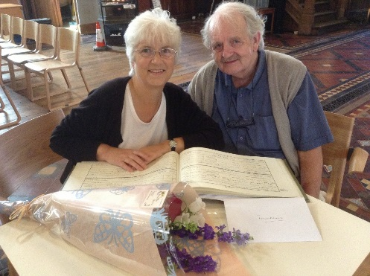

Welcome back to St Mary’s the Affinity Show Choir, performing at the
Co-operative evening concert on the 6th September. They will be
back with us again on the 4th December for our St Mary’s Appeal
Concert and on the 12th December in support of Beechwood Cancer
Care “Tree of Light” Service of Remembering.

There was of course just one thing missing this year…. We had lovely jam and marmalade but no lemon cheese. For some of us the annual “tower stall” is our only chance to sample home made delights such as this – and home produced pickle of course! Still, Christmas is coming so if anyone wishes to make more jam, more marmalade and some lemon curd or yummy pickles – we will be delighted to “re-open” the home made produce stall on the 14th December at our Christmas Fayre.
We will also be bringing in items in support of Traidcraft and will be introducing some of these into the shop area as soon as possible. We will start off with Organic Strawberry Jam, Organic Orange Marmalade and Honey (for baking and spreading) and see how it goes.
Foodie Fridays – Stockport Market will be holding “Foodie Fridays” on the last Friday of the month and we’ll be doing our bit to support them. Helping to bring Stockport Market and the surrounding area back to being the heart of the town. We intend working with Stockport Council and the Market Traders to make Churchgate an exciting place to be, attracting people from far and wide.
Look out next month for our November “treats”
The Nave Café “Pie & Pea Supper” (date to be confirmed), “Nativity Dance” on Friday, 29th November (linked with other activities in and around the market) and the start of the Christmas Season – programme available shortly.
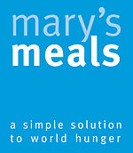
Mary’s Meals is an international movement that sets up school feeding projects in communities where poverty and hunger prevent children from gaining an education.
Mary’s Meals is a simple idea that works – by providing a daily meal in a place of education, chronically poor children are attracted to the classroom where they can gain a basic education that provides an escape route from poverty. Over 700,000 children receive Mary’s Meals every school day – the average cost to feed a child for a whole school year if just £10.70
Each year Mary’s Meals invites its supporters to celebrate the importance of porridge on World Porridge Day. Now in its fifth year, this event is an annual celebration of a traditional dish, and a chance to draw attention to the vital role that porridge plays at our school feeding projects in Malawi.
Porridge, of course, provides a hearty breakfast for people all over the world, but for over 600,000 school children in Malawi it is a powerful incentive to go to school and, for many, the only nutritious meal they will have that day.
At schools in Malawi where Mary’s Meals is working, each child is given a daily serving of likuni phala – which is a nutritious, vitamin-enriched maize porridge served in plastic mugs.
The porridge meets the children’s immediate needs by filling their empty bellies, but also attracts them to the classroom where they can get an education which can lift them out of poverty in later life.

In the Hospitality Area…

Operation Christmas Child is the world’s largest Childrens Christmas charity and last year after 22 years the 100 millionth gift-filled shoe box was delivered to a little girl showing her someone cares for her and God loves her.
It is hoped to be able to again send this Christmas from the UK 1,000,000 show boxes to needy children. The leaflet giving details of how to prepare a shoe box gift are now available in church near the hospitality area along with some empty show boxes if you need one.
Please make up a gift-filled shoe box if you can and bring it to St Mary’s between 1st and 24th November.
If you cannot make up your own box or need help making one please contact Margaret Forster or Irene Hamnett. Any suitable items as listed in the leaflet or cash donations towards the transport of boxes would be appreciated.

The Nave Cafe
It is hard to believe that we have been running the cafe for approximately four months now, but we are delighted to say that we are growing from strength to strength. Our weekly “profit” is creeping up and now stands at around £150 per week (over the first 13 weeks of trading). It needs to be more!
On a day-to-day basis we still need one vital ingredient – as many of YOU as possible to come on board and give us a hand. We need help in the kitchen (to support our Pure Innovations Manager(s) during the week and to help us at weekend). Help to take orders and serve drinks/meals. Help to clear tables, to load/unload the dishwasher as the need arises, to assist generally when the “trainees are on lunch or finding it hard to keep up the pace, particularly when there is a queue to deal with and orders are stacking up. Our working with Pure Innovations is a partnership and they ask us all to support their staff and service users at busy times. We also need to help with doing the café shopping (the fresh food we purchase from the market traders or local supermarket) and help doing the laundry. The “cash and carry” run is undertaken most weeks and takes care of the bulk of our requirements, but we need to purchase cheese, milk, eggs, cooked meat, bread, scones etc. on virtually a daily basis. We aim to buy most these from local traders in or around the Market Hall. We need someone to help undertake a regular weekly stocktake of food items (in liaison with the Duty Manager from Pure Innovations and ourselves) and prepare the weekly shopping list. We need help to do the local shopping (in the Market or down at Asda), help to ensure that food is rotated and stored correctly. We are obliged to provide clean fresh aprons for everyone working in the kitchen on a daily basis, clean towels and dish cloths. This means that there is a bag of washing every day we are open, all items to be washed separately at a temperature of 90 degrees. To do ALL the café laundry single-handed and all the shopping is extremely time-consuming! Can you help? Just being there to lend a hand, or pop out to the market…
Each child is responsible for looking after their own mug, and holding onto it ensures they get a fair portion every school day. Some carry them around their necks on a piece of string to make sure they don’t miss out.
Supporters can get involved in World Porridge Day by hosting a porridge breakfast at home, work, school or elsewhere in the local community. Alternatively, why not try baking flapjacks or any other porridge-related treats?

Support World Porridge Day
10th October
============================================================

Children’s Society Collection Box
If you have a Children’s Society Collection box please bring it into Church as soon as you can so that Frank can ensure your donation is included in our total giving to this worthwhile cause.
=============================================================
Mrs Rita Waters, who has become a familiar figure around St. Mary's in recent months, will be licensed as Reader at to St. Mary's in Chester Cathedral on Saturday 19th October in a great service of thanksgiving for lay ministry in the Diocese of Chester, and the inauguration of many men's and women's ministry as Readers in parish churches across the Diocese. ALL ARE WARMLY INVITED TO ATTEND. Rita will be officially welcomed to St. Mary's as Reader at the Morning Service on Sunday 20th and on Tuesday 22nd.PLEASE SUPPORT RITA WITH YOUR LOVE AND PRAYERS at this special time in her life.
Rev. Roger Scoones
Rector, St.Mary's Stockport
Harvest Weekend
Many thanks to everyone who assisted to make Harvest weekend a success. For those jars of jam and marmalade; cakes, plants and other goodies. Thank you too for your gifts to “The Wellspring”.
The catering team very much hope that everyone attending the Harvest Supper enjoyed themselves and we look forward to seeing you again in the very near future.
The weekend raised the sum of £270.00 (after the deduction of expenses)

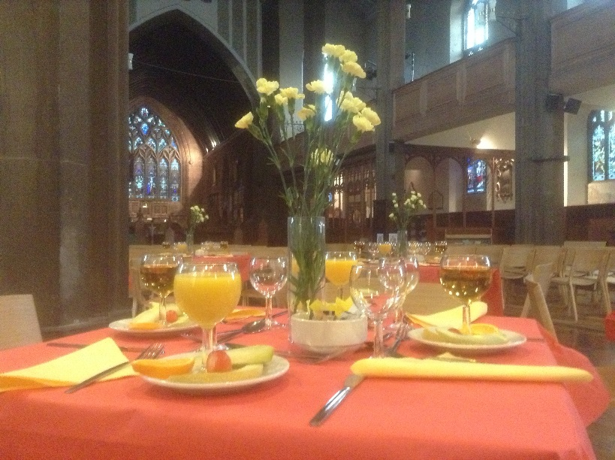

October at St Mary’s

St Mary’s will host a special service for H M Coroner, John Pollard to mark the start of the Coroners’ Society of England and Wales Annual Conference for 2013. John, who is President of the Society for 2012/13 is Senior Coroner for the Greater Manchester South District (covering Stockport, Tameside and Trafford). The preacher will be the Rt Revd Dr Peter Forster, Bishop of Chester. ./
Another “first” this month will be a three-day conference event to be held at St Mary’s by “God Loves Offerton”. The event will be attended by approximately 30 delegates, all to be “fed and watered” and looked after by us and our “café management partners” Pure Innovations.
--------------------------------------------------------------------------------------------------
The spectacular Panorama of STOCKPORT exhibition created by Neil Dimelow, from the top of St Mary’s Tower, will be on show in St Mary’s from 11th October – 10th November (when the church is open). Not to be missed! Artist-architect Neil Dimelow is from North Wales. He’s been in Manchester for 17 years and lives in Crumpsall with his wife and two boys. He’s taken a rest from architecture, and has been a part-time primary school teacher for seven years. He draws on days off. Neil’s work is as” meticulous as it is intriguing”. It is “arrestingly contemporary” and has to be seen. It is truly fantastic! .
Thursday, 10th October – World Porridge Day

