2002 Queso Cup Invitational Wraps Up with Team Poser On Top

August 15, 2002
Associated Press

BELLAIRE, MI –- The inaugural 2002 Queso Cup Invitational concluded without suspense as Team Poser disposed easily of Team Slash. Team Poser was made up of athletic juggernauts Chris Gryskiewicz and Jon Lambert. Team Slash’s only claim to athletic fame can be found in the midst of the intramural cornfields, err playing fields, of GVSU. The team of Jeff Penzien and John Masley had drawn even after two rounds, only to be solidly outpaced in the final round to lose in a final score of 9-6 (modified scoring to confuse all and hide true scores).
Team Poser assesses the 50 foot drop to the Par 3, 14th hole at Cedar River in the final round.
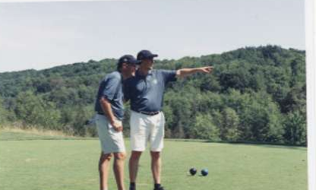

“We knew we were in trouble the minute we heard that Gav (Gryskiewicz) was being inducted to the PBA University Sports Hall of Fame next month. I mean, Lamb (Lambert) probably holds some sort of innings pitched record for their baseball team as well. Heck, we were taking on two of PBA’s most dominant athletes of the past two decades. We were simply outmatched.” was the only statement Masley could utter.

Penzien quickly added, “Did your photographers get a shot of those matching uniforms on days 1 and 3? Impressive…very impressive. We will come much better prepared next year.”

“Our little arrangement with Ranger Dave seems to have paid off nicely,” echoed Jon and Chris, almost in unison. “Team dress is something we hope will catch on for the years to come. In this case, we won psychologically on the first tee on day 1. The standard has been established, it is now up to the up and comers to raise the bar another notch”, noted the cagey veteran Lambert.

Amidst pristine conditions at the Shanty Creek Resort in northern Michigan, the Invitational established itself as a tournament to be reckoned with in the future. The weather was impeccable; with the exception of an afternoon rainstorm that delayed by one day the dinner cruise on Lake Michigan. With the field anticipated to grow in coming years and the venue to change, you can bet that this will become a favorite stop on tour, for both golfers and their families.

Initial plans for next year’s event are in the works with various sites currently under consideration. The executive committee will establish next year’s location and distribute invitations by December 31, 2002.

Final musings from this year:

- I wonder if Barry Cheesman would be upset at our unauthorized use of his name for the title sponsor?
- If we ate at Ivan’s every night, would we even need meal coupons?
- Is the ranger still looking for Johnny Mosley with a message for him?
- Whatever happened to those 80 mph winds blowing in?
- Did the prime rib dinner at The Lakeview have something to do with losing?
- How in the world did Phyllis get her job at Shanty Creek?
- On a related note, if it costs $130 to play a course, and I have credits available of $135, how much do I still owe? $60?
- How many pounds of fudge does $40 buy?

